MS8401 (2022春)课程项目

危国锐 120034910021

（上海交通大学海洋学院，上海 200030）

摘要：.

关键词：词1，词2

Course Project

Guorui Wei 120034910021

(*School of Oceanography*, *Shanghai Jiao Tong University*, *Shanghai* 200030, *China*)

Abstract**:** The purpose of this paper is to compare several commonly used classical decomposition (seasonal adjustment) methods systematically and to provide suggestions for future research.

**Keywords:** keyword 1, keyword 2

**Table of Contents**

摘 要 i

Abstract i

Table of Contents ii

1 Introduction 1

2 Data and Method 2

2.1 Data 2

2.1.1 NOAA Extended Reconstructed SST V5 (ERSST v5) 2

2.2 Classical decomposition 2

2.2.1 Simple method 2

2.2.2 Predictor-corrector method 4

2.2.3 Global model-fitting method 6

2.3 Experiment setup 7

2.3.1 Idealized time series 7

2.3.2 Real time-indices 8

2.4 Assessment methodology 8

2.4.1 Idealized time series 8

2.4.2 Real time-indices 8

3 Results 9

3.1 Idealized experiments 9

3.1.1 Classical decomposition results 9

3.1.2 Comparison of different methods 15

3.2 Classical decomposition of several real time-indices 19

3.2.1 ERSST v5 global monthly SST (1902-2021) 19

3.2.2 Comparison of different methods 29

4 Discussion 32

4.1 经典分解的基本假定及合理性 32

4.2 对时间序列经典分解方案的物理-数学理解 32

4.3 造成各分解方式间差异的因素 32

4.4 预估-校正的收益 32

4.5 时间序列分解质量评价 32

4.6 年际及以上变率的数学期望和样本均值 32

4.7 未来研究建议 32

5 Conclusions 32

References 34

# Introduction

A time series of a climate variable can be viewed as a single realization of a stochastic process that represents the mechanism generating it. One goal of the time-series analysis is to figure out (estimate) the underlying mechanism of the time series. It is usually a daunting challenge to accomplish this goal, because of the lack of high-quality observations (limited samples), and the non-linear and non-stationary nature of the process. To alleviate this, climatologists may want to decompose the data generation mechanism into a somewhat deterministic component and a stochastic component. For example, if the time series of a variable exhibits a pattern of annual cycle superimposed on a long-term trend, one may want to do the (*additive*)*classical decomposition*, which decomposes its underlying process into a long-term trend component, a seasonal component, and a residual component. This paper will focus on the analysis of this type of variable.

From the observed time series, an estimate of the first two deterministic components can be drawn. Once the decomposition is done, the removal of the deterministic component from the original time series may facilitate the analysis of the remaining part. However, this decomposition may also produce ambiguous results, since it is not easy to distinguish long-term trends and seasonal components from the residual. Different decomposition methods may produce different results, which may have implications for the classification and analysis of climate events.

There are at least three kinds of procedures that are commonly used for the classical decomposition of a given time series. The first, which we call the *Simple method*, is to determine the long-term trend using either moving mean or locally linear regression, and then determine the annual cycle by averaging the state of the detrended time series concerning a fixed phase of the cycle, or by fitting the detrended time series to a sum of sines and cosines. The second, which we call the *Predictor-corrector method*, is to do method-1 iteratively, that is, update the estimated trend using the deseasonalized series, and then update the estimated seasonal component using the newly detrended series, and so on, until convergence criteria are met. The third, which we call the *Global model-fitting method*, is to determine the long-term trend and seasonal components simultaneously, by fitting the time series to a function containing a global linear trend and some sine and cosine terms.

Previous studies (Chen & Li, 2021; Findley et al., 1998; Narapusetty et al., 2009; Pezzulli et al., 2005; Wu et al., 2007)… (文献综述待补充. ). However, few of those ... (研究gap待补充). The purpose of this paper is to compare several commonly used classical decomposition (*seasonal adjustment*) methods systematically and to provide suggestions for future research.

This paper is organized as follows. (the plan of development待补充)

# Data and Method

## Data

### NOAA Extended Reconstructed SST V5 (ERSST v5)

“A global monthly SST analysis from 1854 to the present derived from ICOADS data with missing data filled in by statistical methods.” ()

“ERSST is suitable for long-term global and basin-wide studies, and smoothed local and short-term variations are used in the dataset.” ()

NOAA Extended Reconstructed SST V5 data provided by the NOAA PSL, Boulder, Colorado, USA, from their website at <https://psl.noaa.gov>.

Citation: Boyin Huang, Peter W. Thorne, Viva F. Banzon, Tim Boyer, Gennady Chepurin, Jay H. Lawrimore, Matthew J. Menne, Thomas M. Smith, Russell S. Vose, and Huai-Min Zhang (2017): NOAA Extended Reconstructed Sea Surface Temperature (ERSST), Version 5. [indicate subset used]. NOAA National Centers for Environmental Information. doi:10.7289/V5T72FNM. Obtain at NOAA/ESRL/PSD at their website https://www.esrl.noaa.gov/psd/ [2022-07-23].

## Classical decomposition

*Classical decomposition* is to decompose a time series into the following three components: 1) a long-term trend, 2) an annual cycle, or seasonal component, and 3) a residual component. In climatological studies, these three terms are usually assumed to be combined in an additive manner. The trend plus the annual cycle is sometimes referred to as the *climatological mean*.

Typically, climate data are sampled at equal time intervals. For simplicity, the following discussion will be focused on monthly data. However, the following discussions can easily be generalized to daily data, or data obtained by sampling at other time intervals.

Denote the original time series as $x_{i}≔x\left(t_{i}\right), i=1,⋯,N$, where $t_{i}$ is the time value of the $i^{th}$ month. One can simply let $t_{i}≔i$.

### Simple method

#### Trend determined by locally weighted linear regression (LWLR)

For each time $t$, the *trend* component $x_{trend}\left(t\right)$ of the original series is determined through the following locally weighted linear regression (LWLR) procedure.

The goal of LWLR is to find a model of the form $\hat{x}\left(t\right)={\hat{β}}_{0}+{\hat{β}}_{1}t$ that best fits the original series in the sense of least mean square loss, that is, to find $\hat{β}≔{\left({\hat{β}}_{0},{\hat{β}}_{1}\right)}^{T}$ that minimize

$${\left(x-M\hat{β}\right)}^{T}W\left(x-M\hat{β}\right)=\sum_{i=1}^{N}{w_{i}{\left(x_{i}-\left({\hat{β}}_{0}+{\hat{β}}_{1}t\right)\right)}^{2}},$$

where $x$ is the *response vector*, $M$ is the *data matrix*, and $W$ is the diagonal *weight matrix*, which are defined as

$$x≔{\left(x_{1},⋯,x_{N}\right)}^{T}, M≔\left(\begin{matrix}1 & t_{1} \\ ⋮ & ⋮ \\ 1 & t_{N}\end{matrix}\right), W≔\left(\begin{matrix}w_{1} & & \\ & ⋱ & \\ & & w_{N}\end{matrix}\right).$$

The solution of $\hat{β}$ is

$$\begin{aligned}\hat{β}≔\underset{β∈R^{2}}{argmin}\left\{{\left(x-Mβ\right)}^{T}W\left(x-Mβ\right)\right\}={\left(M^{T}WM\right)}^{-1}M^{T}Wx.\#\text{(}\text{ SEQ Equation \backslash * ARABIC \backslash * MERGEFORMAT }\text{1}\text{)}\end{aligned}$$

The trend component is determined by

$$\begin{aligned}x_{trend}\left(t\right)=\hat{x}\left(t\right)={\hat{β}}_{0}+{\hat{β}}_{1}t.\#\text{(}\text{ SEQ Equation \backslash * ARABIC \backslash * MERGEFORMAT }\text{2}\text{)}\end{aligned}$$

Note that $W$ depends on query time $t$, so the above LWLR procedure should be executed individually for each $t$.

Let $x_{trend}≔{\left(x_{trend}\left(t_{1}\right),⋯,x_{trend}\left(t_{N}\right)\right)}^{T}$, the trend series can be written as

$$\begin{aligned}x_{trend}≔M\hat{β}.\#\text{(}\text{ REF eqn_o2 \backslash h }\text{ \backslash * MERGEFORMAT }\text{2}\text{)}'\end{aligned}$$

#### Seasonal components determined by simple averaging

The seasonal component can be determined by the *simple averaging* method, in which the time series is averaged concerning a fixed phase of the cycle. Specifically, the seasonal component

$$\begin{aligned}x_{season}\left(t_{i}\right)≔\left\{\begin{aligned}&\frac{1}{M}\sum_{j=1}^{M}{x_{i+12j}}-\overline{x}, &1≤i≤12, \\ &x_{season}\left(t_{i-12}\right), &N≥i>12,\end{aligned}\right.\#\text{(}\text{ SEQ Equation \backslash * ARABIC \backslash * MERGEFORMAT }\text{3}\text{)}\end{aligned}$$

where $\overline{x}≔\frac{1}{N}\sum_{i=1}^{N}{x_{i}}$.

#### Classical decomposition by LWLR and simple averaging

Using the LWLR procedure and simple averaging, the classical decomposition of a time series can be done. We call this kind of decomposing method the *simple method*. In this paper, the following two commonly used simple methods will be evaluated.

*(a) M-1A method*

Step-1 Determine the trend component. Apply LWLR procedure ($\text{1}$)($\text{2}$) to the original series to obtain $x_{trend}$, with the diagonal weight matrix $W$ in ($\text{1}$) defined as

$$\begin{aligned}w_{i}≔I\left\{t-ρ≤t_{i}<t+ρ\right\}≔\left\{\begin{aligned}1, &t-ρ≤t_{i}<t+ρ, \\ 0, &otherwise,\end{aligned}\right.\#\text{(}\text{ SEQ Equation \backslash * ARABIC \backslash * MERGEFORMAT }\text{4}\text{)}\end{aligned}$$

which means $x_{trend}\left(t\right)$ is determined by those data near $t$. When $t$ is near boundary $t_{1}$ or $t_{N}$ so that $t-ρ<t_{1}$ or $t+ρ>t_{N}$, less data is available to determine $x_{trend}\left(t\right)$. In this case, one can adapt the following *boundary adjustment* strategy: let $w_{i}≔I\left\{t_{1}≤t_{i}<2ρ-t_{1}\right\}$ or $w_{i}≔I\left\{t_{N}-2ρ≤t_{i}<t_{N}\right\}$ such that the same number of data is used for determining $x_{trend}\left(t\right)$.

Step-2 Determine the seasonal component. Apply simple averaging ($\text{3}$) to the detrended series $x_{i}^{'}≔x_{i}-x_{trend}\left(t_{i}\right)$ to obtain

$$\begin{aligned}x_{season}\left(t_{i}\right)≔\left\{\begin{aligned}&\frac{1}{M}\sum_{j=1}^{M}{x_{i+12j}^{'}}-\overline{x^{'}}, &1≤i≤12, \\ &x_{season}\left(t_{i-12}\right), &N≥i>12,\end{aligned}\right.\#\text{(}\text{ SEQ Equation \backslash * ARABIC \backslash * MERGEFORMAT }\text{5}\text{)}\end{aligned}$$

where $\overline{x^{'}}≔\frac{1}{N}\sum_{i=1}^{N}{x_{i}^{'}}$.

Step-3 Determine the residual component. Simply let $x_{residual}\left(t_{i}\right)≔x_{i}-x_{trend}\left(t_{i}\right)-\overline{x^{'}}-x_{season}\left(t_{i}\right)$.

The procedure above decomposes the original time series as

$$\begin{aligned}x_{i}=x_{trend}^{\text{(}\text{M-1A}\text{)}}\left(t_{i}\right)+{\overline{x^{'}}}^{\text{(}\text{M-1A}\text{)}}+x_{season}^{\text{(}\text{M-1A}\text{)}}\left(t_{i}\right)+x_{residual}^{\text{(}\text{M-1A}\text{)}}\left(t_{i}\right).\#\text{(}\text{ SEQ Equation \backslash * ARABIC \backslash * MERGEFORMAT }\text{6}\text{)}\end{aligned}$$

*(b) M-1B method*

M-1B method is like M-1A, but determine the seasonal component first, before detrending.

Step-1 Determine the seasonal component. Apply simple averaging ($\text{3}$) to the original series ${\left\{x_{i}\right\}}_{i=1}^{N}$ to obtain

$$\begin{aligned}x_{season}\left(t_{i}\right)≔\left\{\begin{aligned}&\frac{1}{M}\sum_{j=1}^{M}{x_{i+12j}}-\overline{x}, &1≤i≤12, \\ &x_{season}\left(t_{i-12}\right), &N≥i>12,\end{aligned}\right.\#\text{(}\text{ SEQ Equation \backslash * ARABIC \backslash * MERGEFORMAT }\text{7}\text{)}\end{aligned}$$

where $\overline{x}≔\frac{1}{N}\sum_{i=1}^{N}{x_{i}}$.

Step-2 Determine the trend component. Apply LWLR procedure ($\text{1}$)($\text{2}$) to the *deseasonalized* series $x_{i}^{'}≔x_{i}-x_{season}\left(t_{i}\right)$ to obtain trend, with the diagonal weight matrix $W$ in ($\text{1}$) defined as ($\text{4}$). The same near boundary adjustment strategy as in M-1A can be adapted.

Step-3 Determine the residual component. Simply let $x_{residual}\left(t_{i}\right)≔x_{i}-x_{trend}\left(t_{i}\right)-x_{season}\left(t_{i}\right)$.

The M-1B method decomposes the original time series as

$$\begin{aligned}x_{i}=x_{\text{trend}}^{\text{(M}\text{-}\text{1B)}}\left(t_{i}\right)+x_{season}^{\text{(M}\text{-}\text{1B)}}\left(t_{i}\right)+x_{residual}^{\text{(M}\text{-}\text{1B)}}\left(t_{i}\right).\#\text{(}\text{ SEQ Equation \backslash * ARABIC \backslash * MERGEFORMAT }\text{8}\text{)}\end{aligned}$$

### Predictor-corrector method

Intuitively, the trend estimator will work better if there’s no seasonal component, and the seasonal estimator will work better if there’s no trend. This is the motivation of the following *predictor-corrector method*.

*(a) M-2 method*

Step-1 Initial trend and seasonal estimates

Apply M-1A method to obtain the initial estimate $x_{trend}^{\text{(M}\text{-}\text{1A)}}\left(t_{i}\right)$ and $x_{season}^{\text{(M}\text{-}\text{1A)}}\left(t_{i}\right)$.

Step-2 Revised trend and seasonal estimates

Apply the LWLR procedure ($\text{1}$)($\text{2}$) on the deseaonalized series $x_{i}^{\text{(1)}}≔x_{i}-x_{season}^{\text{(M}\text{-}\text{1A)}}\left(t_{i}\right)$ to obtain a revised estimator of trend $x_{trend}^{'}\left(t_{i}\right)$. Then apply the simple averaging method ($\text{3}$) on the revised detrended series $x_{i}^{\text{(2)}}≔x_{i}-x_{trend}^{'}\left(t_{i}\right)$ to obtain a final estimator of seasonal components, $x_{season}^{\text{(M}\text{-}\text{2)}}\left(t_{i}\right)$.

Step-3 Final trend and residual estimates

Apply the LWLR procedure ()() on the revised deseaonalized series $x_{i}^{\text{(3)}}≔x_{i}-x_{season}^{\text{(M}\text{-}\text{2)}}\left(t_{i}\right)$ to obtain the final estimator of trend, $x_{trend}^{\text{(M}\text{-}\text{2)}}\left(t_{i}\right)$, and finally compute the residual components $x_{residual}^{\text{(M}\text{-}\text{2)}}\left(t_{i}\right)≔x_{i}-x_{trend}^{\text{(M}\text{-}\text{2)}}\left(t_{i}\right)-x_{season}^{\text{(M}\text{-}\text{2)}}\left(t_{i}\right).$

The M-2 method decompose the original time series into

$$\begin{aligned}x_{i}=x_{trend}^{\text{(M}\text{-}\text{2)}}\left(t_{i}\right)+x_{season}^{\text{(M}\text{-}\text{2)}}\left(t_{i}\right)+x_{residual}^{\text{(M}\text{-}\text{2)}}\left(t_{i}\right).\#\text{(}\text{ SEQ Equation \backslash * ARABIC \backslash * MERGEFORMAT }\text{9}\text{)}\end{aligned}$$

*(b) M-2A method*

M-2A method is like M-2 but determines the seasonal component first, before detrending.

Step-1 Initial seasonal and seasonal estimates

Apply M-1B method to obtain the initial estimate $x_{season}^{\text{(M}\text{-}\text{1B)}}\left(t_{i}\right), x_{trend}^{\text{(M}\text{-}\text{1B)}}\left(t_{i}\right)$.

Step-2 Revised seasonal and trend estimates

Apply the simple averaging method ($\text{3}$) on the detrended series $x_{i}^{\text{(1)}}≔x_{i}-x_{trend}^{\text{(M}\text{-}\text{1B)}}\left(t_{i}\right)$ to obtain a revised estimator of seasonal components, $x_{season}^{'}\left(t_{i}\right)$, and then apply the LWLR procedure ($\text{1}$)($\text{2}$) on the revised deseasonalized series $x_{i}^{\text{(2)}}≔x_{i}-x_{season}^{'}\left(t_{i}\right)$ to obtain a final estimator of trend, denoted as $x_{trend}^{\text{(M-2A)}}\left(t_{i}\right)$.

Step-3 Final seasonal components and residual estimates

Apply the simple averaging method ($\text{3}$) on the revised detrended series $x_{i}^{\text{(3)}}≔x_{i}-x_{trend}^{\text{(M-2A)}}\left(t_{i}\right)$ to obtain the final estimator of seasonal components, $x_{season}^{\text{(M-2A)}}\left(t_{i}\right)$ and ${\overline{x_{i}^{'}}}^{\text{(M-2A)}}≔\frac{1}{N}\sum_{i=1}^{N}{x_{i}^{'}}$. Finally, compute the residual components $x_{residual}^{\text{(M}\text{-}\text{2}\text{A}\text{)}}\left(t_{i}\right)≔x_{i}-x_{trend}^{\text{(M}\text{-}\text{2}\text{A}\text{)}}\left(t_{i}\right)-{\overline{x_{i}^{'}}}^{\text{(M-2A)}}-x_{season}^{\text{(M}\text{-}\text{2}\text{A}\text{)}}\left(t_{i}\right).$

The M-2A method decompose the original time series into

$$\begin{aligned}x_{i}=x_{trend}^{\text{(M}\text{-}\text{2}\text{A}\text{)}}\left(t_{i}\right)+{\overline{x_{i}^{'}}}^{\text{(M-2A)}}+x_{season}^{\text{(M}\text{-}\text{2}\text{A}\text{)}}\left(t_{i}\right)+x_{residual}^{\text{(M}\text{-}\text{2}\text{A}\text{)}}\left(t_{i}\right).\#\text{(}\text{ SEQ Equation \backslash * ARABIC \backslash * MERGEFORMAT }\text{10}\text{)}\end{aligned}$$

*(c) M-2S method*

The M-2S method is like M-2 but uses *the spectral method* ([Narapusetty et al., 2009](#_ENREF_3" \o "Narapusetty, 2009 #3)) to determine the seasonal component. The spectral method is to fit several sines and cosines

$$\begin{aligned}x_{SM}\left(t\right)≔{\hat{a}}_{0}+\sum_{k=1}^{H}{{\hat{a}}_{j}\cos\left(kω_{0}t\right)+{\hat{b}}_{j}\sin\left(kω_{0}t\right)}\end{aligned}$$

to the raw series ${\left\{x\left(t_{i}\right)\right\}}_{i=1}^{N}$, where $ω_{0}≔{2π}/P$, $P$ is the annual period. If $t$ is in units of months, i.e., $t$ = 0, ..., 12 corresponds to month 0, ..., 12, then $P$ should be taken as 12.

Let be the data matrix, $x$ be the response vector, and $\hat{β}$ be the parameters vector, which are defined as

$$\begin{aligned}M≔\left(\begin{matrix}1 & \cos\left(1ω_{0}t_{1}\right) & ⋯ & \cos\left(Hω_{0}t_{1}\right) & \sin\left(1ω_{0}t_{1}\right) & ⋯ & \sin\left(Hω_{0}t_{N}\right) \\ 1 & \cos\left(1ω_{0}t_{2}\right) & ⋯ & \cos\left(Hω_{0}t_{2}\right) & \sin\left(1ω_{0}t_{2}\right) & ⋯ & \sin\left(Hω_{0}t_{2}\right) \\ ⋮ & ⋮ & ⋯ & ⋮ & ⋮ & ⋯ & ⋮ \\ 1 & \cos\left(1ω_{0}t_{N}\right) & ⋯ & \cos\left(Hω_{0}t_{N}\right) & \sin\left(1ω_{0}t_{N}\right) & ⋯ & \sin\left(Hω_{0}t_{N}\right)\end{matrix}\right), \\ x≔{\left(x\left(t_{i}\right),⋯,x\left(t_{i}\right)\right)}^{T}, \hat{β}≔{\left({\hat{a}}_{0},⋯,{\hat{a}}_{N},{\hat{b}}_{1},⋯,{\hat{b}}_{N}\right)}^{T}.\#\text{(}\text{ SEQ Equation \backslash * ARABIC \backslash * MERGEFORMAT }\text{11}\text{)}\end{aligned}$$

The least-square solution of $\hat{β}$ is

$$\begin{aligned}\hat{β}≔\underset{β∈R^{2}}{argmin}\left\{{\left(x-Mβ\right)}^{T}\left(x-Mβ\right)\right\}={\left(M^{T}M\right)}^{-1}M^{T}x,\#\text{(}\text{ SEQ Equation \backslash * ARABIC \backslash * MERGEFORMAT }\text{12}\text{)}\end{aligned}$$

and the seasonal series is defined as

$$\begin{aligned}x_{SM}\left(t_{i}\right)≔\sum_{k=1}^{H}{{\hat{a}}_{j}\cos\left(kω_{0}t_{i}\right)+{\hat{b}}_{j}\sin\left(kω_{0}t_{i}\right)}.\#\text{(}\text{ SEQ Equation \backslash * ARABIC \backslash * MERGEFORMAT }\text{13}\text{)}\end{aligned}$$

Let $x_{SM}≔{\left(x_{SM}\left(t_{1}\right),⋯,x_{SM}\left(t_{N}\right)\right)}^{T}$, the seasonal series ($\text{13}$) can be written as

$$\begin{aligned}x_{SM}≔M\hat{β}-{\hat{a}}_{0}u,\#\text{(}\text{ REF eqn_o13 \backslash h \backslash * MERGEFORMAT }\text{13}\text{)}'\end{aligned}$$

where $u≔{\left(1,⋯,1\right)}^{T}∈R^{N}$. Since ($\text{13}$) contains no trend, the original series should be detrended first.

The procedure of the M-2P method is as follows.

Step-1 Initial trend and seasonal estimates

Apply the LWLR procedure ($\text{1}$)($\text{2}$) on the original series to obtain the initial trend estimate $x_{trend}^{\text{(1)}}\left(t_{i}\right)$, and then apply the spectral method ($\text{12}$)($\text{13}$) on the detrended series $x_{i}^{\text{(1)}}≔x_{i}-x_{trend}^{\text{(1)}}\left(t_{i}\right)$ to obtain the initial seasonal series $x_{SM}^{\text{(1)}}\left(t_{i}\right)$.

Step-2 Revised trend and seasonal estimates

Apply the LWLR procedure ($\text{1}$)($\text{2}$) on the deseaonalized series $x_{i}^{\text{(2)}}≔x_{i}-x_{SM}^{\text{(1)}}\left(t_{i}\right)$ to obtain a revised estimator of trend, $x_{trend}^{\text{(2)}}\left(t_{i}\right)$. Then apply the spectral method ($\text{12}$)($\text{13}$) on the revised detrended series $x_{i}^{\text{(3)}}≔x_{i}-x_{trend}^{\text{(2)}}\left(t_{i}\right)$ to obtain a final estimator of seasonal components, $x_{season}^{\text{(M-2S)}}\left(t_{i}\right)$.

Step-3 Final trend and residual estimates

Apply the LWLR procedure ()() on the revised deseaonalized series $x_{i}^{\text{(4)}}≔x_{i}-x_{season}^{\text{(M-2S)}}\left(t_{i}\right)$ to obtain the final estimator of trend, $x_{trend}^{\text{(M-2S)}}\left(t_{i}\right)$, and finally compute the residual components $x_{residual}^{\text{(M-2S)}}\left(t_{i}\right)≔x_{i}-x_{trend}^{\text{(M-2S)}}\left(t_{i}\right)-x_{season}^{\text{(M-2S)}}\left(t_{i}\right).$

The M-2S method decompose the original time series into

$$\begin{aligned}x_{i}=x_{trend}^{\text{(M-2S)}}\left(t_{i}\right)+x_{season}^{\text{(M-2S)}}\left(t_{i}\right)+x_{residual}^{\text{(M-2S)}}\left(t_{i}\right).\#\text{(}\text{ SEQ Equation \backslash * ARABIC \backslash * MERGEFORMAT }\text{14}\text{)}\end{aligned}$$

### Global model-fitting method

Another classical decomposition method, which we call the *global model-fitting method*, assumes that the original series is composed of trend and seasonal components with a pre-assumed form, and a residual term. Typically, the trend is assumed to be a linear or quadratic polynomial, and the seasonal component is assumed to be the sum of a few sine and cosine signals.

*(a)**M-3L method*

M-3L method fits a model of the form

$$\hat{x}\left(t\right)≔{\hat{c}}_{0}+{\hat{c}}_{1}t+\sum_{k=1}^{H}{{\hat{a}}_{k}\cos\left(kω_{0}t\right)+{\hat{b}}_{k}\sin\left(kω_{0}t\right)},$$

to the original time series, where $ω_{0}≔{2π}/P$, $P$ is the annual period. If $t$ is in units of months, i.e., $t$ = 0, ..., 12 corresponds to month 0, ..., 12, then $P$ should be taken as 12.

Let be the data matrix, $x$ be the response vector, and $\hat{β}$ be the parameters vector, which are defined as

The least-square solution of $\hat{β}$ is

$$\begin{aligned}\hat{β}≔\underset{β∈R^{2}}{argmin}\left\{{\left(x-Mβ\right)}^{T}\left(x-Mβ\right)\right\}={\left(M^{T}M\right)}^{-1}M^{T}x.\#\text{(}\text{ SEQ Equation \backslash * ARABIC \backslash * MERGEFORMAT }\text{16}\text{)}\end{aligned}$$

The trend series ${\left\{x_{trend}\left(t_{i}\right)\right\}}_{i=1}^{N}$ and the seasonal series ${\left\{x_{SM}\left(t_{i}\right)\right\}}_{i=1}^{N}$ is defined to be

$$\begin{aligned}x_{trend}\left(t_{i}\right)≔{\hat{c}}_{0}+{\hat{c}}_{1}t_{i},\#\text{(}\text{ REF eqn_o17 \backslash h }\text{ \backslash * MERGEFORMAT }\text{17}\text{a)} \\ x_{SM}\left(t_{i}\right)≔\sum_{k=1}^{H}{{\hat{a}}_{j}\cos\left(kω_{0}t_{i}\right)+{\hat{b}}_{j}\sin\left(kω_{0}t_{i}\right)}.\#\text{(}\text{ SEQ Equation \backslash * ARABIC \backslash * MERGEFORMAT }\text{17}\text{b)}\end{aligned}$$

Let $x_{trend}≔{\left(x_{trend}\left(t_{1}\right),⋯,x_{trend}\left(t_{N}\right)\right)}^{T}, x_{SM}≔{\left(x_{SM}\left(t_{1}\right),⋯,x_{SM}\left(t_{N}\right)\right)}^{T}$, the trend and seasonal series ($\text{17}$) can be written as

$$\begin{aligned}x_{trend}≔M_{trend}{\hat{β}}_{trend}, x_{SM}≔M_{season}{\hat{β}}_{season}.\#\text{(}\text{ REF eqn_o17 \backslash h }\text{ \backslash * MERGEFORMAT }\text{17}\text{)}'\end{aligned}$$

*(b)* *M-3Q method*

The M-3Q method is like M-3L method but assumes a quadratic trend.

M-3Q method fits a model of the form

$$\hat{x}\left(t\right)≔{\hat{c}}_{0}+{\hat{c}}_{1}t+{\hat{c}}_{2}t^{2}+\sum_{k=1}^{H}{{\hat{a}}_{k}\cos\left(kω_{0}t\right)+{\hat{b}}_{k}\sin\left(kω_{0}t\right)},$$

to the original time series, where $ω_{0}≔{2π}/P$, $P$ is the annual period. If $t$ is in units of months, i.e., $t$ = 0, ..., 12 denotes the month 0, ..., 12, then $P$ should be taken as 12.

Let $M$ be the data matrix, $x$ be the response vector, and $\hat{β}$ be the parameters vector, which are defined as

The least-square solution of $\hat{β}$ is

$$\begin{aligned}\hat{β}≔\underset{β∈R^{2}}{argmin}\left\{{\left(x-Mβ\right)}^{T}\left(x-Mβ\right)\right\}={\left(M^{T}M\right)}^{-1}M^{T}x.\#\text{(}\text{ SEQ Equation \backslash * ARABIC \backslash * MERGEFORMAT }\text{19}\text{)}\end{aligned}$$

The trend series ${\left\{x_{trend}\left(t_{i}\right)\right\}}_{i=1}^{N}$ and the seasonal series ${\left\{x_{SM}\left(t_{i}\right)\right\}}_{i=1}^{N}$ is defined to be

$$\begin{aligned}x_{trend}\left(t_{i}\right)≔{\hat{c}}_{0}+{\hat{c}}_{1}t_{i}+{\hat{c}}_{2}t_{i}^{2},\#\text{(}\text{ REF eqn_o20 \backslash h }\text{ \backslash * MERGEFORMAT }\text{20}\text{a)} \\ x_{SM}\left(t_{i}\right)≔\sum_{k=1}^{H}{{\hat{a}}_{j}\cos\left(kω_{0}t_{i}\right)+{\hat{b}}_{j}\sin\left(kω_{0}t_{i}\right)}.\#\text{(}\text{ SEQ Equation \backslash * ARABIC \backslash * MERGEFORMAT }\text{20}\text{b)}\end{aligned}$$

Let $x_{trend}≔{\left(x_{trend}\left(t_{1}\right),⋯,x_{trend}\left(t_{N}\right)\right)}^{T}, x_{SM}≔{\left(x_{SM}\left(t_{1}\right),⋯,x_{SM}\left(t_{N}\right)\right)}^{T}$, the trend and seasonal series ($\text{20}$) can be written as

$$\begin{aligned}x_{trend}≔M_{trend}{\hat{β}}_{trend}, x_{SM}≔M_{season}{\hat{β}}_{season}.\#\text{(}\text{ REF eqn_o20 \backslash h }\text{20}\text{)}'\end{aligned}$$

## Experiment setup

### Idealized time series

理想试验，共设置三组：

1. 第1组（理想仿真），对多项式trend的次数和余项的敏感性.

（1）线性/二次trend + 1年周期信号 + 噪声.

（2）线性/二次trend + 1年周期信号 + 4.3年周期信号.

（3）线性/二次trend + 1年周期信号 + 4.3年周期信号 + 噪声.

2. 第2组，对trend的增量的敏感性.

（3）同上.

（4）剧烈的线性/二次trend + 1年周期信号 + 4.3年周期信号 + 噪声.

3. 第3组，对seasonal cycle的解释方差的敏感性.

（3）同上.

（5）线性/二次trend + 小幅度的1年周期信号+ 4.3年周期信号 + 噪声.

### Real time-indices

Global SST (Monthly), ….

## Assessment methodology

### Idealized time series

对于按经典分解方式构造的理想时间信号，“真实”分量已知，故可将各方法的输出与“真实”误差比较.

指标1：输出的余项（或，气候平均态）对“真实”余项（或，气候平均态）的样本相关系数(sample Pearson correlation coefficient, CC)和样本均方误差(sample root mean square error, RMSE).

指标2：输出的气候平均态对“真实”原始序列的样本相关系数和样本均方误差.

指标3：气候平均态的交叉验证误差(cross-validated mean squared error, CVE). CVE定义为：将原始序列中的第*i*年数据作为测试集，其余作为训练集，求输出的测试集上气候平均态对真实气候平均态的平方误差，对所有*i*重复执行，对*i*的平均值.

### Real time-indices

对于实际时间指数，“真实”分量未知. 根据气候平均态的定义，气候平均态应最小化总体均方误差，故合理期待方法的输出应使得样本均方误差较小.

指标4：输出的气候平均态对原时间序列的样本相关系数和样本均方误差.

指标5：输出的气候平均态对原时间序列的交叉验证误差CVE. CVE的定义类比指标3.

# Results

## Idealized experiments

### Classical decomposition results

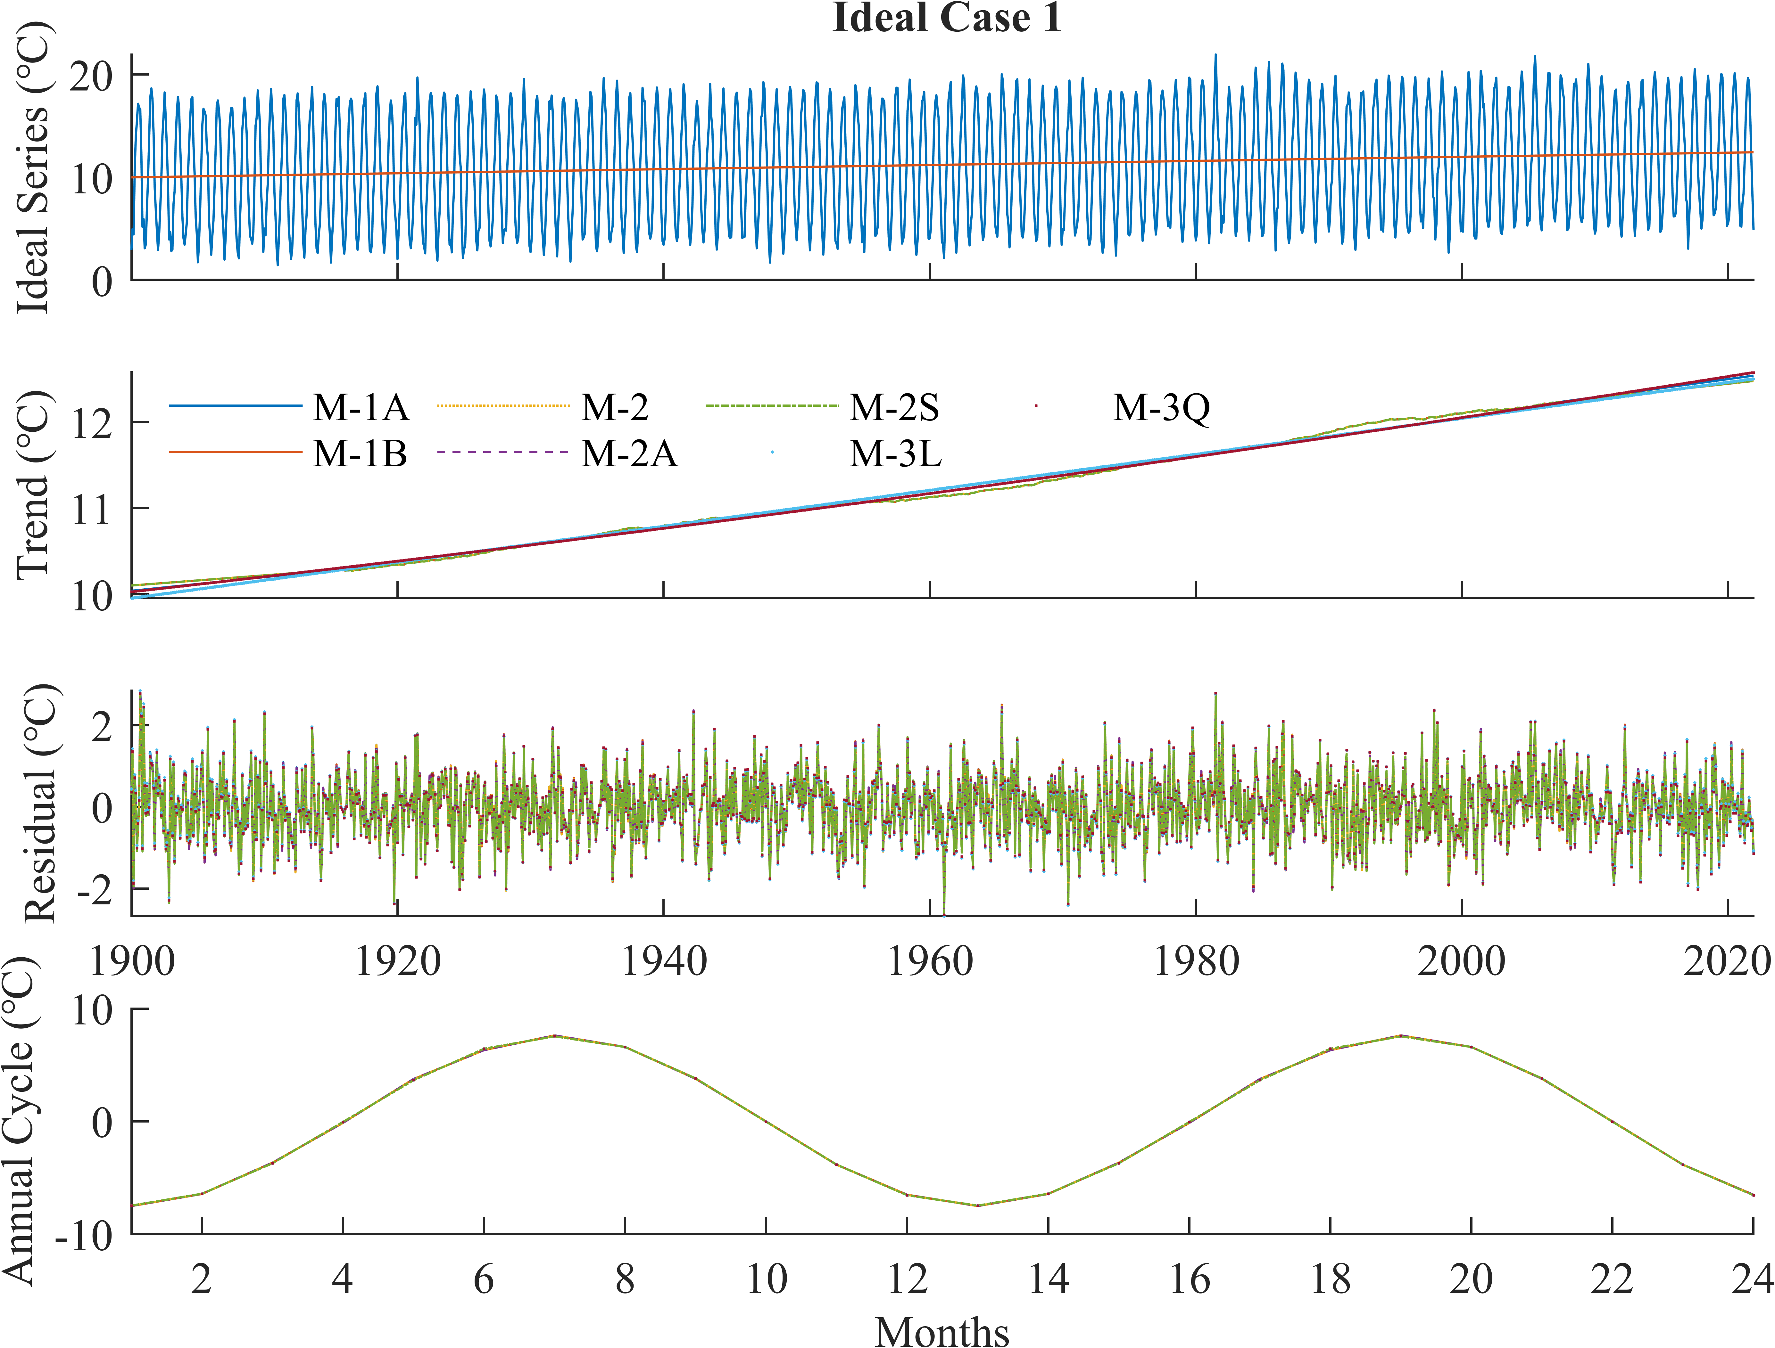

图1 理想试验Case 1. 理想时间序列(a)由线性趋势、以12个月为周期的seasonal components和Gaussian noise组成，(a)中红线展示其trend分量. 用三类方法分解出的trend分量示于(b)，Residual分量示于(c)，seasonal components示于(d).

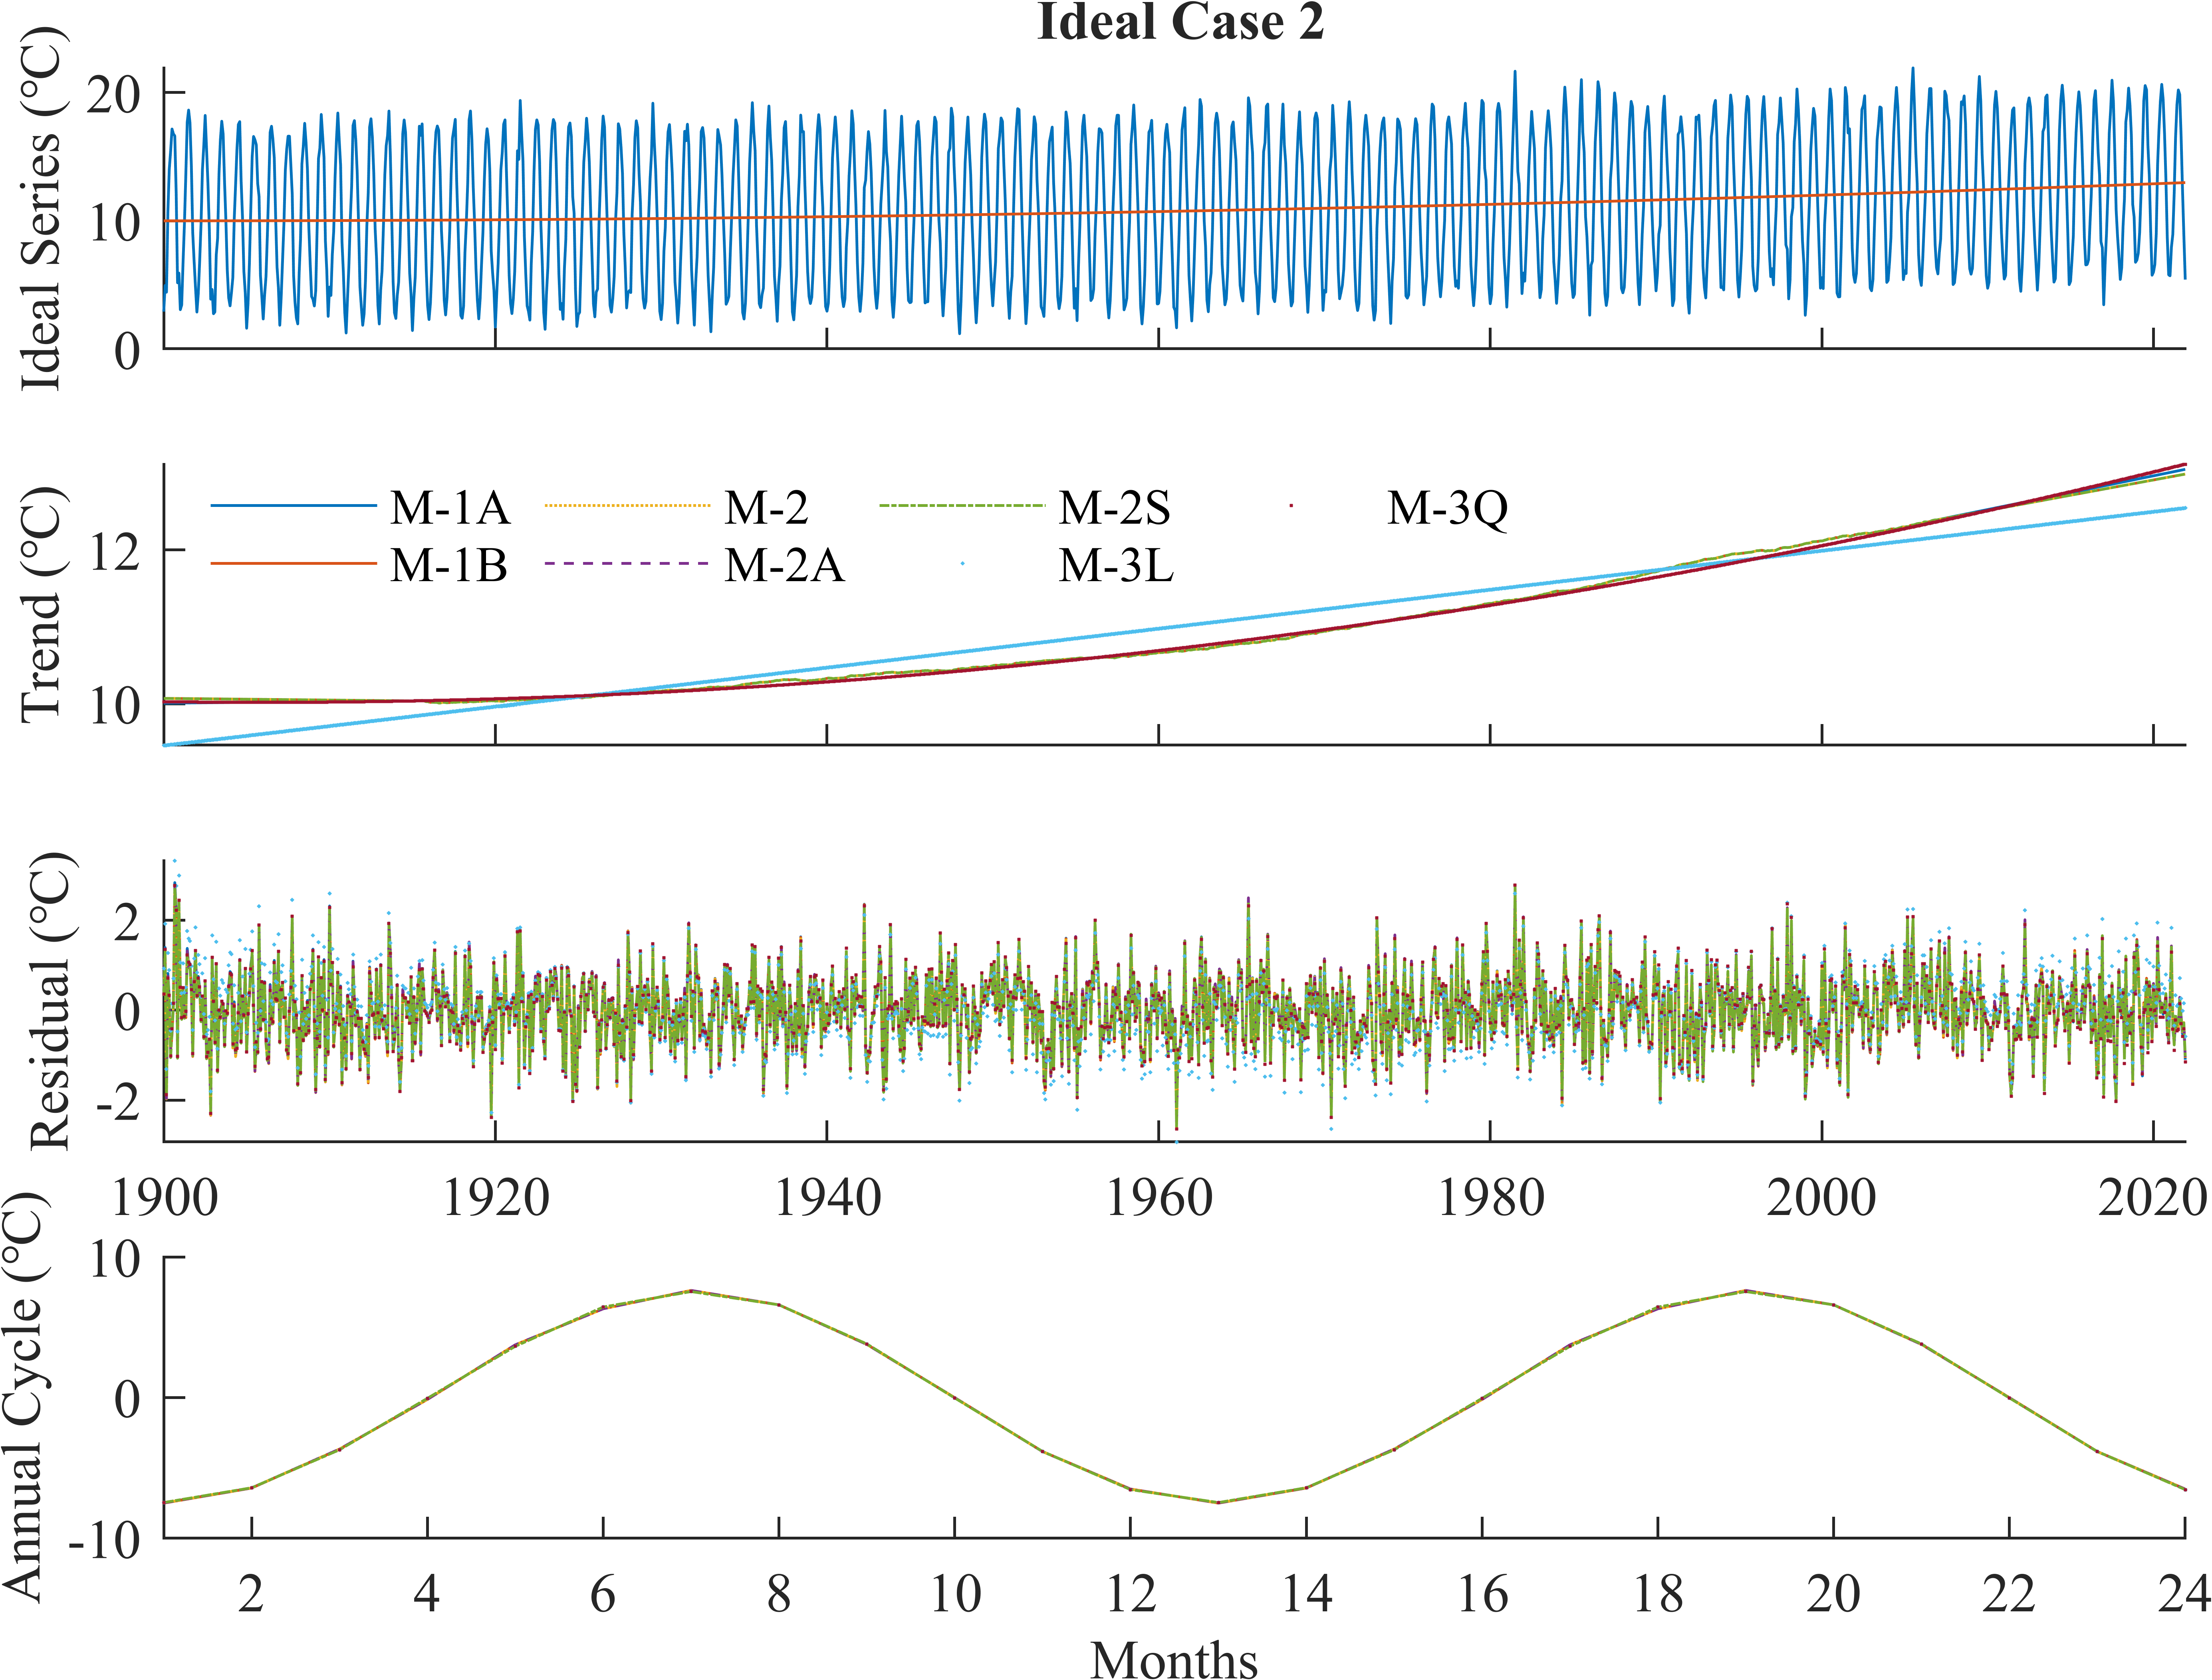

图2 理想试验Case 2. 理想时间序列(a)由二次多项式趋势、以12个月为周期的seasonal components和Gaussian noise组成，(a)中红线展示其trend分量. 用三类方法分解出的trend分量示于(b)，residual分量示于(c)，seasonal components示于(d).

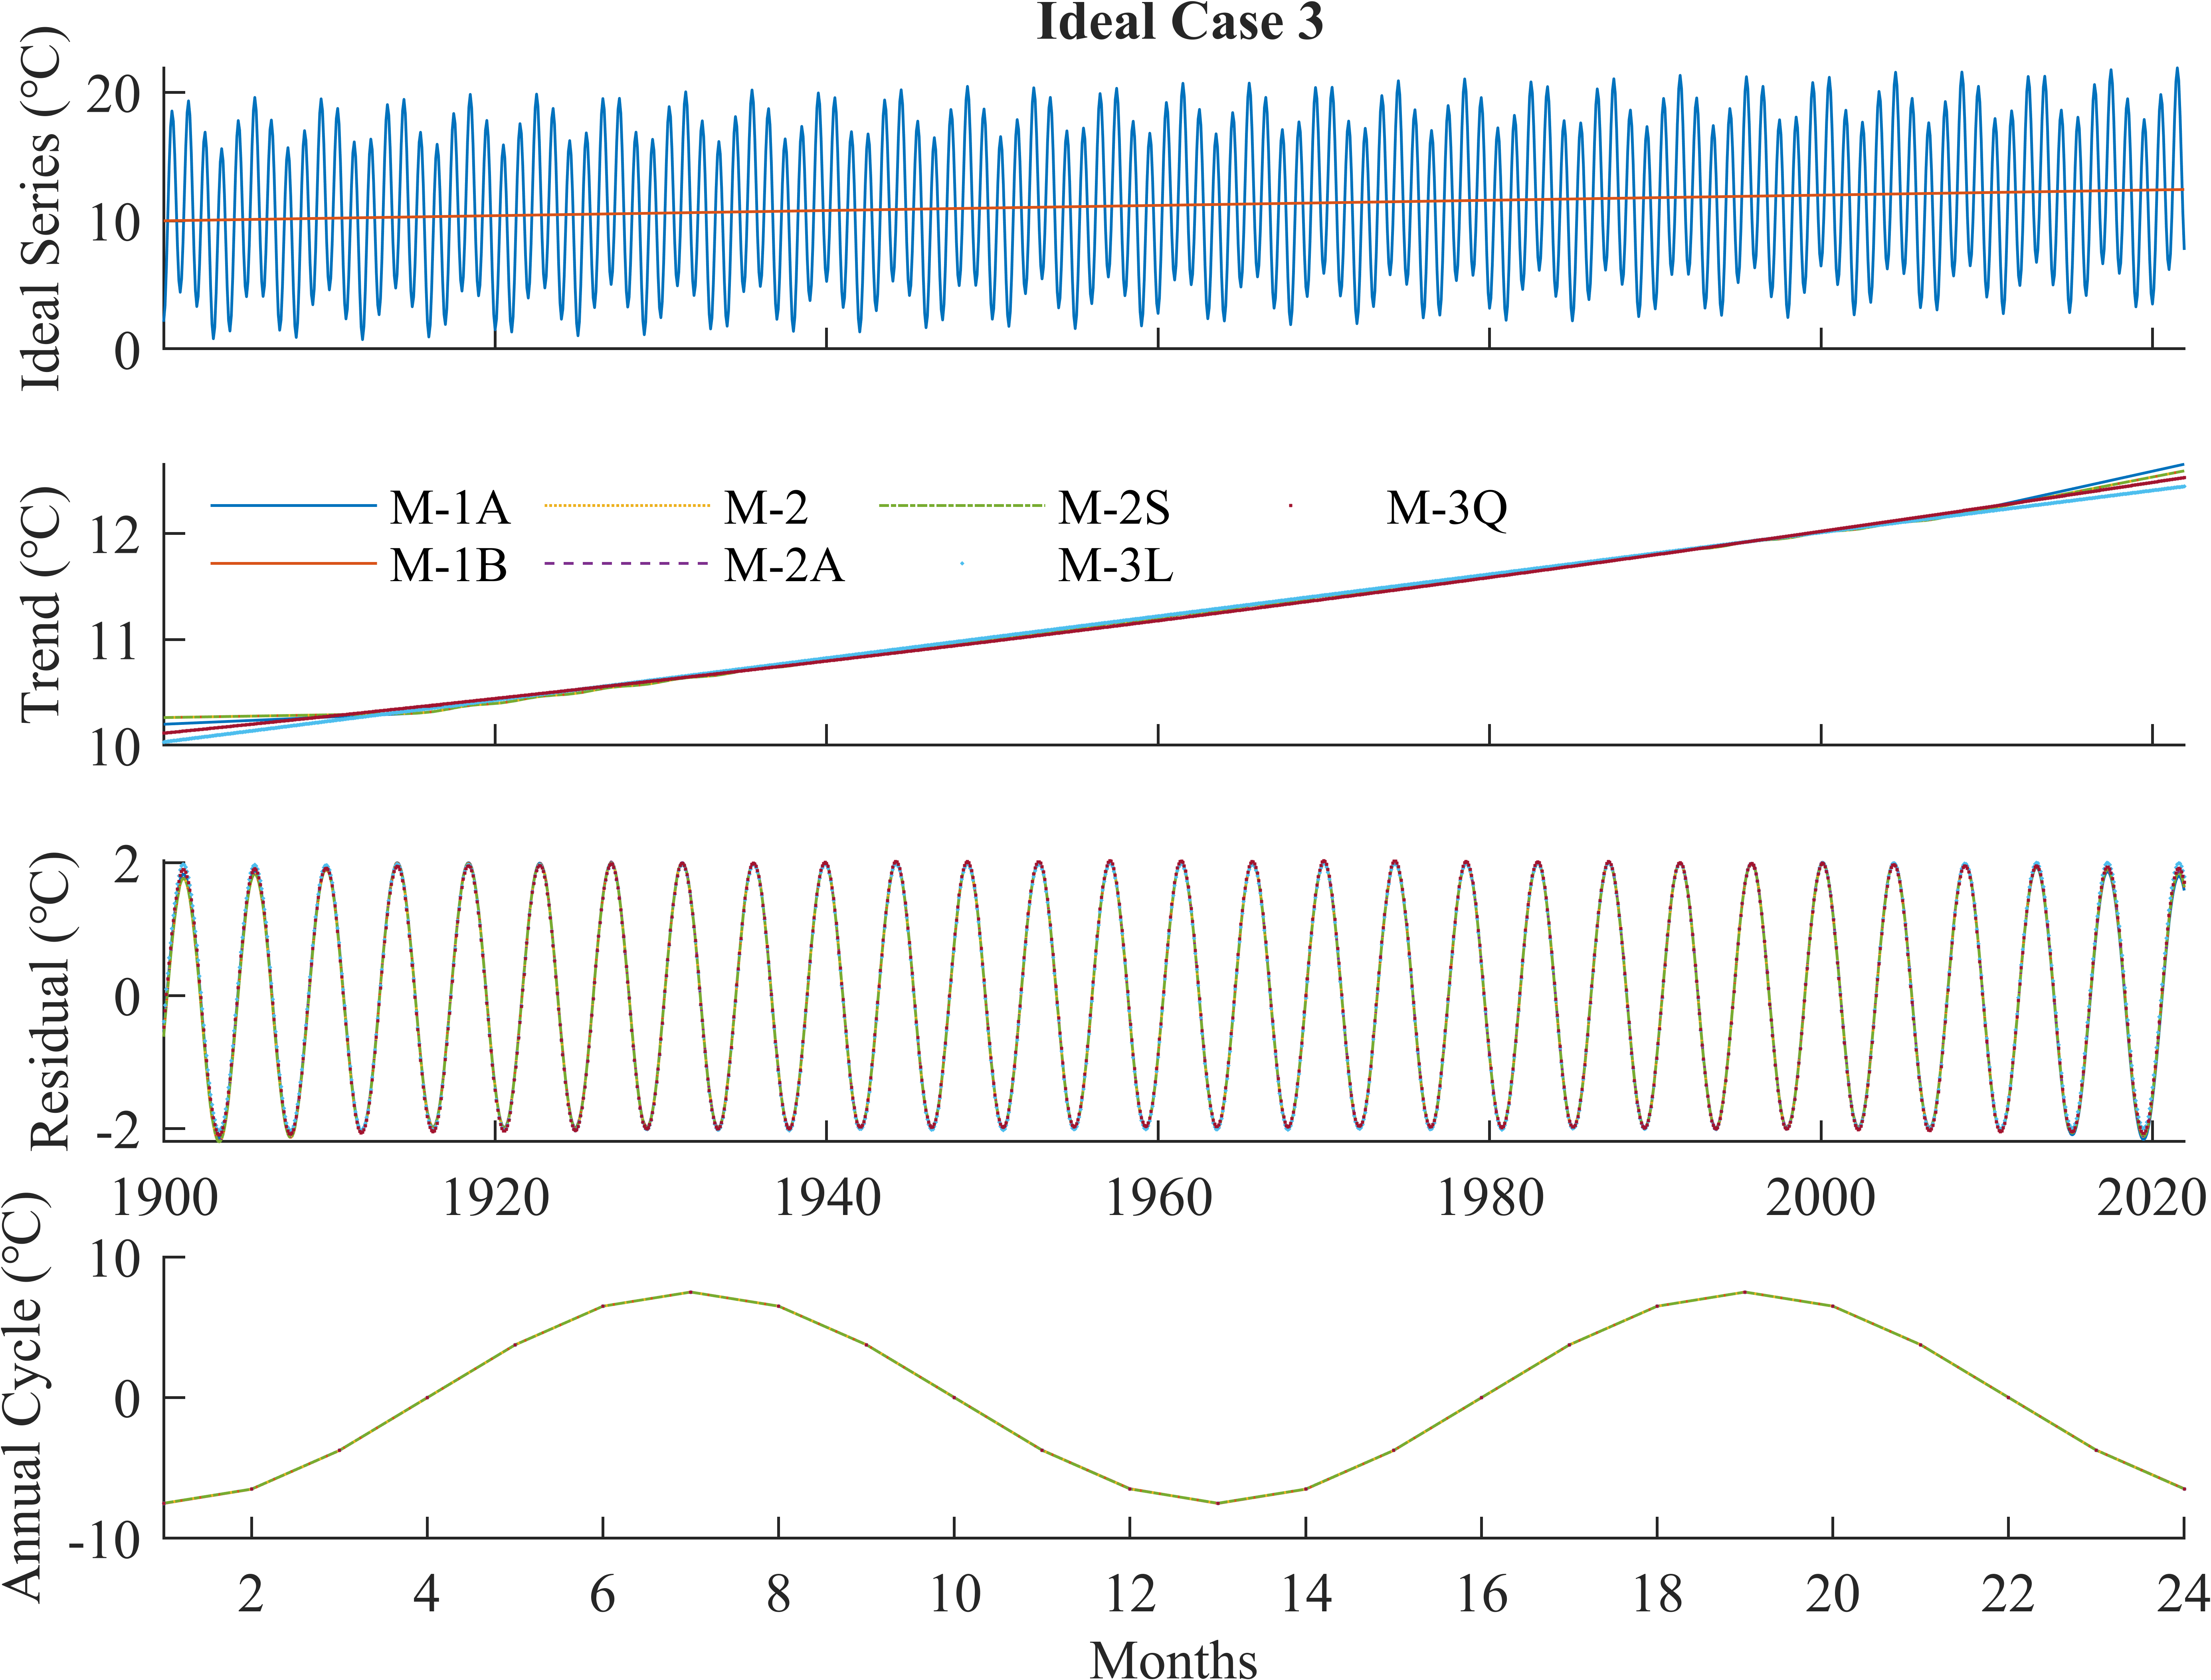

图3 理想试验Case 3. 理想时间序列(a)由线性趋势、以12个月为周期的seasonal components和以4.3年为周期的inter-annual变率组成，(a)中红线展示其trend分量. 用三类方法分解出的trend分量示于(b)，residual分量示于(c)，seasonal components示于(d).

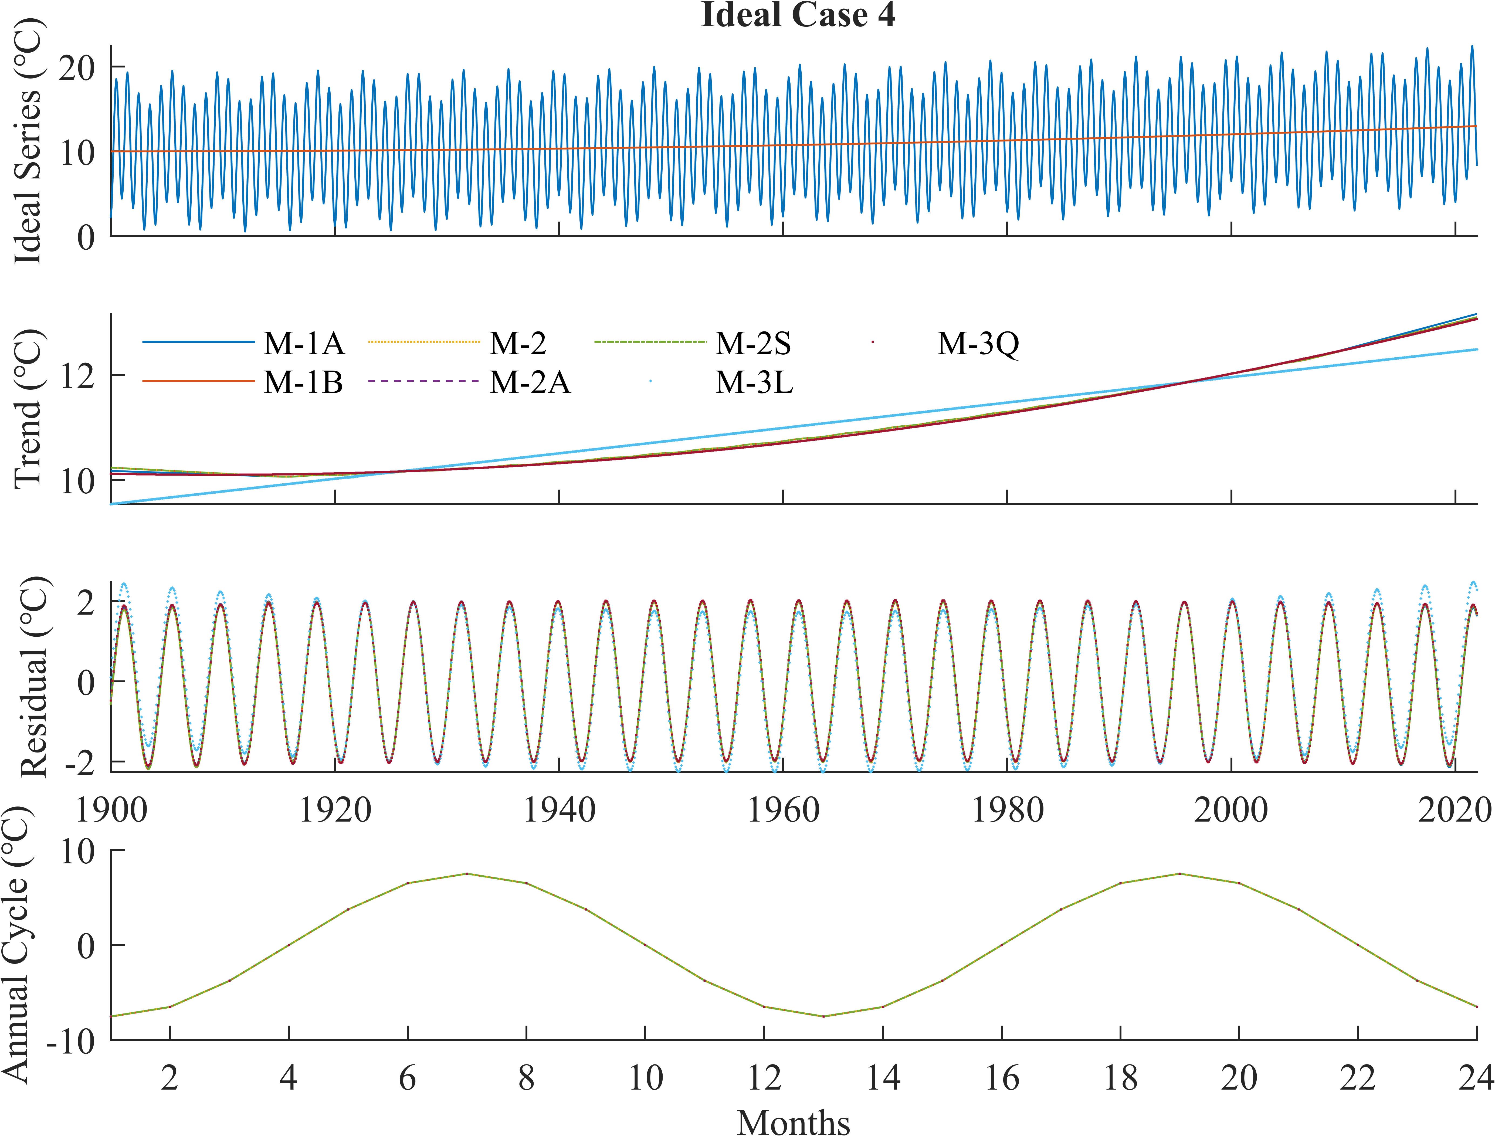

图4 理想试验Case 4. 理想时间序列(a)由二次多项式趋势、以12个月为周期的seasonal components和以4.3年为周期的inter-annual变率组成，(a)中红线展示其trend分量. 用三类方法分解出的trend分量示于(b)，residual分量示于(c)，seasonal components示于(d).

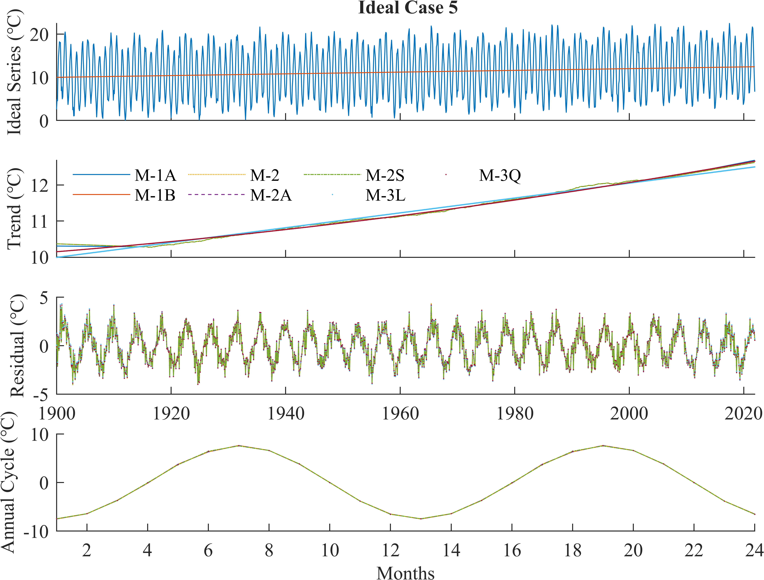

图5 理想试验Case 5. 理想时间序列(a)由线性趋势、以12个月为周期的seasonal components、以4.3年为周期的inter-annual变率和Gaussian noise组成，(a)中红线展示其trend分量. 用三类方法分解出的trend分量示于(b)，residual分量示于(c)，seasonal components示于(d).

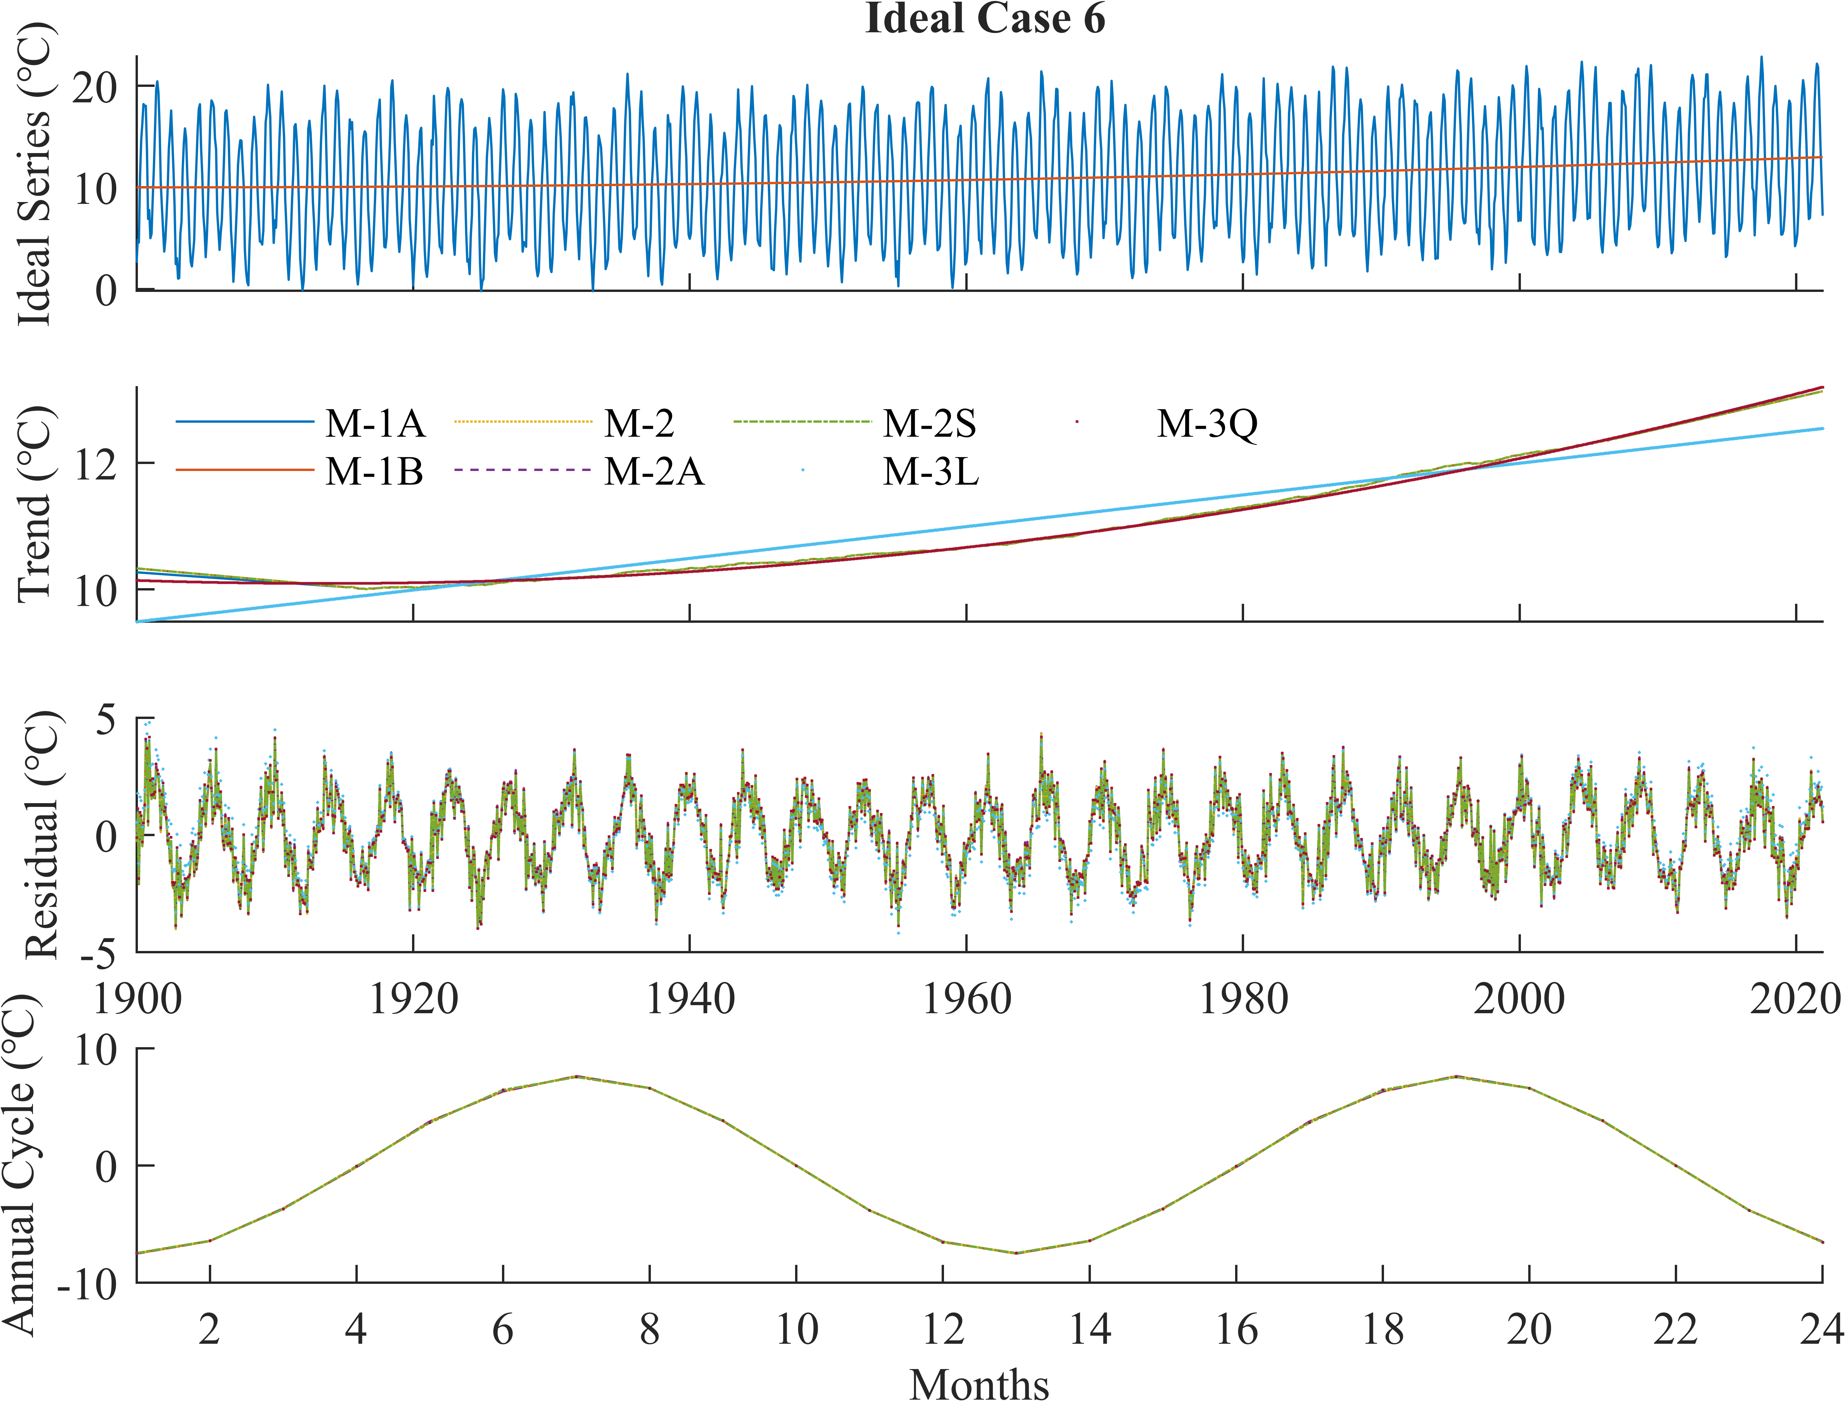

图6 理想试验Case 6. 理想时间序列(a)由二次多项式趋势、以12个月为周期的seasonal components、以4.3年为周期的inter-annual变率和Gaussian noise组成，(a)中红线展示其trend分量. 用三类方法分解出的trend分量示于(b)，residual分量示于(c)，seasonal components示于(d).

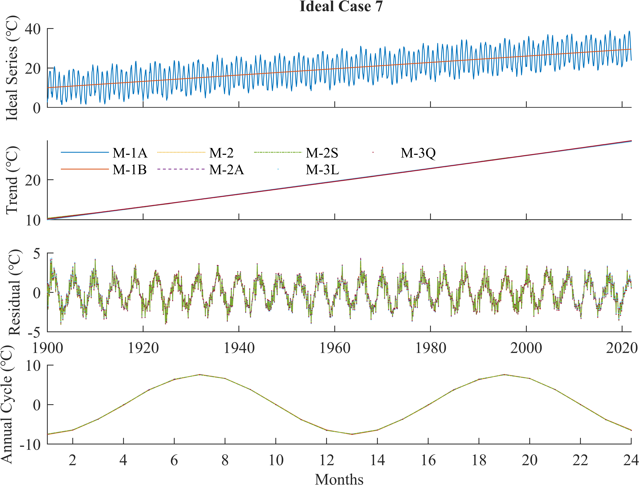

图7 理想试验Case 7. 理想时间序列(a)由剧烈的线性趋势、以12个月为周期的seasonal components、以4.3年为周期的inter-annual变率和Gaussian noise组成，(a)中红线展示其trend分量. 用三类方法分解出的trend分量示于(b)，residual分量示于(c)，seasonal components示于(d).

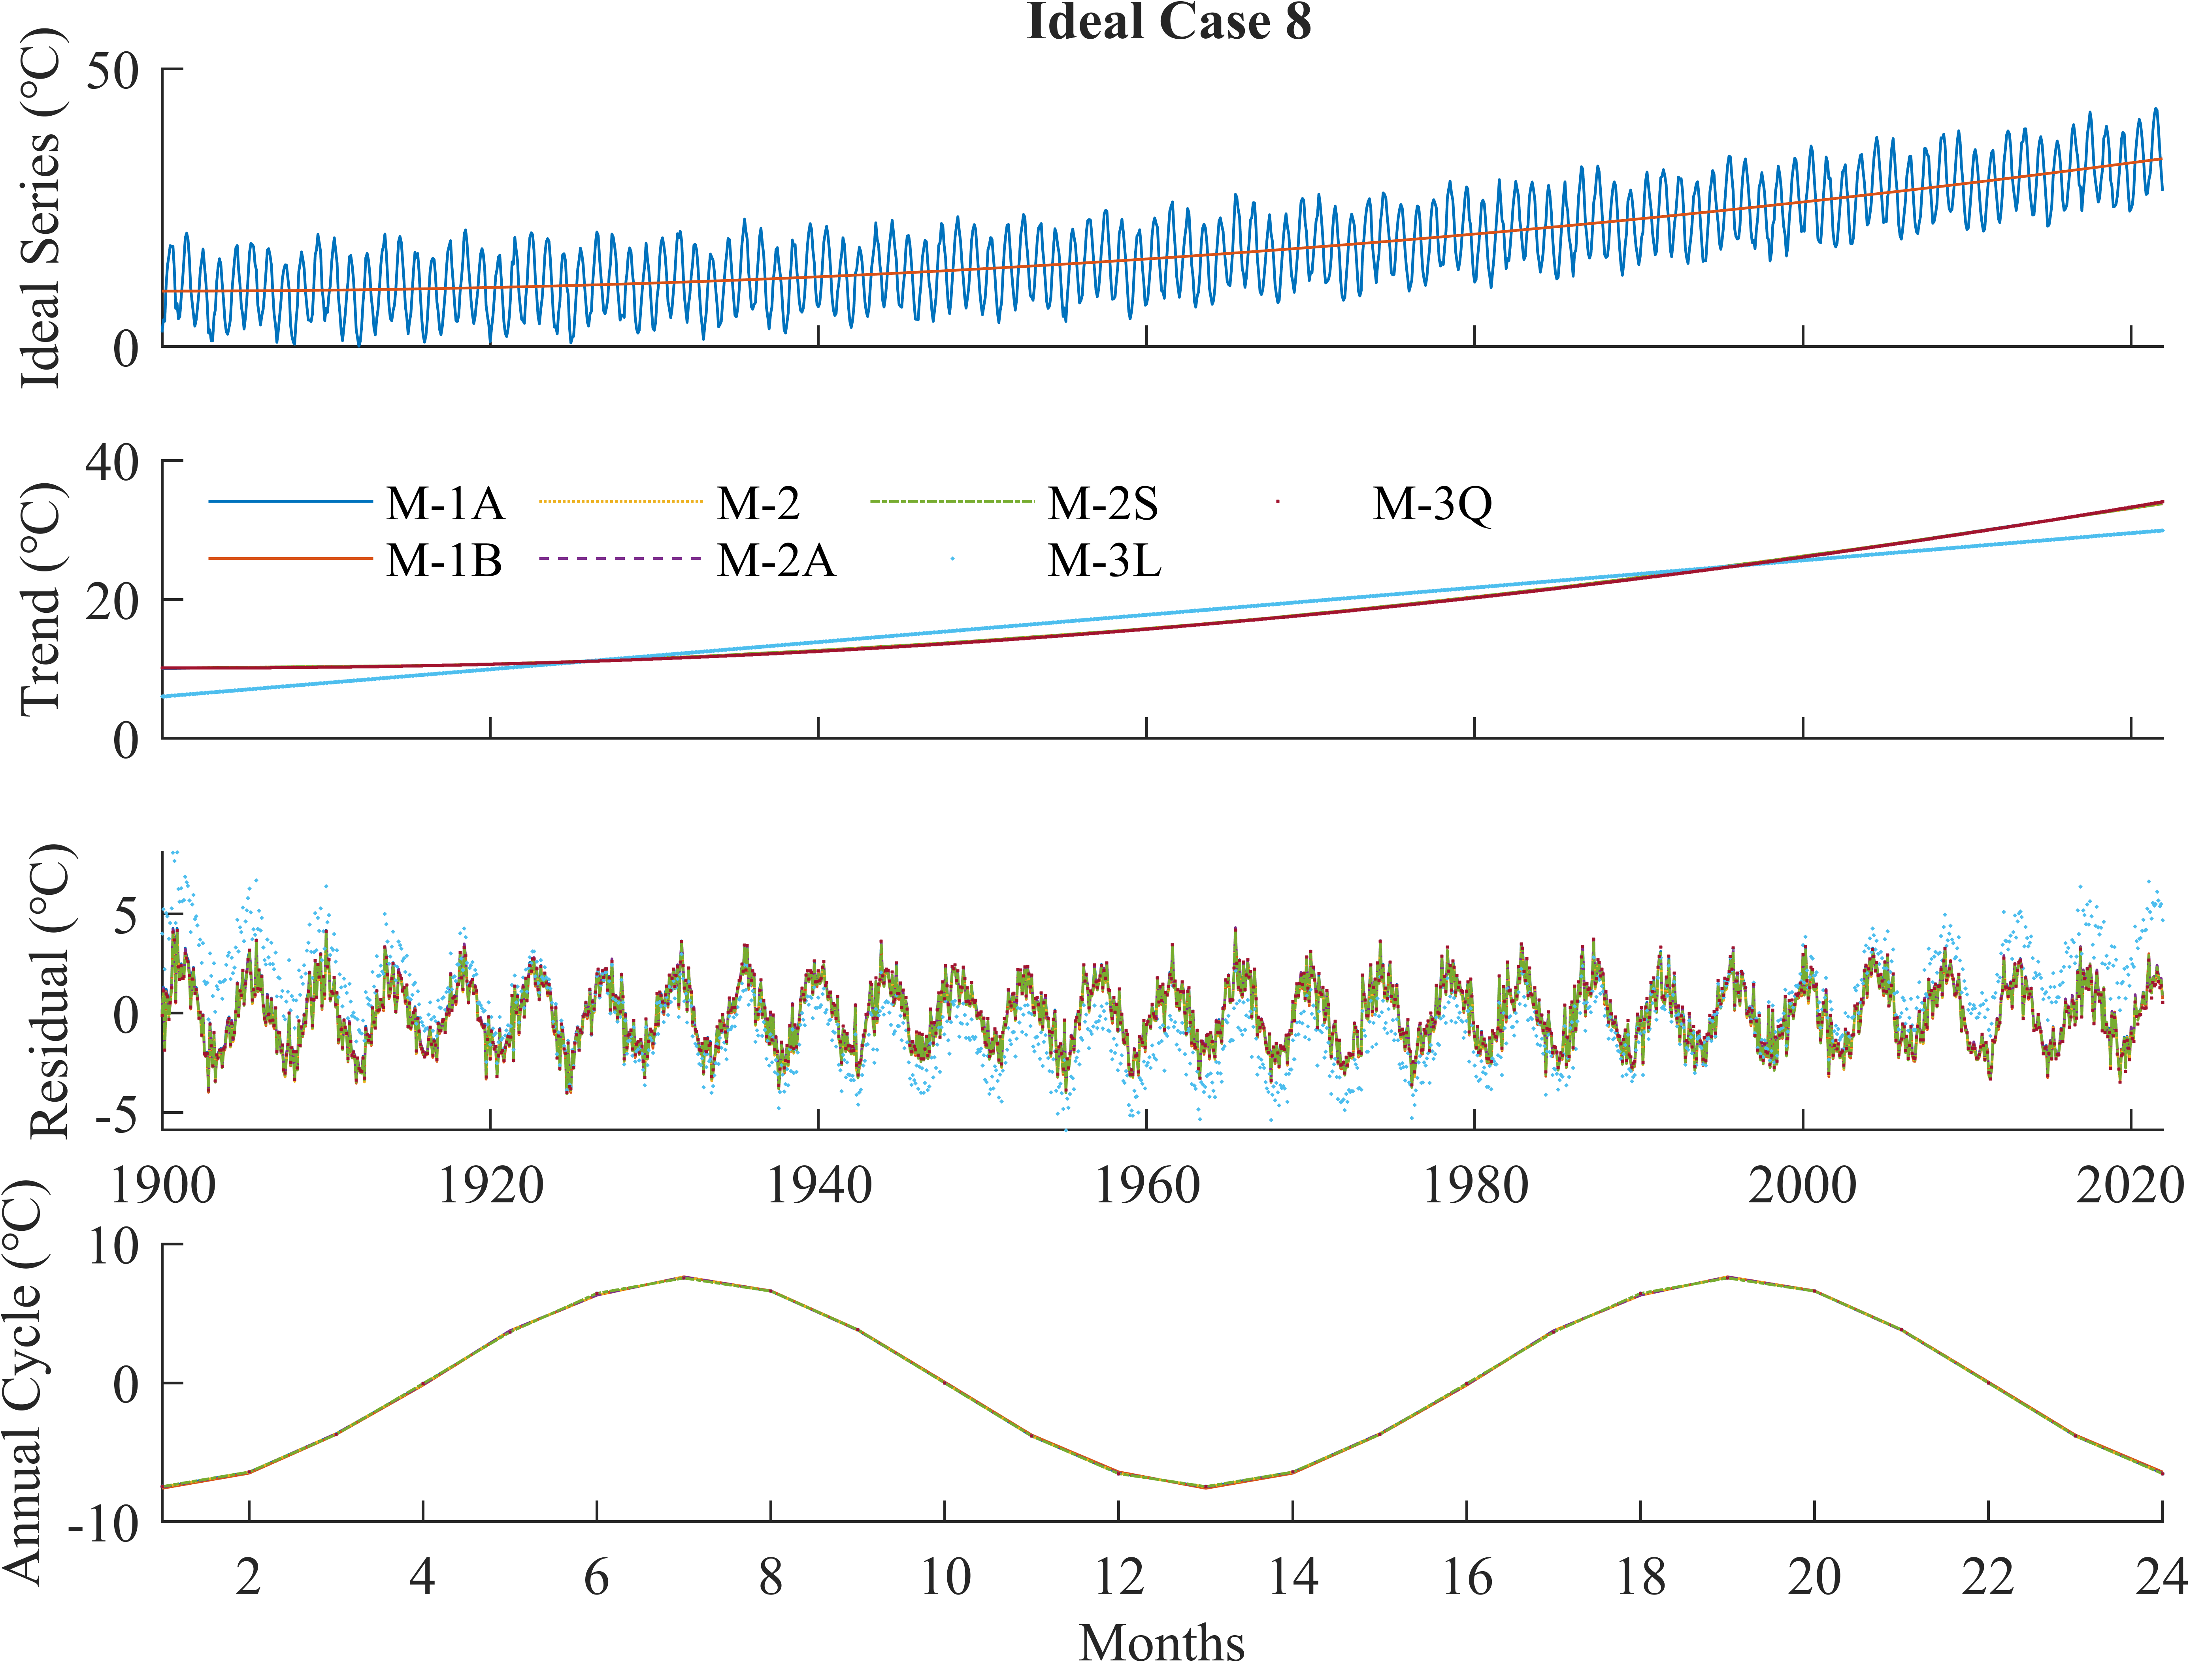

图8 理想试验Case 8. 理想时间序列(a)由剧烈的二次多项式趋势、以12个月为周期的seasonal components、以4.3年为周期的inter-annual变率和Gaussian noise组成，(a)中红线展示其trend分量. 用三类方法分解出的trend分量示于(b)，residual分量示于(c)，seasonal components示于(d).

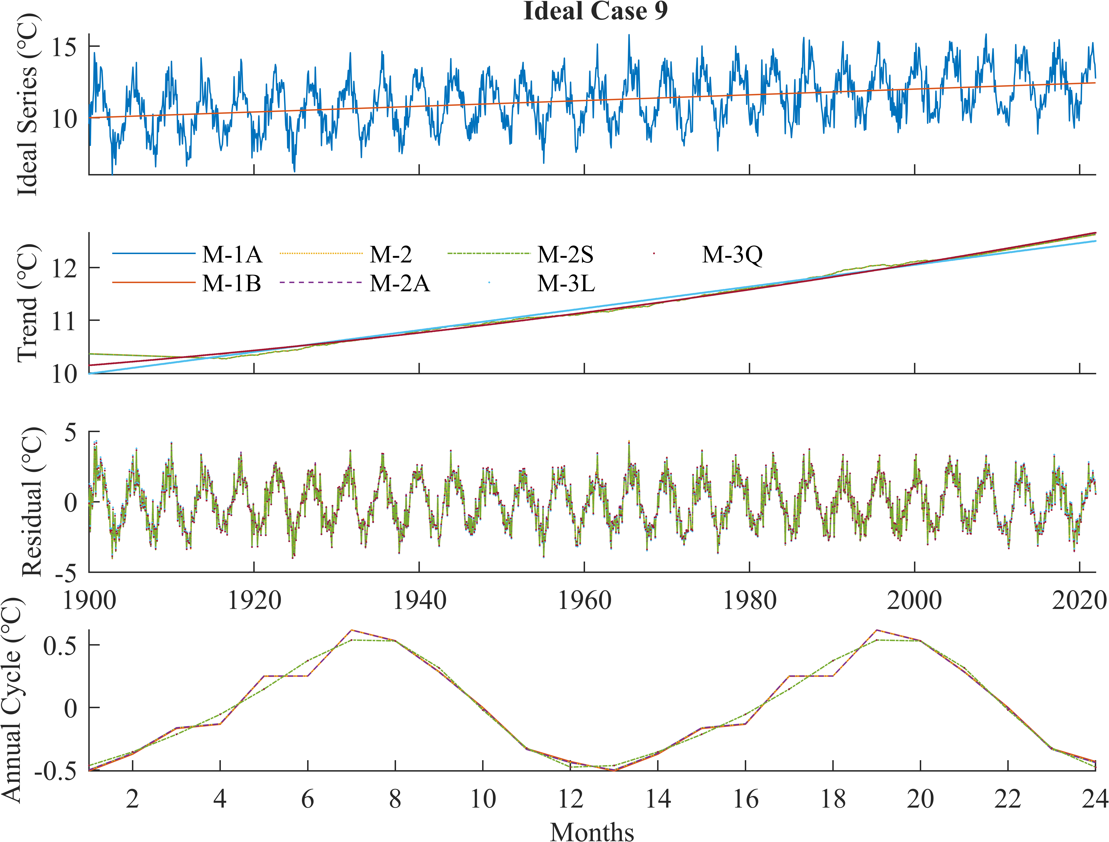

图9 理想试验Case 9. 理想时间序列(a)由线性趋势、以12个月为周期的微弱seasonal components、以4.3年为周期的inter-annual变率和Gaussian noise组成，(a)中红线展示其trend分量. 用三类方法分解出的trend分量示于(b)，residual分量示于(c)，seasonal components示于(d).

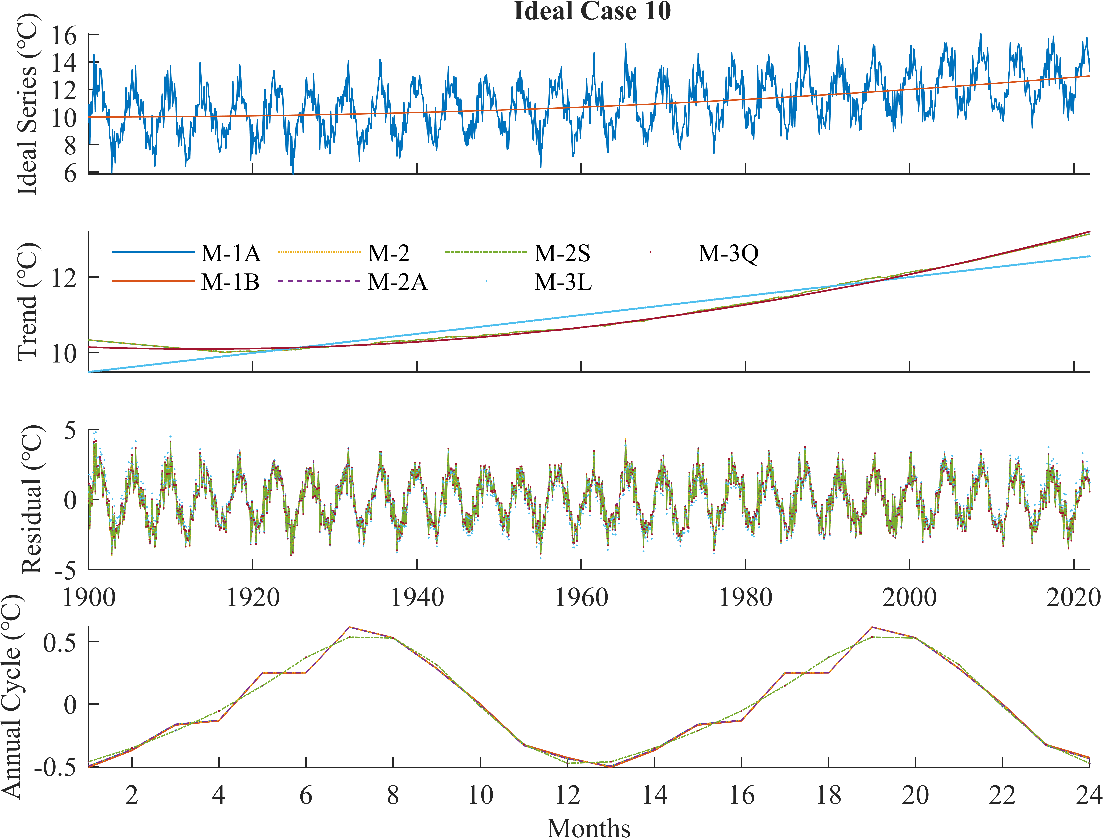

图10 理想试验Case 10. 理想时间序列(a)由二次多项式趋势、以12个月为周期的微弱seasonal components、以4.3年为周期的inter-annual变率和Gaussian noise组成，(a)中红线展示其trend分量. 用三类方法分解出的trend分量示于(b)，residual分量示于(c)，seasonal components示于(d).

### Comparison of different methods

M-2S方法在有噪声（对应算例C1, 2, 5, 6, 7, 8, 9, 10）时，在特定指标（RMSE, CVE）上略优于其他M-1, M-2方法，但不及当全局模型选择正确时的M-3系列方法（图11, 图12, 图13, 图14）.

M-1A方法在长期趋势剧烈（对应算例C7, C8）或年际变率理想（对应算例C3, C4，其中的年际变率信号为理想的4.3年周期单音信号）时，在特定指标上略优于M-1B，但不及M-2S（图11, 图12, 图13, 图14）.

M-2, 2A与M-1A, 1B的差异. 在理想试验中，以算例C8（图8）为例，M-2与2A的差异很小. 在输出的trend上，M-2更接近M-1B而稍远离M-1A；在输出的季节信号和余项上，M-2更接近M-1A而稍远离M-1B，且M-2A比M-2稍向M-1B移动、位于M-1A和1B之间. 考察各项指标（图11, 图12, 图14），发现在无噪声时（算例C3, 4），M-2更接近M-1B而稍远离M-1A；当长期趋势剧烈且有噪声时（算例C7, 8），M-2更接近M-1A而稍远离M-1B. 从余项均值的角度（图15），尽管当长期趋势剧烈且有噪声时（算例C7, 8），M-1B和M-2的余项样本均值仍接近、且对有零样本均值保证的M-1A, 2A的差异增大，但未能决定前述方法在各项指标（图11, 图12, 图14）上的相对接近程度.

长期趋势对分解结果的影响. 在本文的试验设置下，长期趋势的线性（对应算例C1, 3, 5, 7, 9）与非线性（对应算例C2, 4, 6, 8, 10）对M-1, 2系列的影响较小（图11, 图12, 图13）. 当长期趋势剧烈（对应算例C7, 8）时，M-1, 2系列的CVE略有增大（图14），M-1B和M-2的余项样本均值增大（图15）. 长期趋势的非线性对M-3系列的影响很大. 当长期趋势的实际形式与M-3模型假定相同时（算例C1, 3, 5, 7, 9之于M-3L，C2, 4, 6, 8, 10之于M-3Q），方法输出与理想信号一致性好；当长期趋势的实际形式不能被M-3模型包含时（算例C2, 4, 6, 8, 10之于M-3L），方法输出与理想信号一致性不好；当长期趋势的实际形式被M-3模型的退化版本包含时（算例C1, 3, 5, 7, 9之于M-3Q），方法输出与理想信号的一致性比非退化时（算例C1, 3, 5, 7, 9之于M-3L）略有恶化（图9, 图10）.

季节周期对分解结果的影响. 在理想试验中，当季节信号的幅度或解释方差较小时（算例C9, 10），M-1A, 1B, 2, 2A这四个采取简单平均提取季节信号的方法的输出几乎一样，均存在畸变，与M-2S和M-3系列等采取谱方法提取季节信号的方法的输出有差异.

余项和季节信号的零样本均值性. M-1A, 2A, 3L, 3Q方法可保证residual的样本均值接近零（图15）. 这是因为，M-1A, 2A方法的residual是deseason操作的副产品，其均值（如果非零）已被归入seasonal component. M-3L, 3Q的residual零样本均值性似乎不能获得理论保证？当采样时间是年周期的整数倍时（本文所有算例都满足），所有方法输出的seasonal component的样本均值都接近零，这是由各方法的定义保证的.

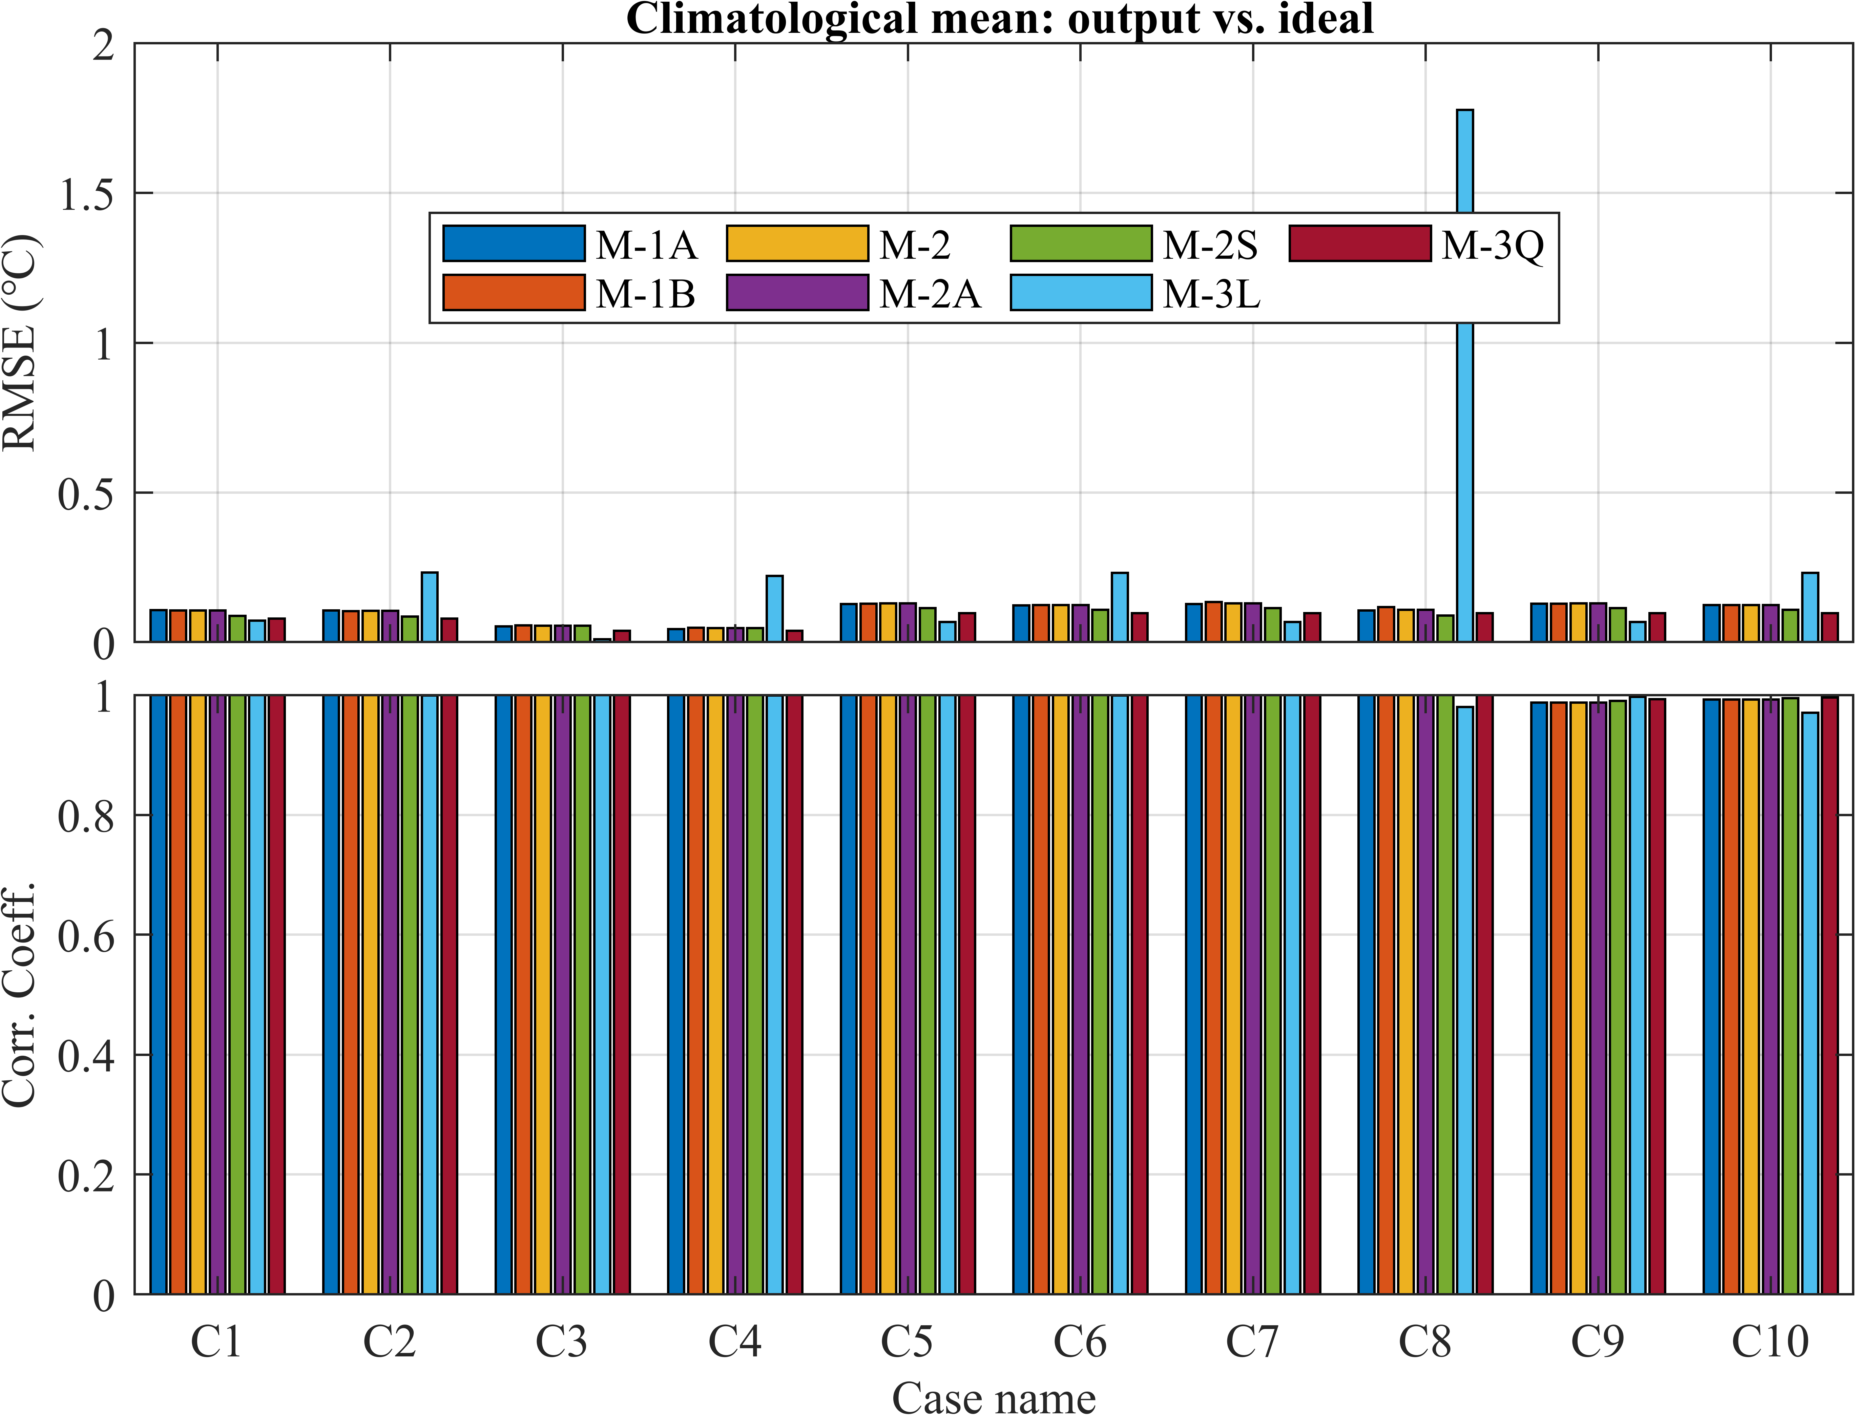

图11 在理想试验中，三类classical decomposition methods输出的气候平均态（trend + seasonal components）对理想时间序列中气候平均态的样本均方根误差(RMSE)和Pearson线性相关系数(CC).

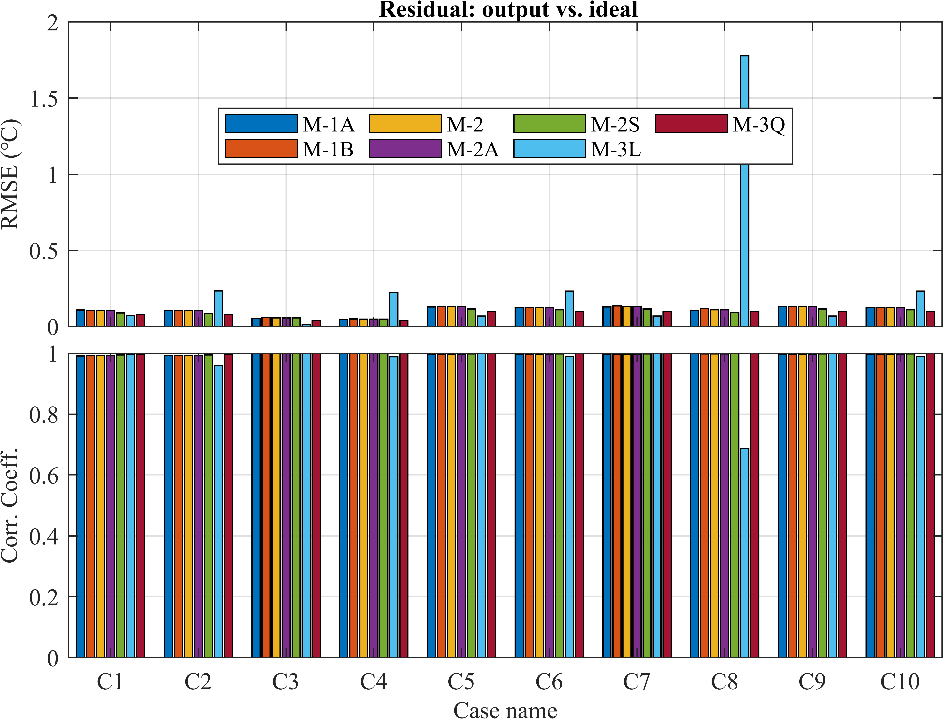

图12 在理想试验中，三类classical decomposition methods输出的residual分量对理想时间序列中residual分量的样本均方根误差(RMSE)和Pearson线性相关系数(CC).

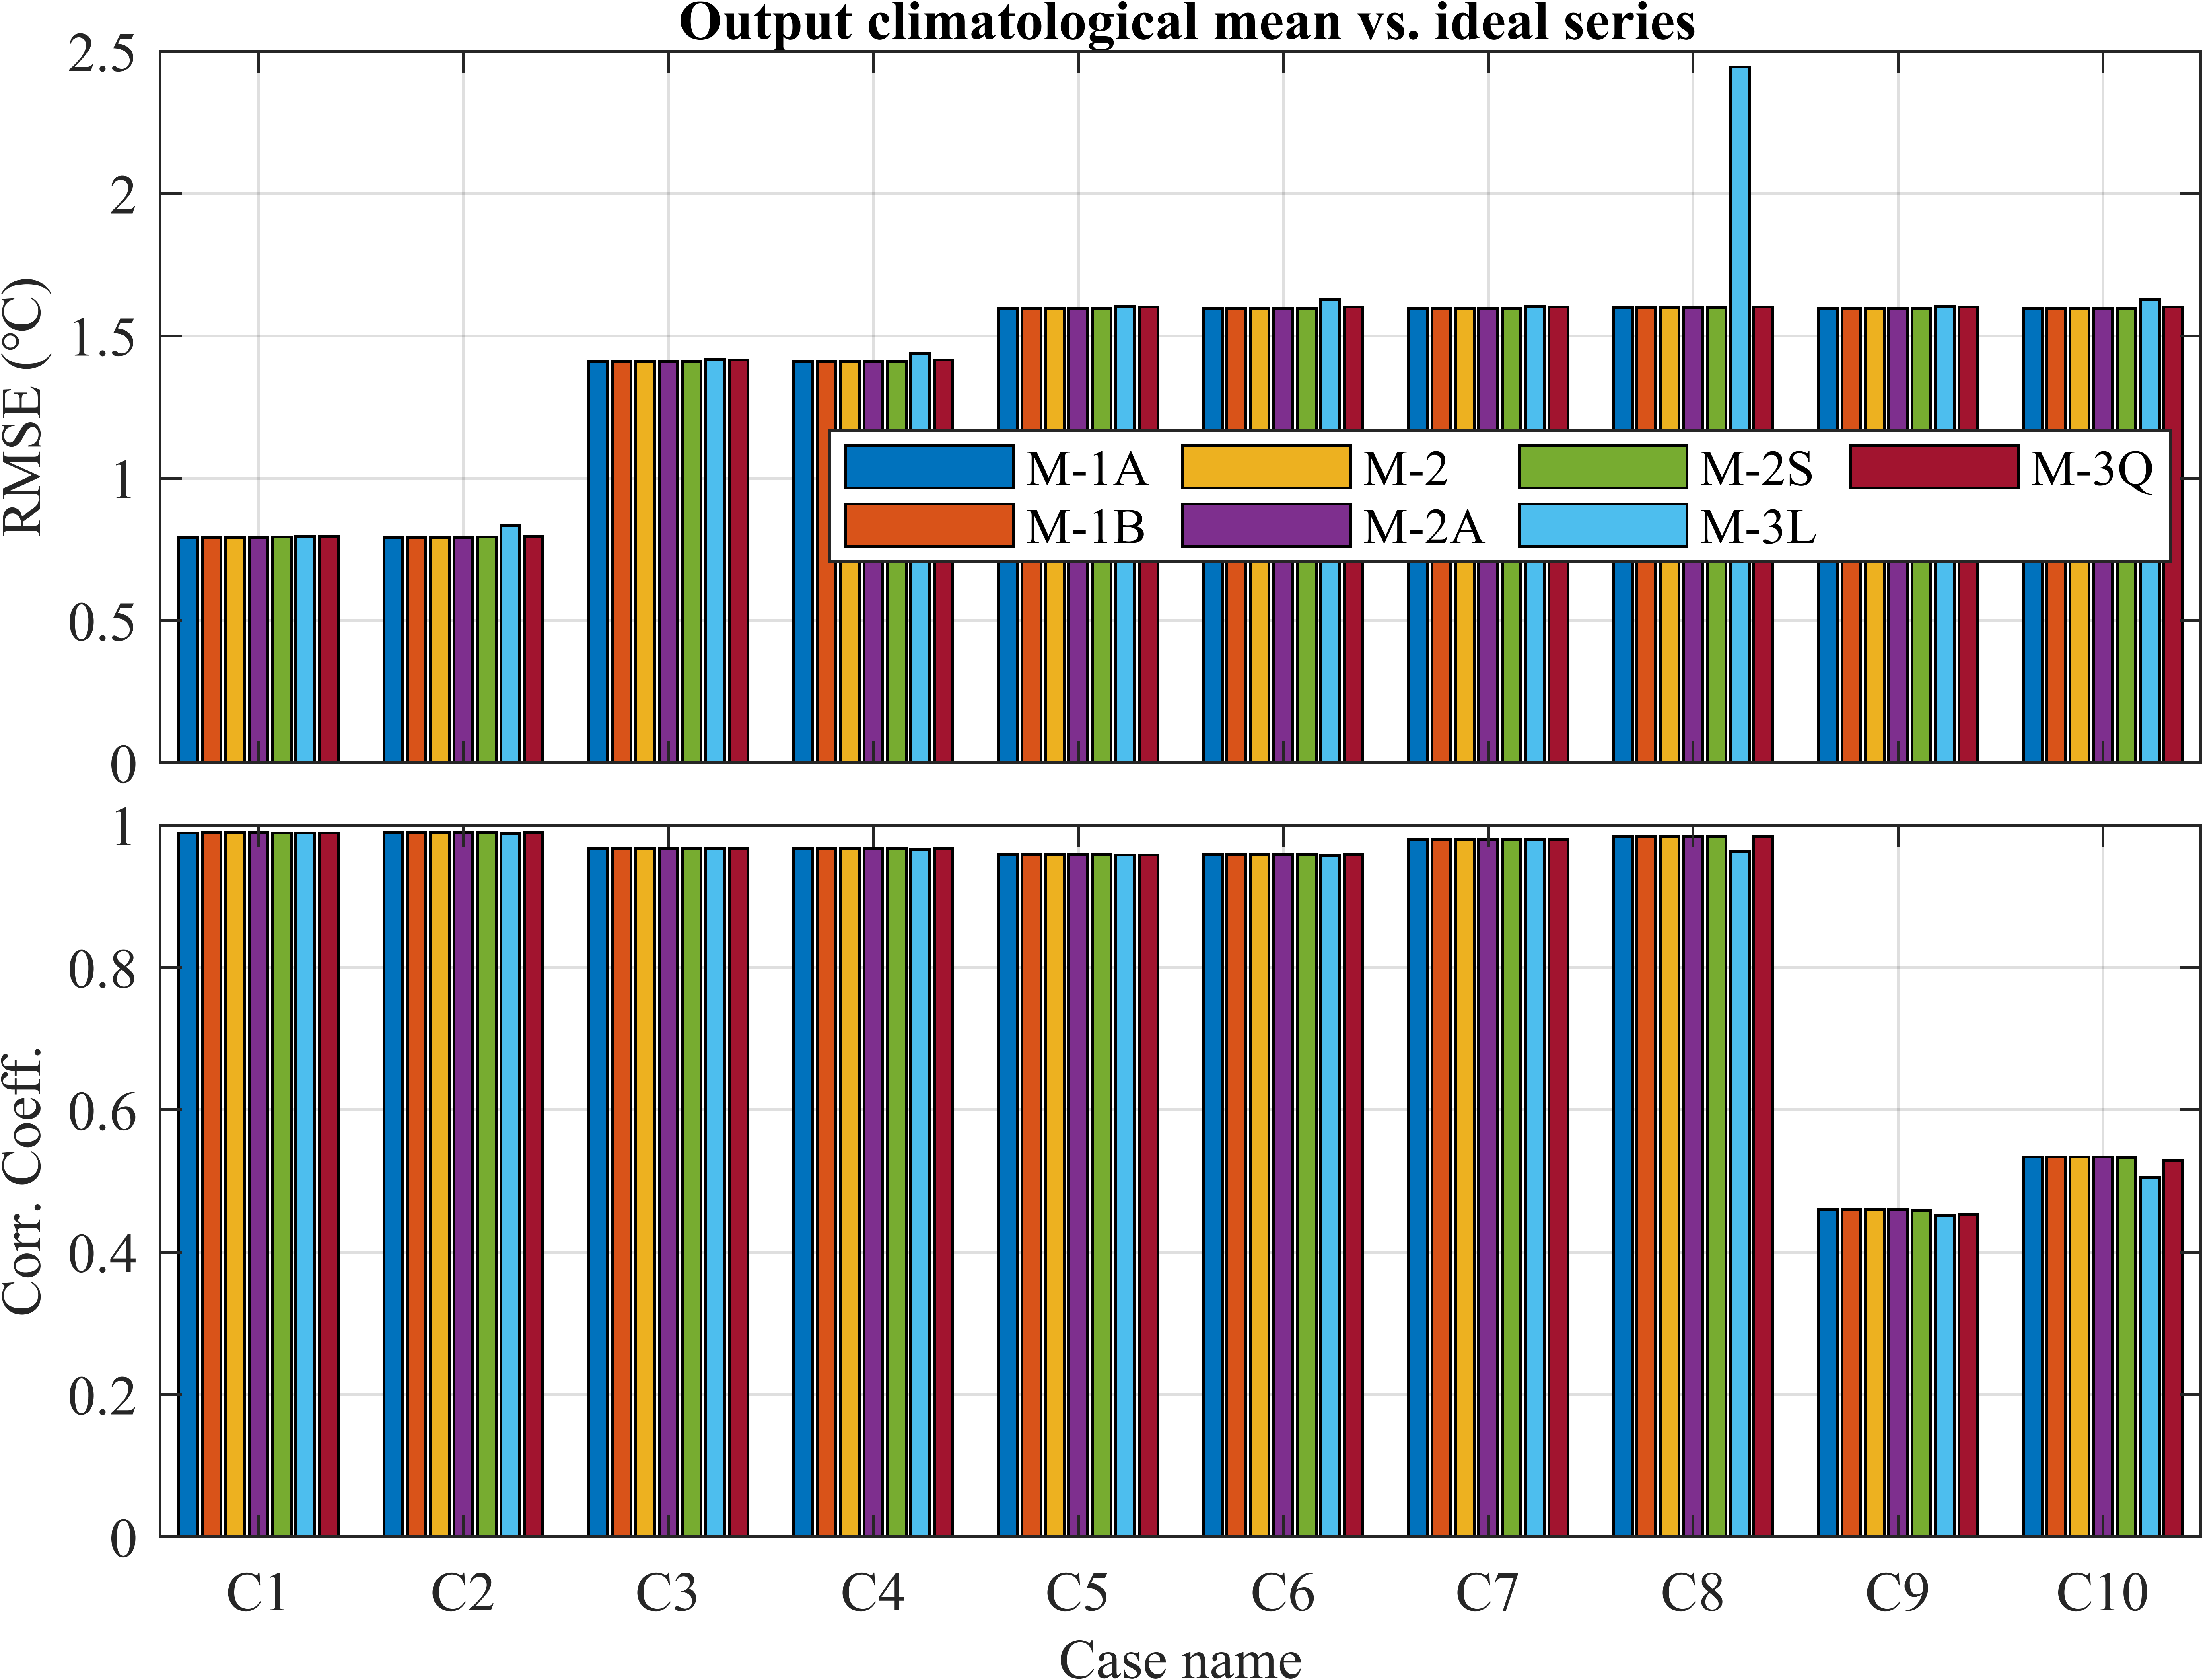

图13 在理想试验中，三类classical decomposition methods输出的气候平均态（trend + seasonal components）对理想时间序列的样本均方根误差(RMSE)和Pearson线性相关系数(CC).

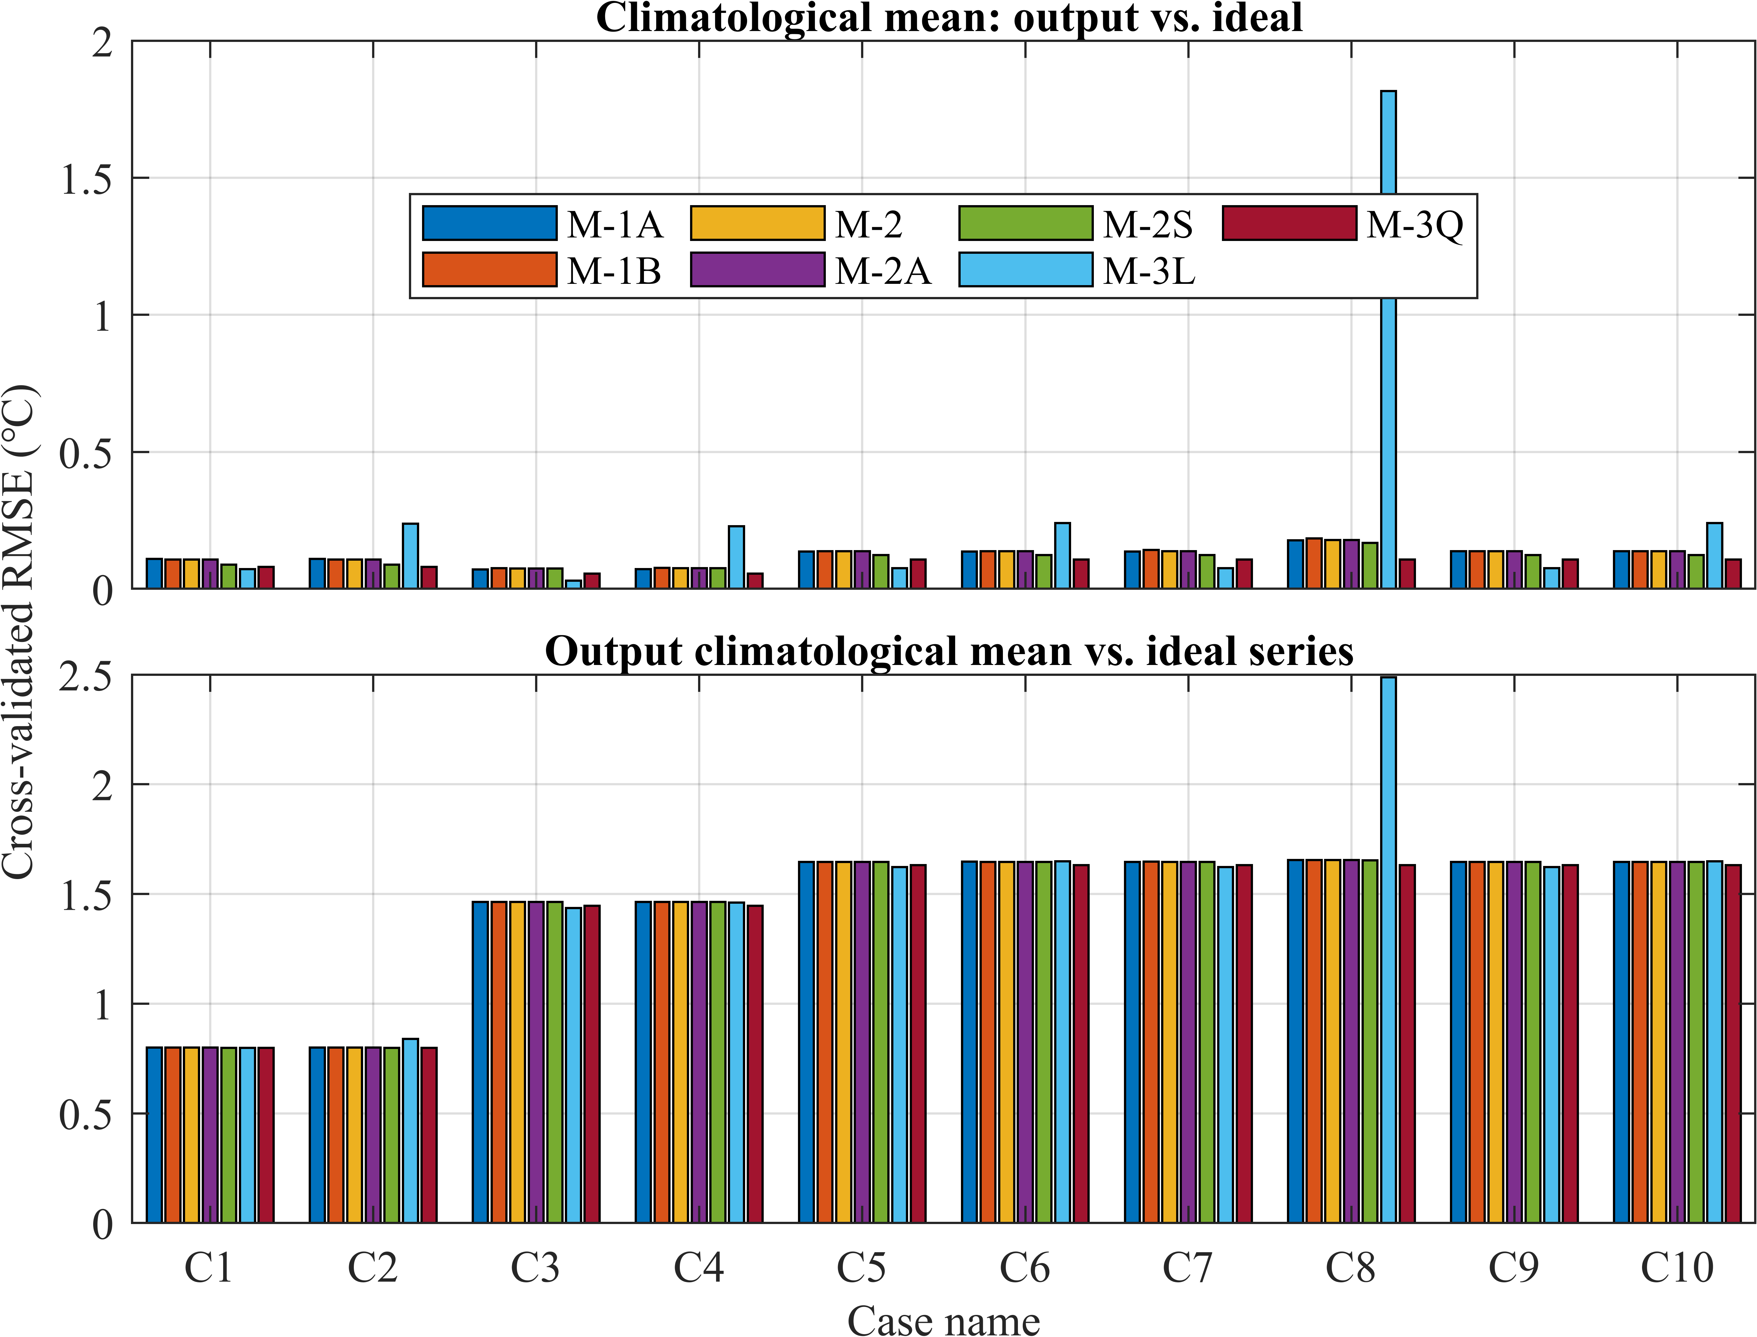

图14 在理想试验中，三类classical decomposition methods输出的气候平均态（trend + seasonal components）对理想时间序列(b)及其气候平均态(a)的交叉验证均方根误差(CVE).

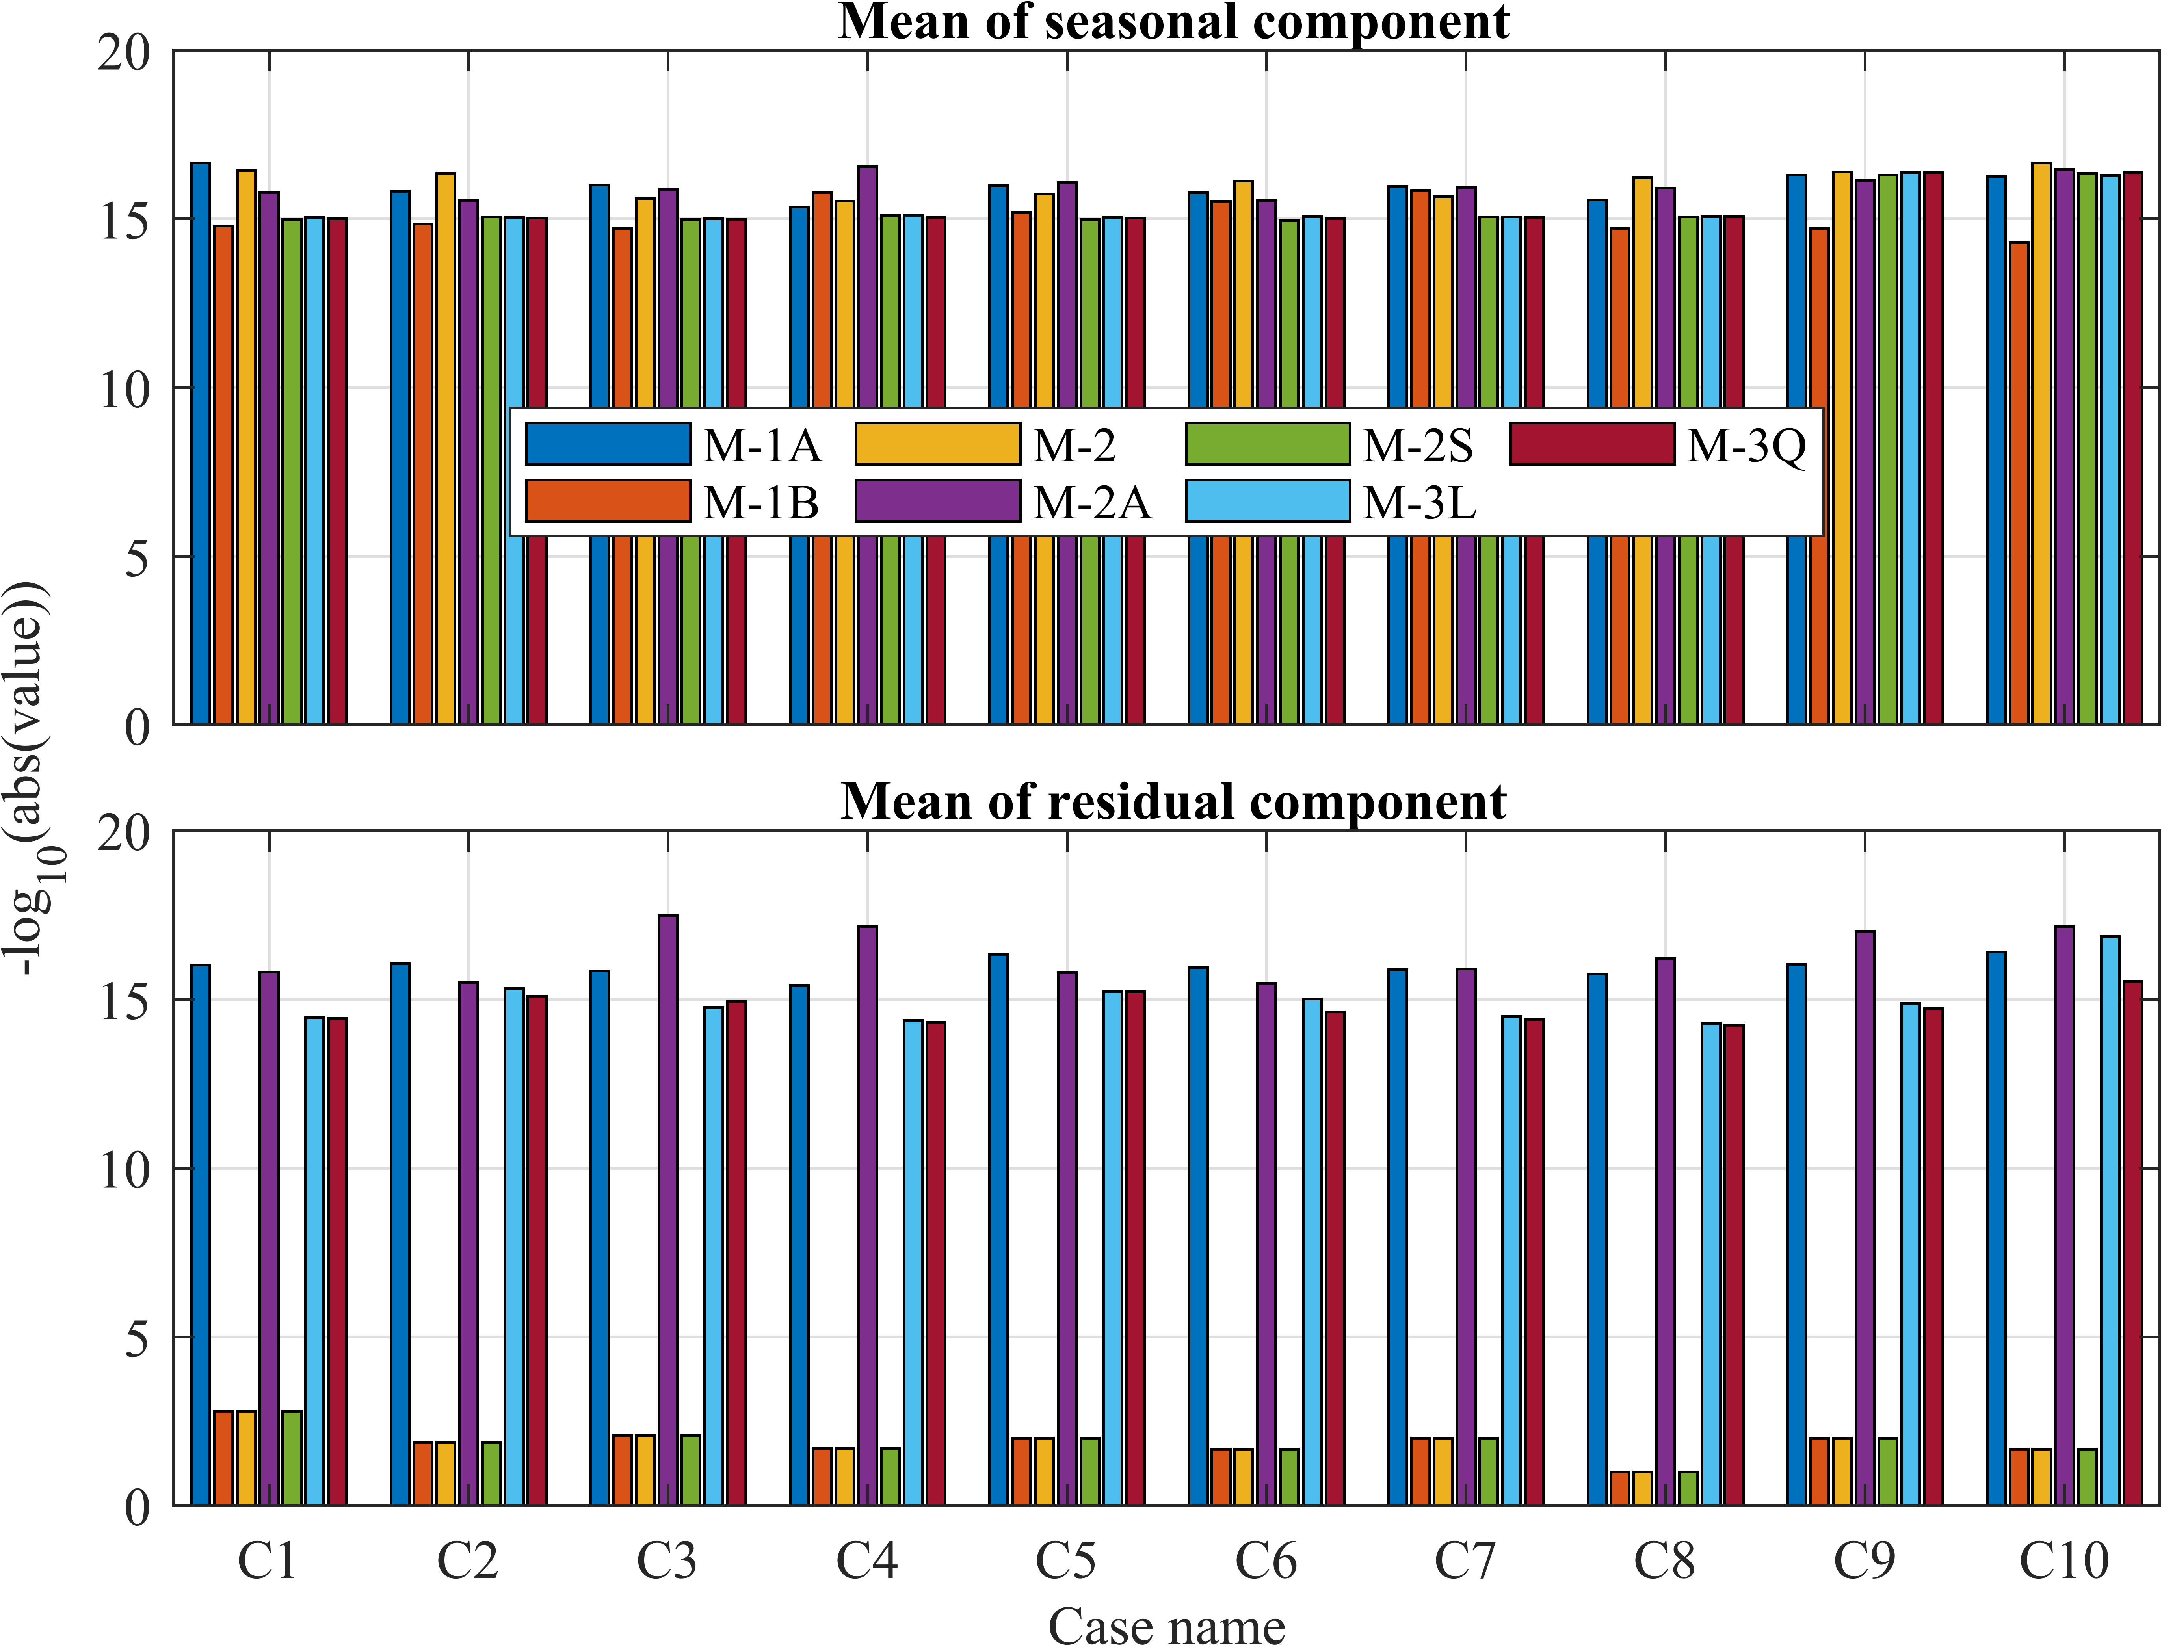

图15 在理想试验中，三类classical decomposition methods输出的气候平均态（trend + seasonal components）对理想时间序列(b)及其气候平均态(a)的交叉验证均方根误差(CVE).

## Classical decomposition of several real time-indices

### ERSST v5 global monthly SST (1902-2021)

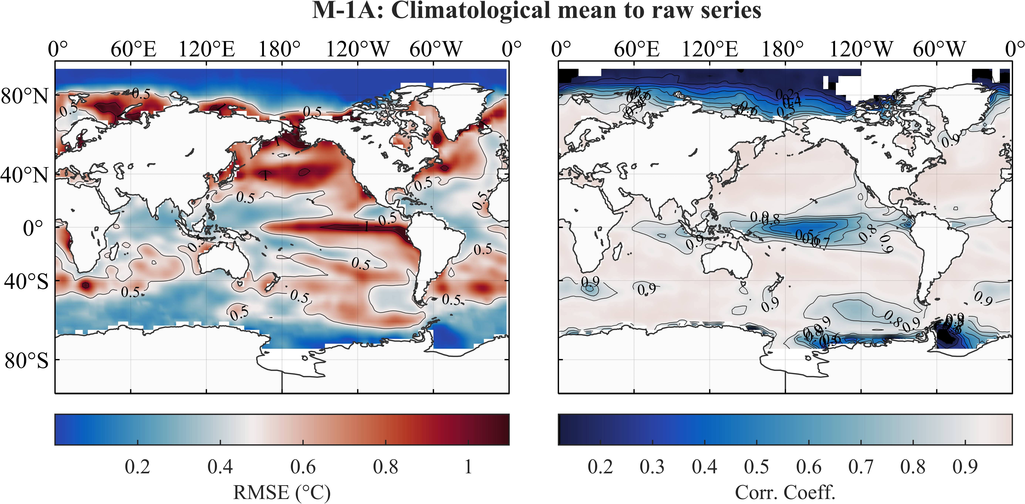

图16 对ERSST v5全球SST数据(1902-2021)，M-1A方法输出的气候平均态（trend + seasonal components）对原时间序列的root-mean-square error (RMSE) (a) and Pearson linear correlation coefficients (CC) (b).

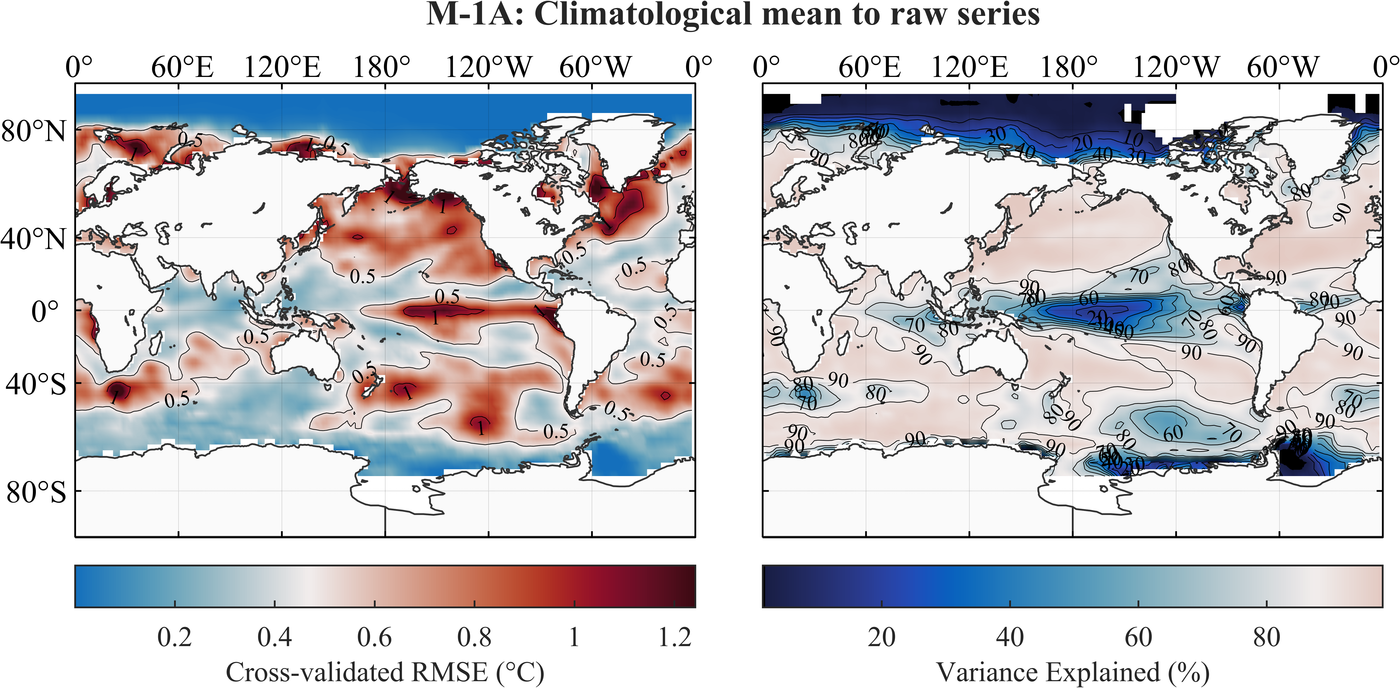

图17 对ERSST v5全球SST数据(1902-2021)，M-1A方法输出的气候平均态（trend + seasonal components）对原时间序列的cross-validated RMSE (CVE) (a) and explained variance (EV) (b).

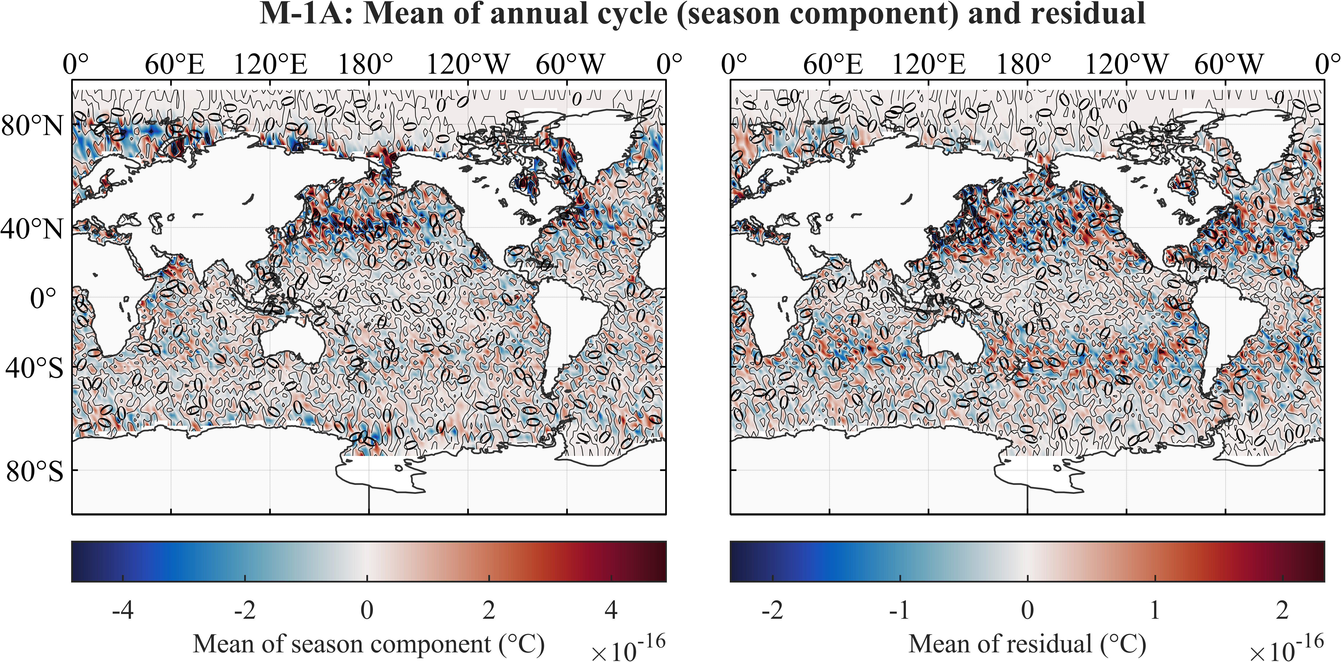

图18 对ERSST v5全球SST数据(1902-2021)，M-1A方法输出的seasonal component (a)和residual (b)的平均值.

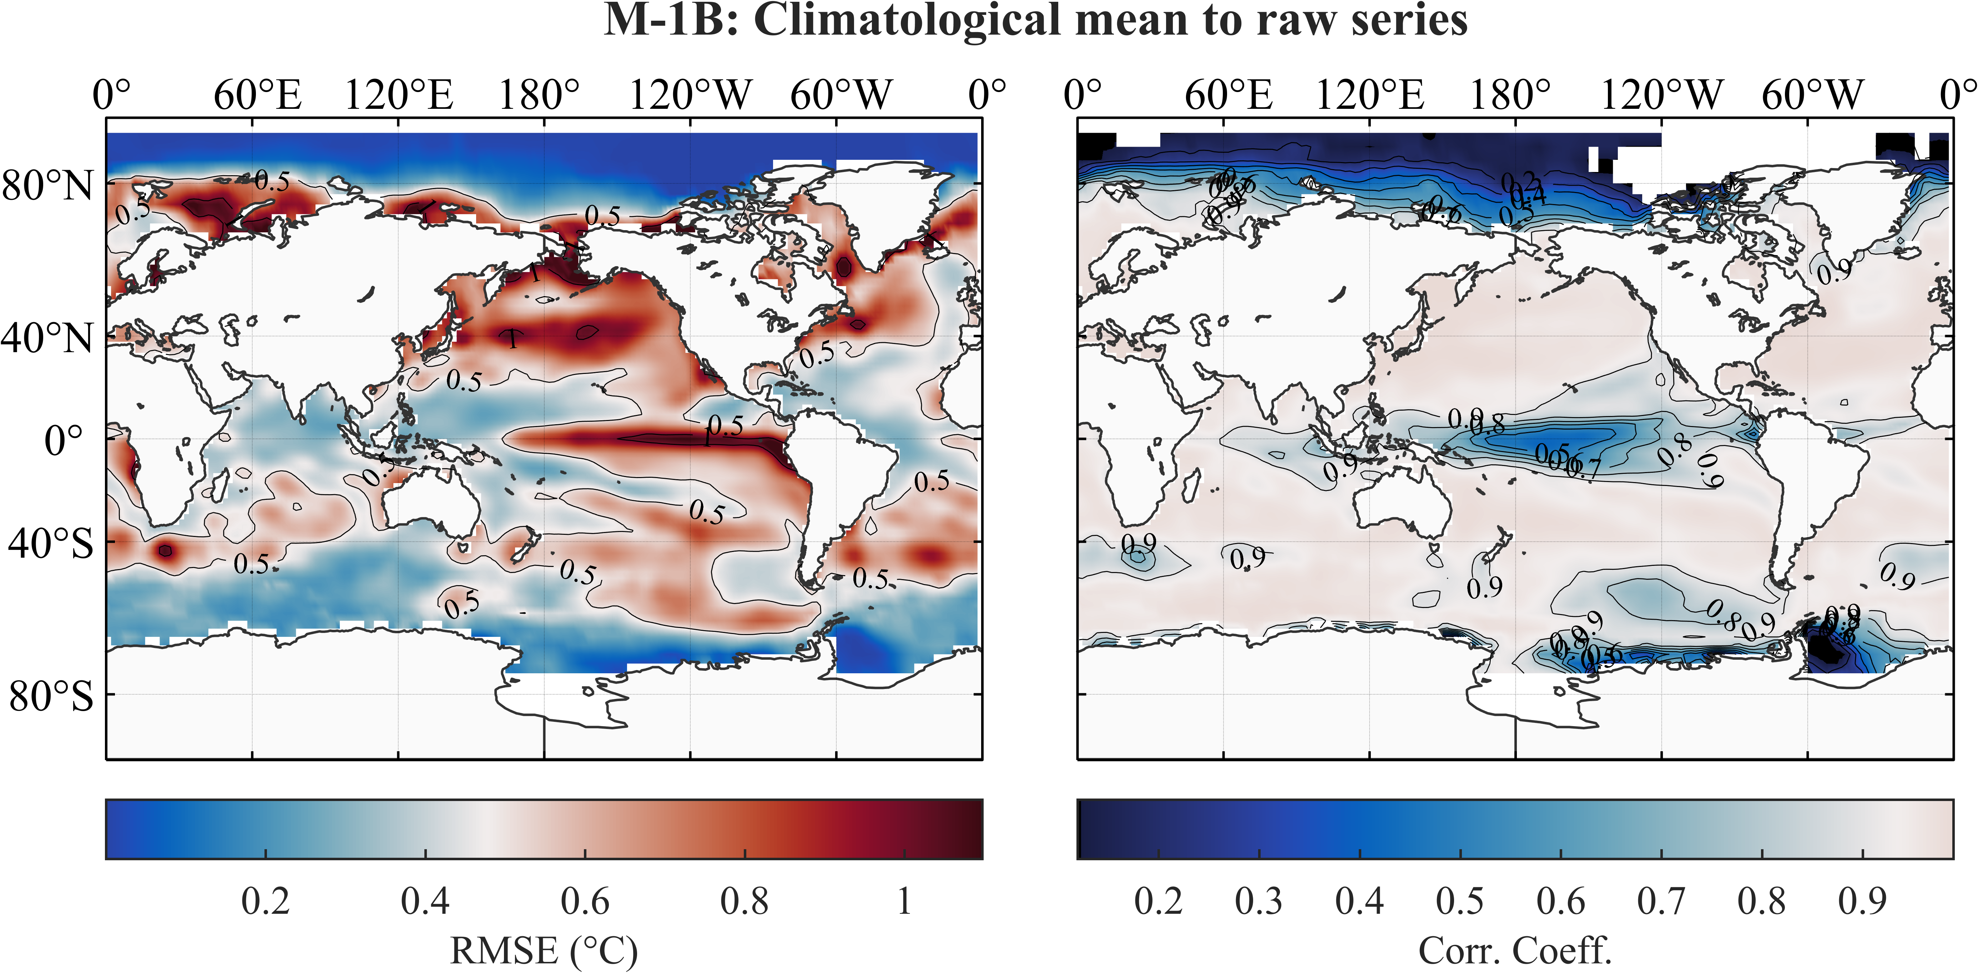

图19 对ERSST v5全球SST数据(1902-2021)，M-1B方法输出的气候平均态（trend + seasonal components）对原时间序列的root-mean-square error (RMSE) (a) and Pearson linear correlation coefficients (CC) (b).

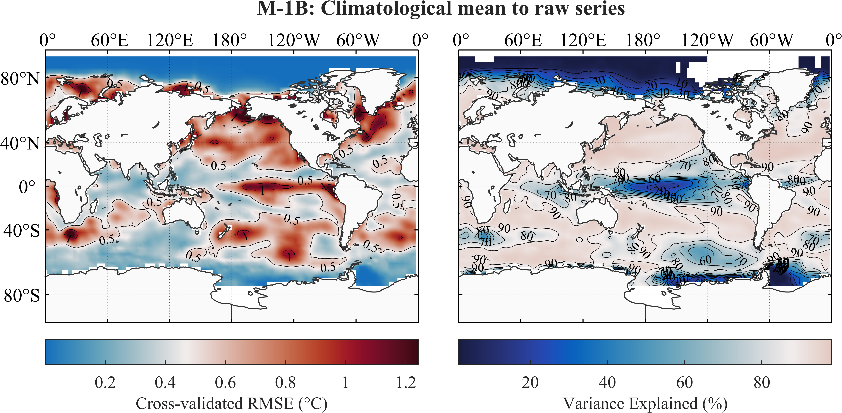

图20 对ERSST v5全球SST数据(1902-2021)，M-1B方法输出的气候平均态（trend + seasonal components）对原时间序列的cross-validated RMSE (CVE) (a) and explained variance (EV) (b).

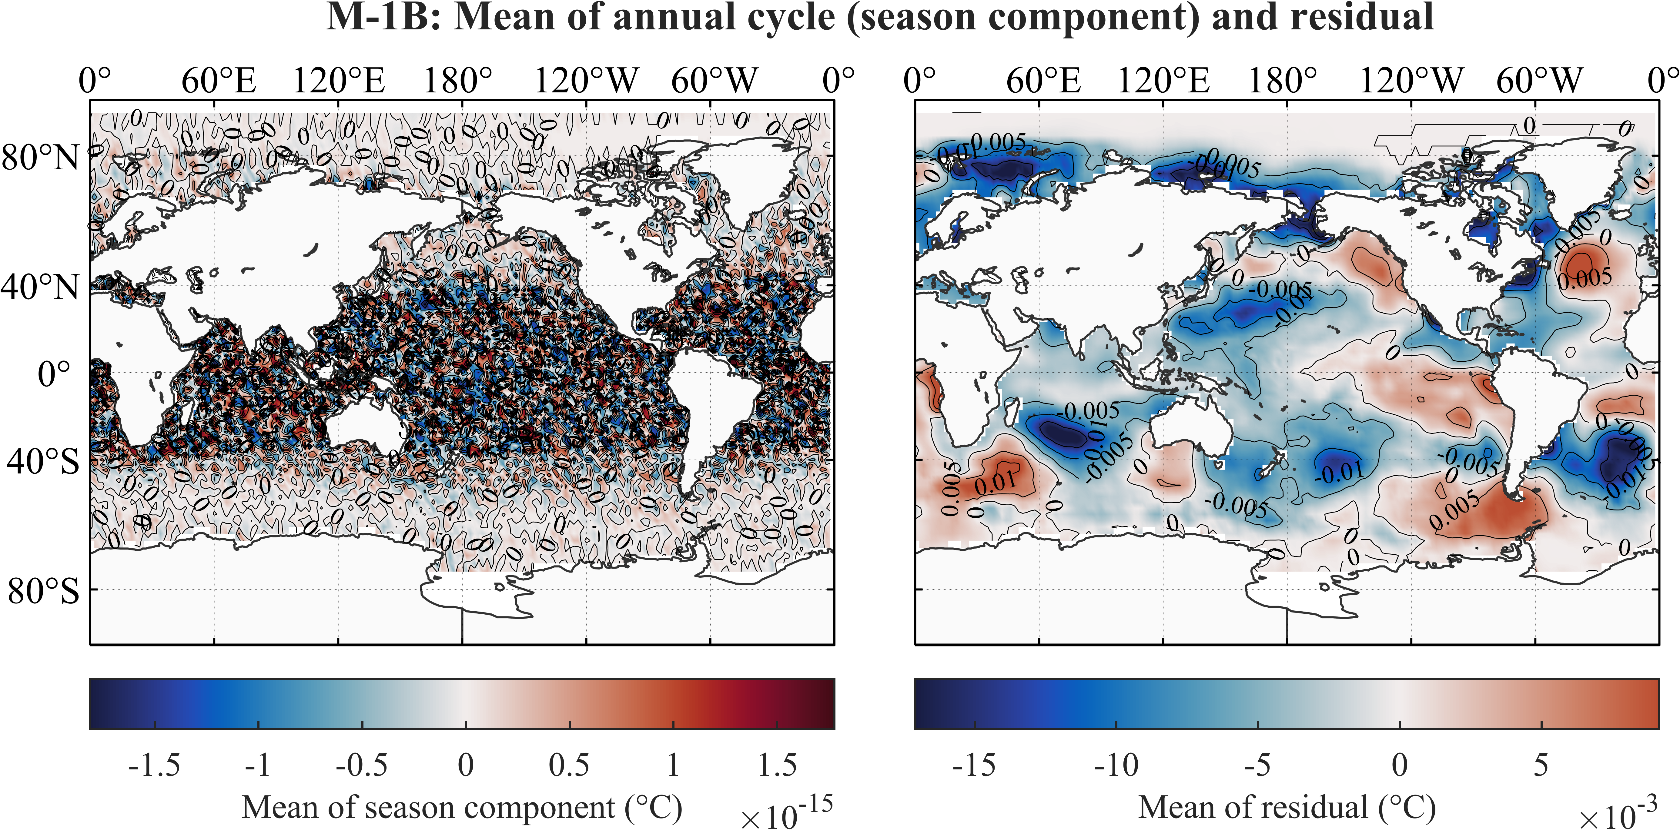

图21 对ERSST v5全球SST数据(1902-2021)，M-1B方法输出的seasonal component (a)和residual (b)的平均值.

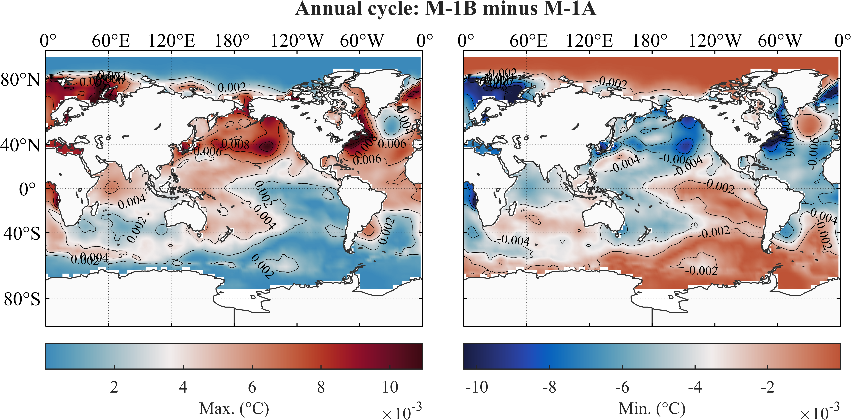

图22 对ERSST v5全球SST数据(1902-2021)，M-1B方法与M-1A方法输出的seasonal component之差.

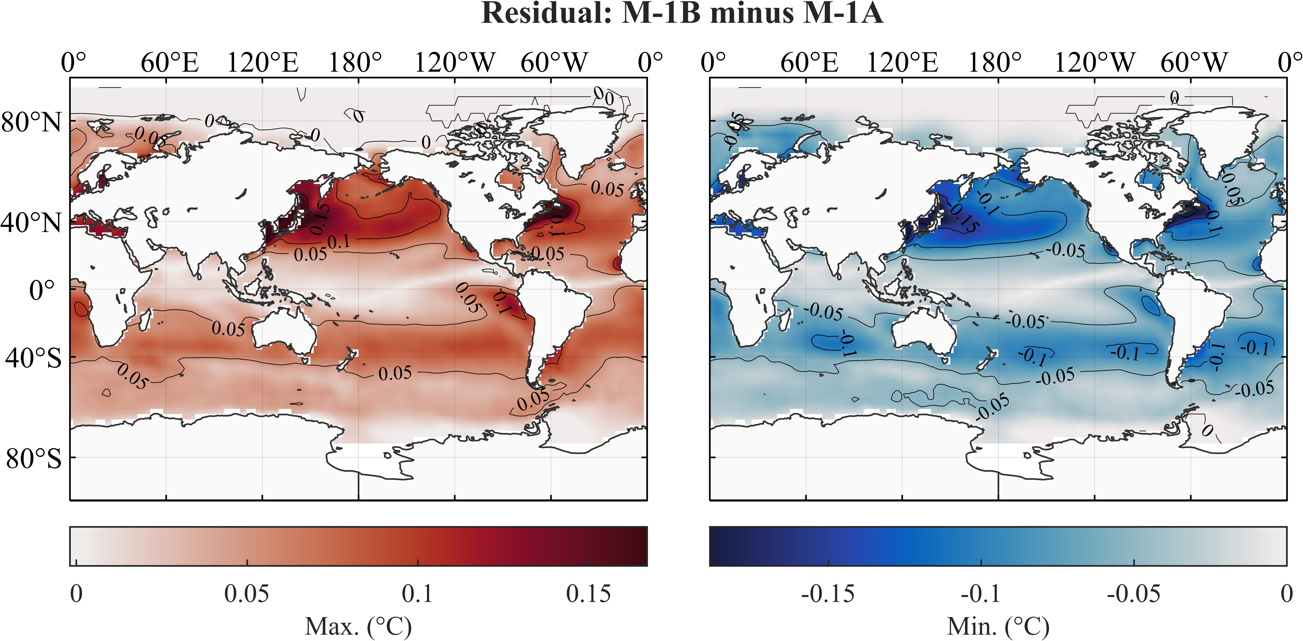

图23 对ERSST v5全球SST数据(1902-2021)，M-1B方法与M-1A方法输出的residual之差.

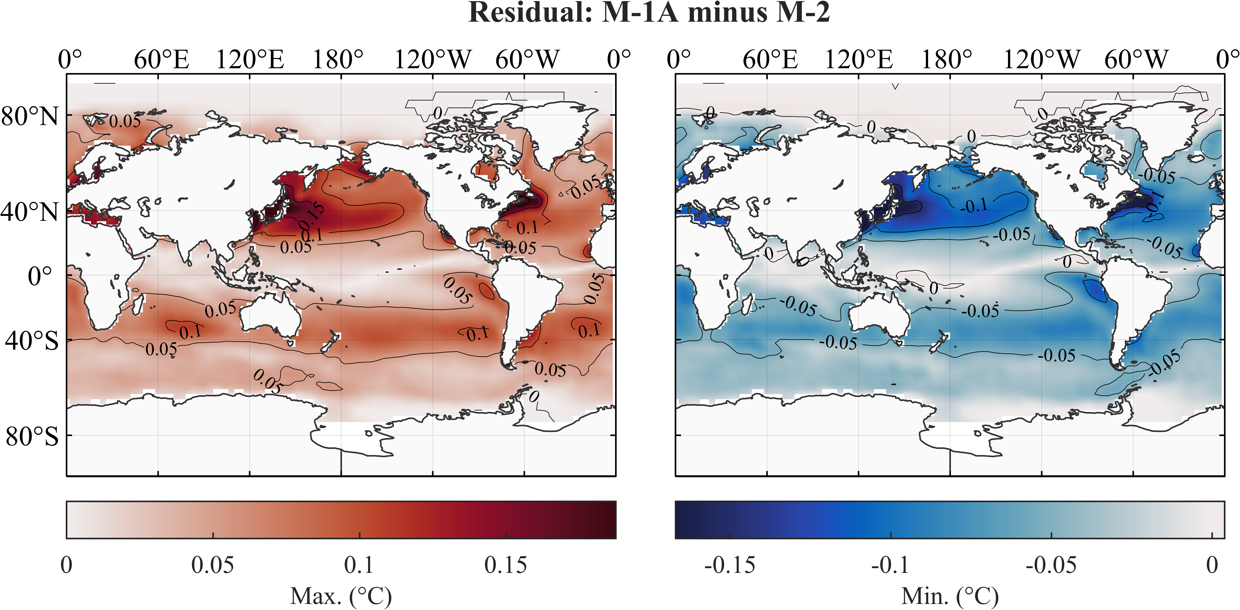

图24 对ERSST v5全球SST数据(1902-2021)，M-1A方法与M-2方法输出的residual之差.

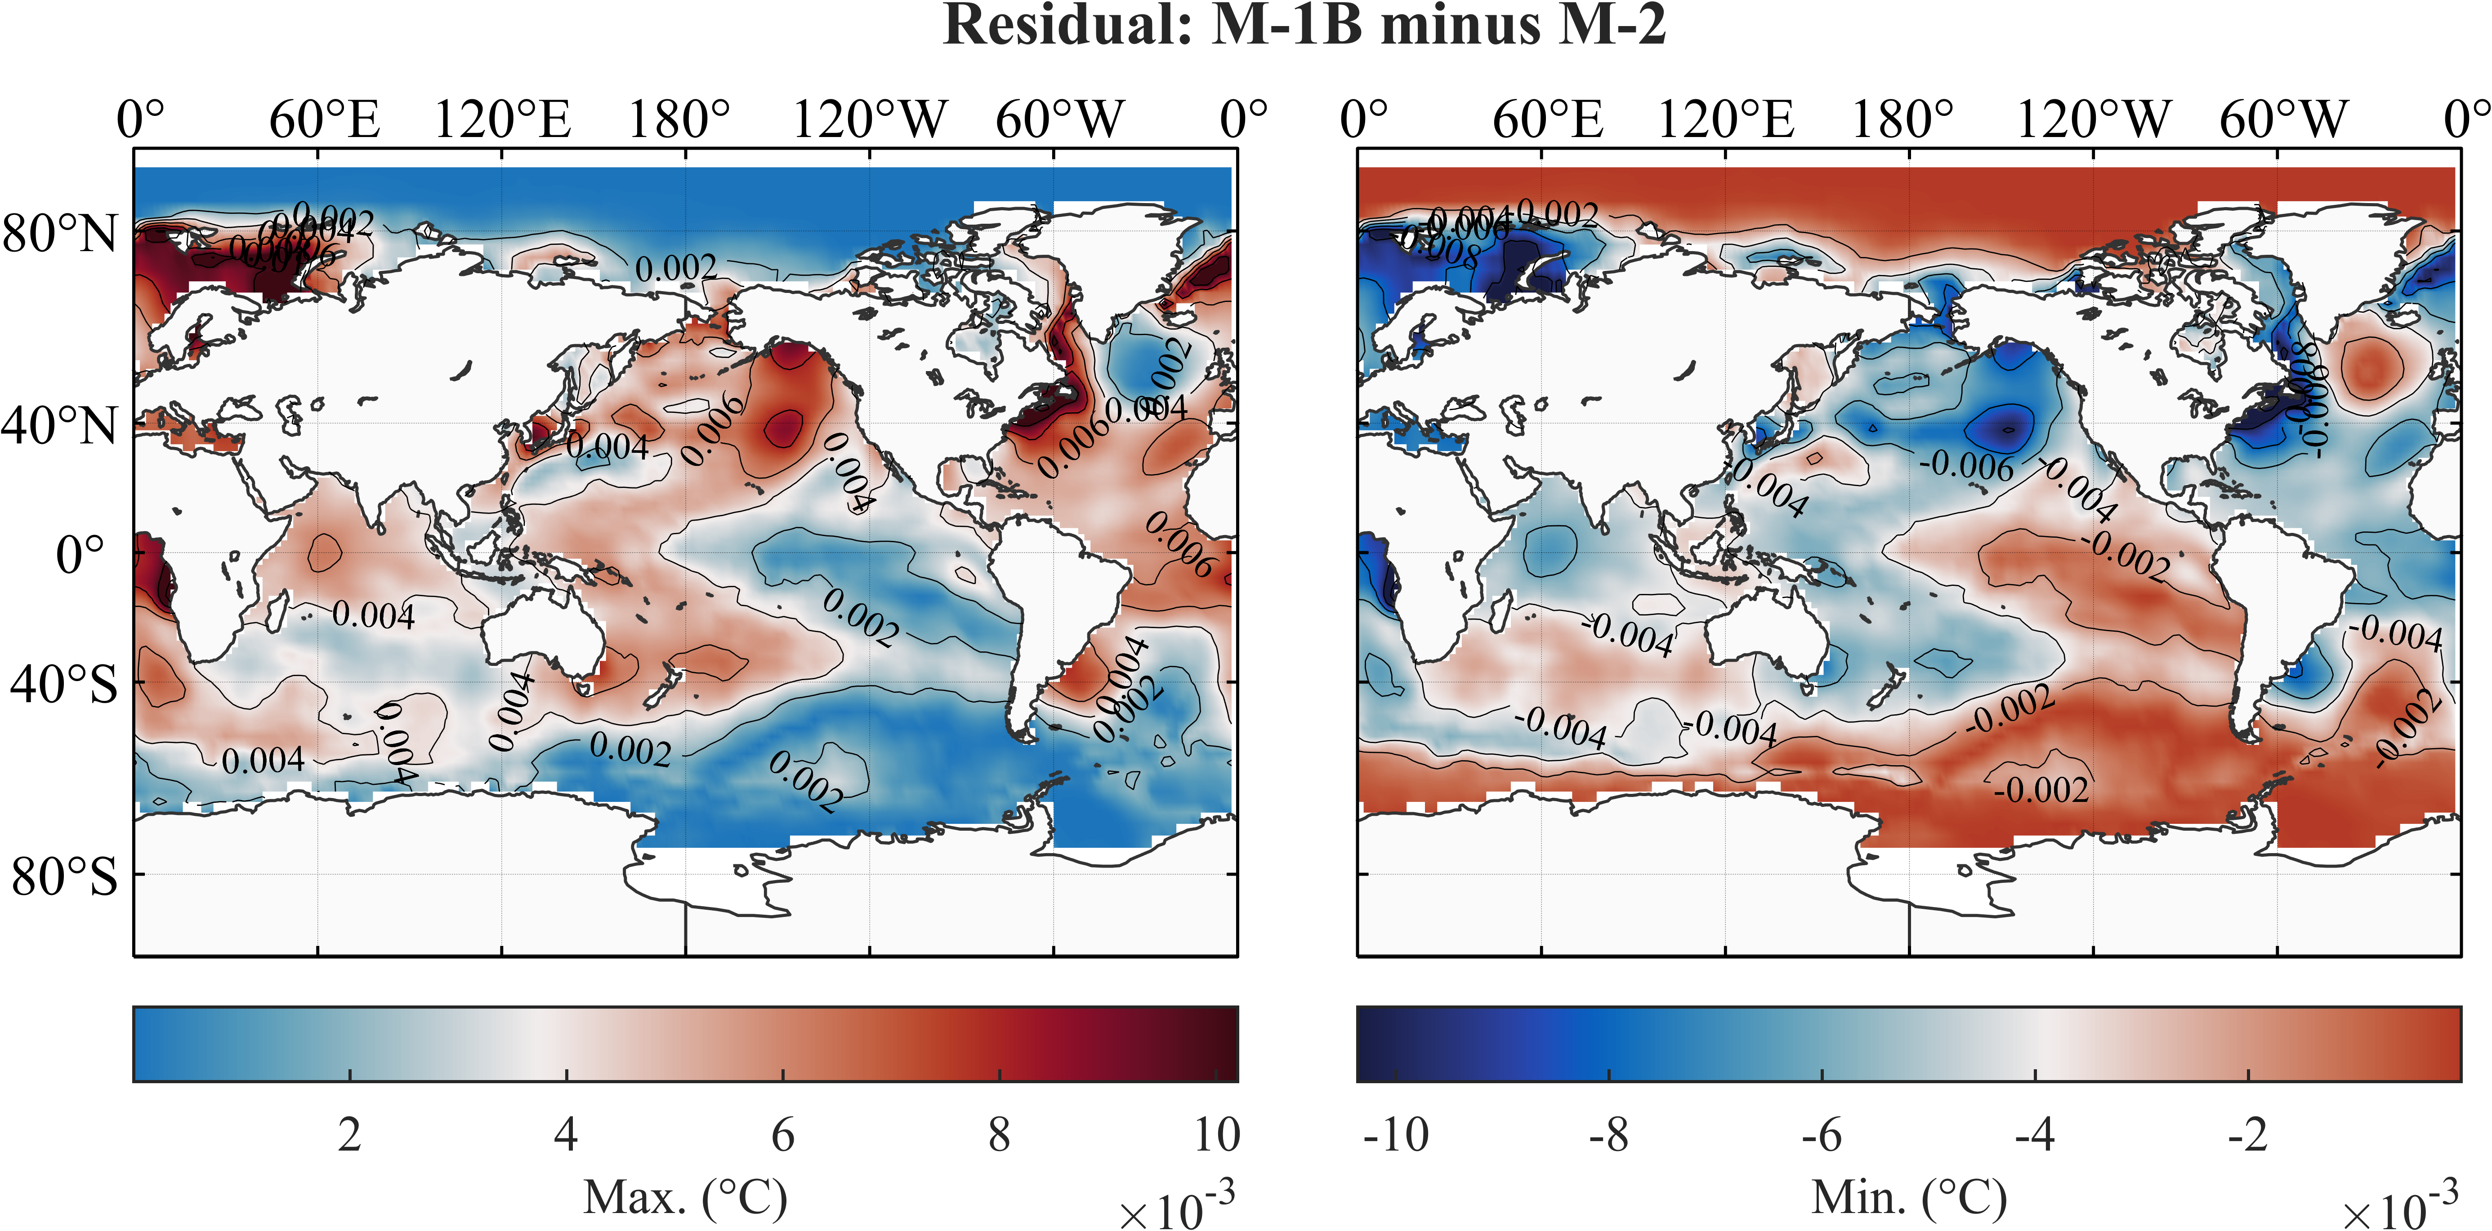

图25 对ERSST v5全球SST数据(1902-2021)，M-1B方法与M-2方法输出的residual之差.

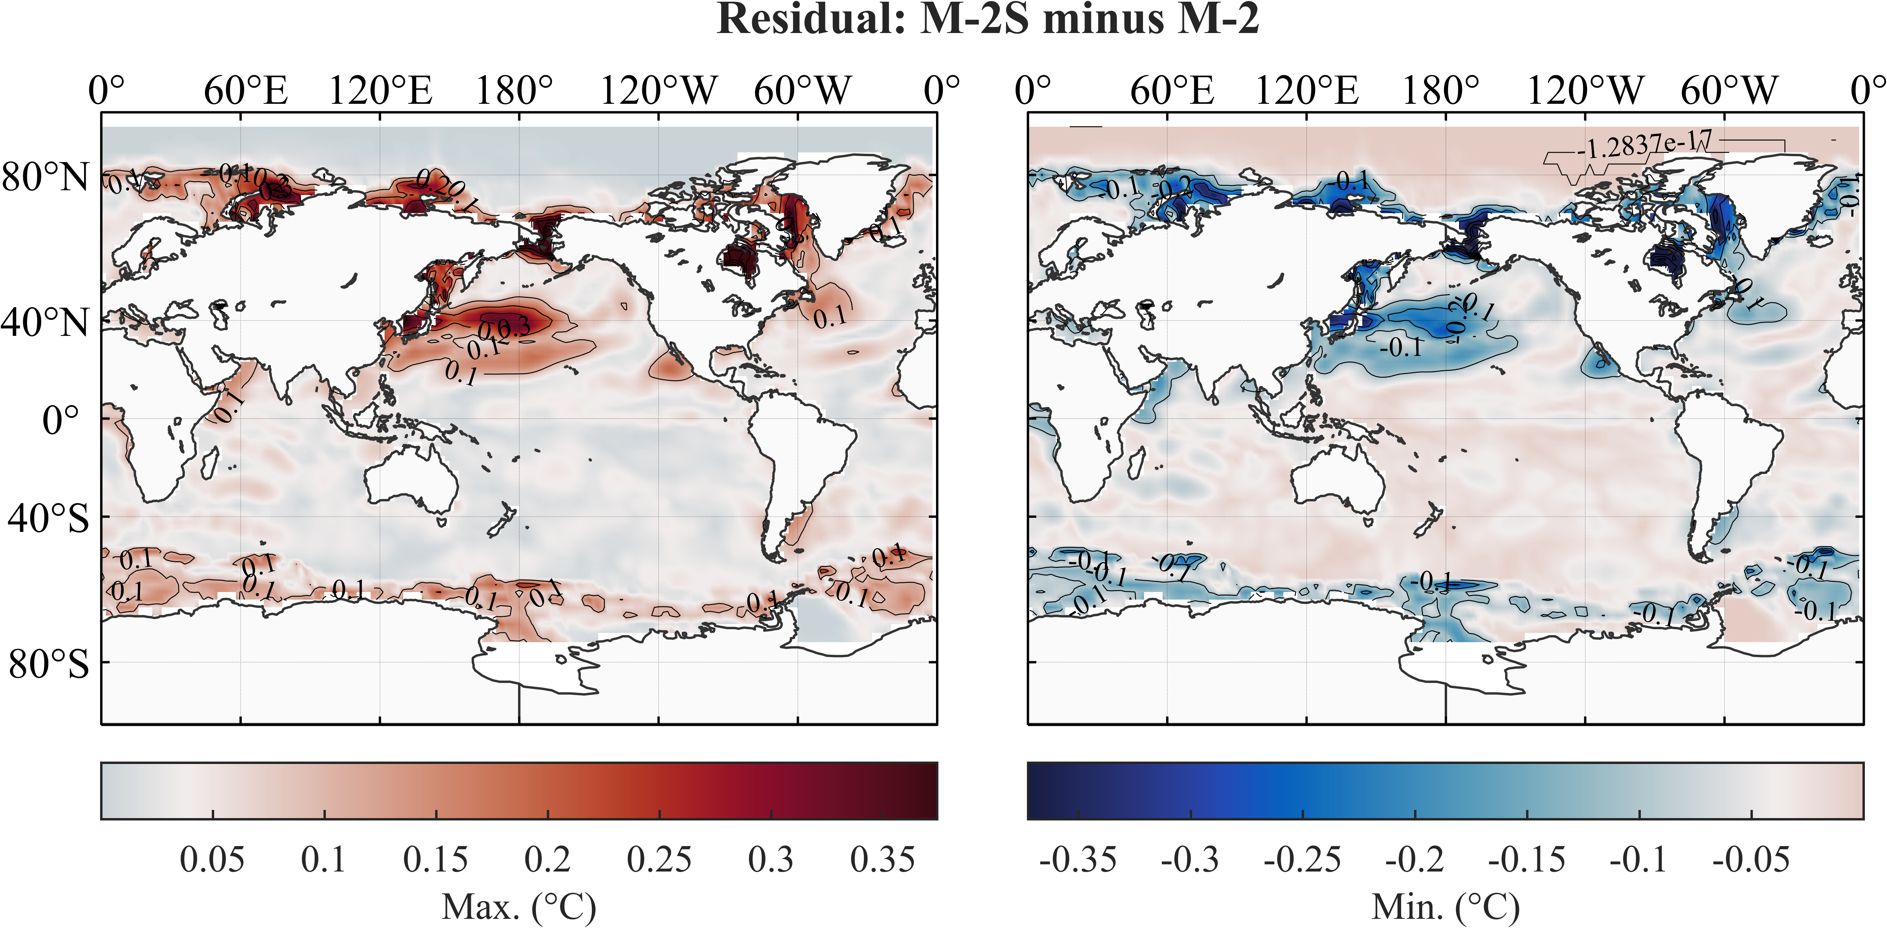

图26 对ERSST v5全球SST数据(1902-2021)，M-2S方法与M-2方法输出的residual之差.

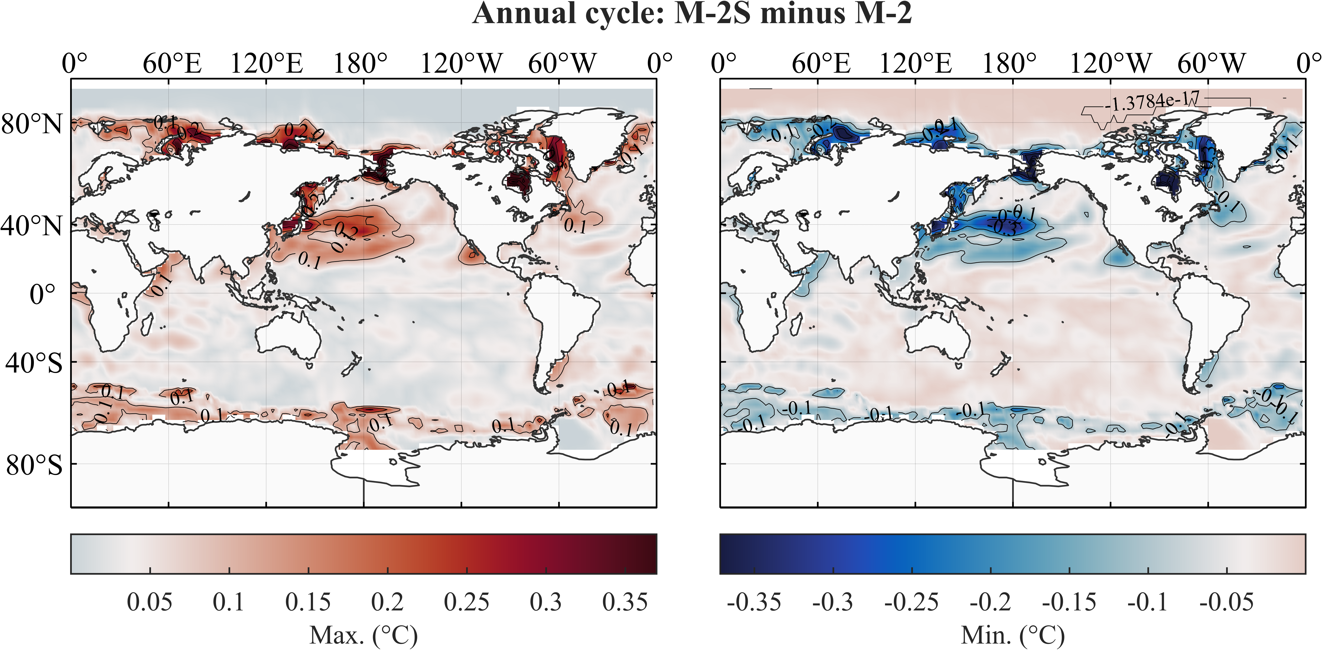

图27 对ERSST v5全球SST数据(1902-2021)，M-2S方法与M-2方法输出的seasonal component之差.

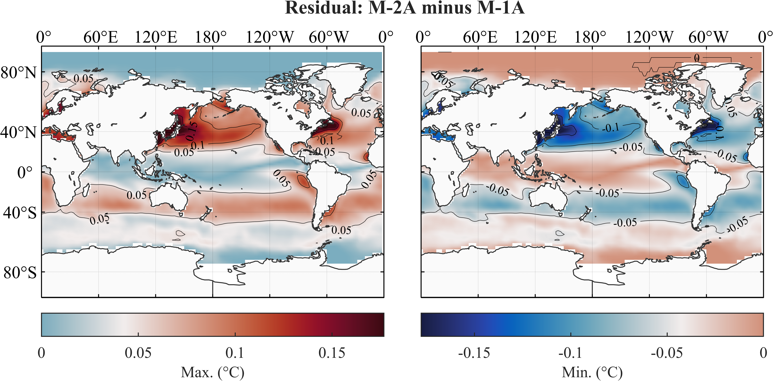

图28 对ERSST v5全球SST数据(1902-2021)，M-2A方法与M-1A方法输出的residual之差.

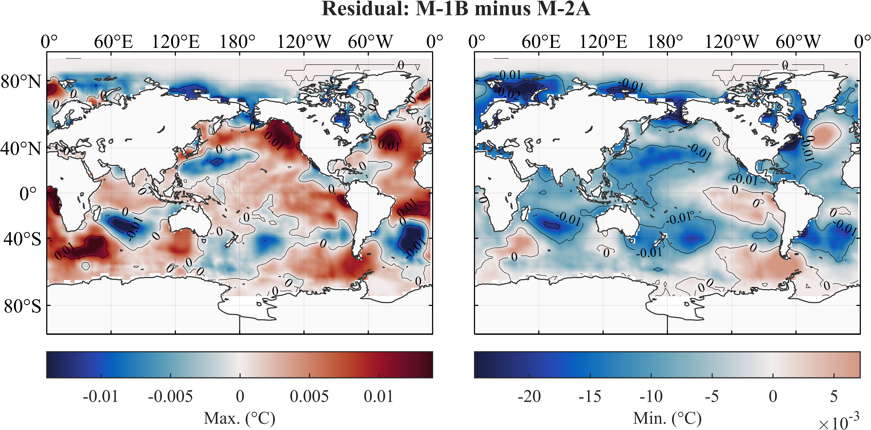

图29 对ERSST v5全球SST数据(1902-2021)，M-2A方法与M-1B方法输出的residual之差.

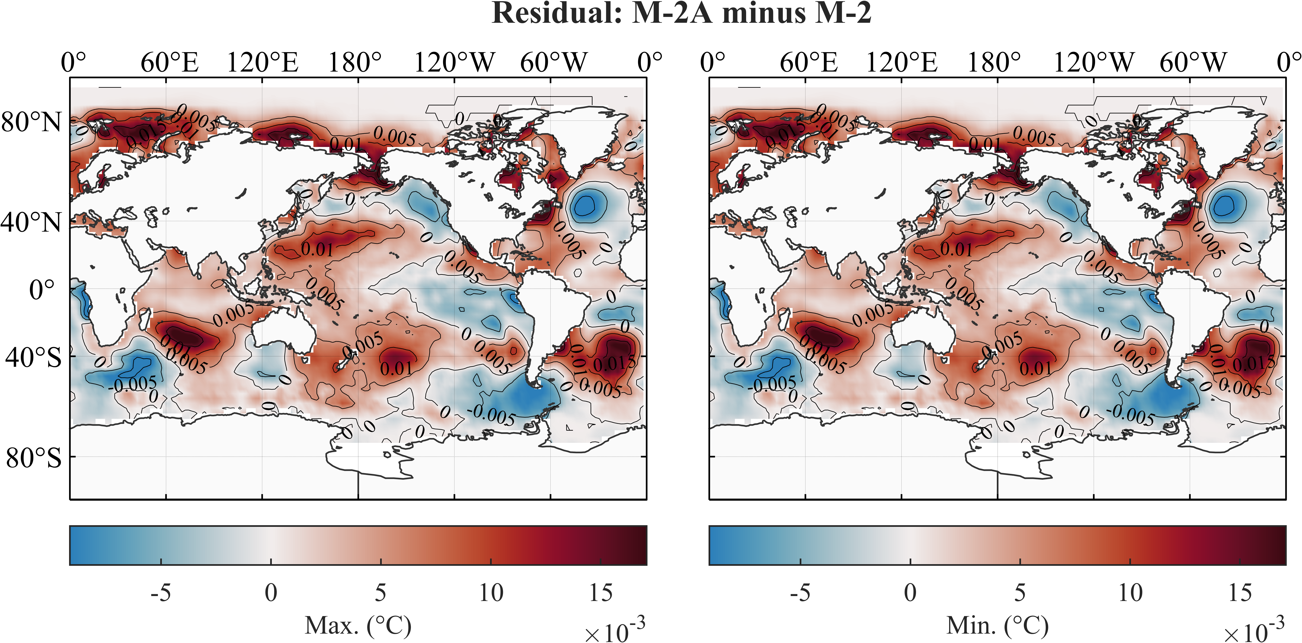

图30 对ERSST v5全球SST数据(1902-2021)，M-2A方法与M-2方法输出的residual之差.

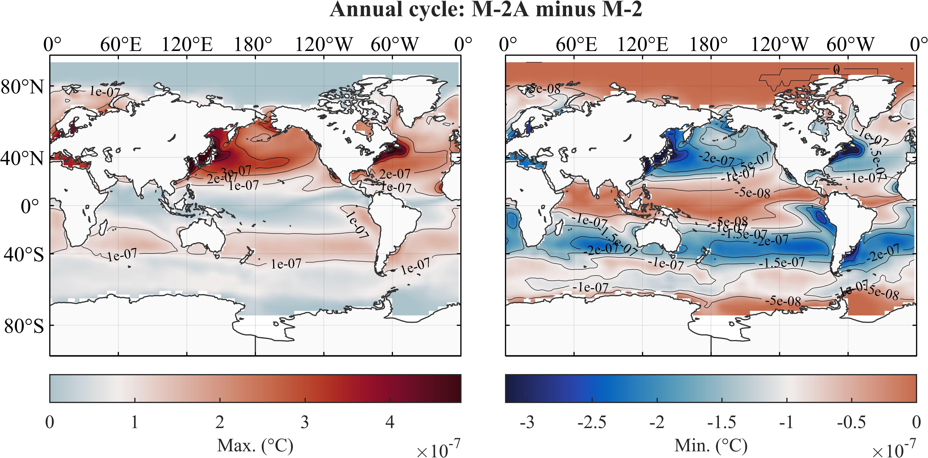

图31 对ERSST v5全球SST数据(1902-2021)，M-2A方法与M-2方法输出的seasonal component之差.

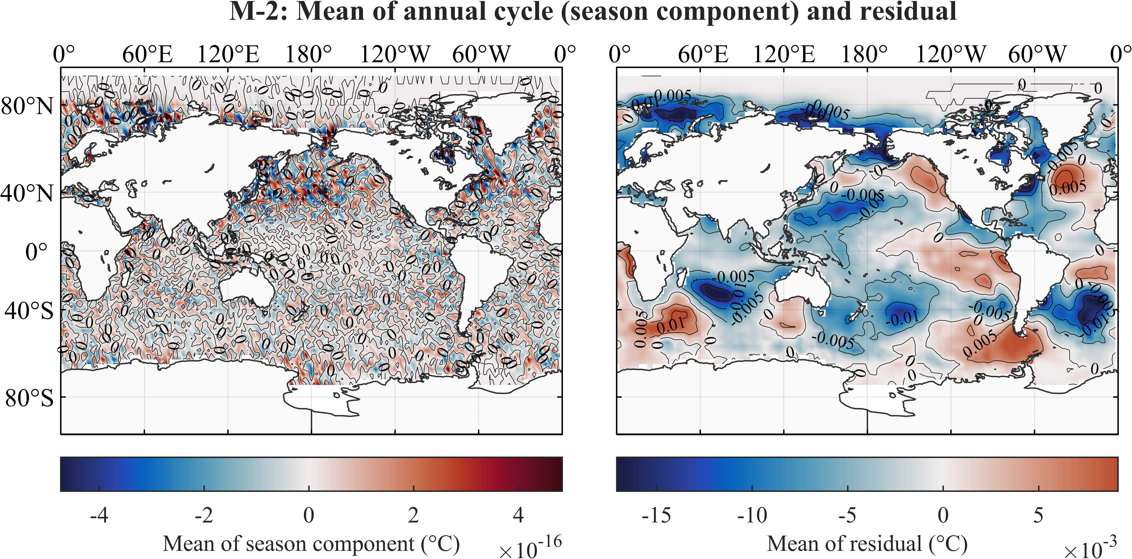

图32 对ERSST v5全球SST数据(1902-2021)，M-2方法输出的seasonal component (a)和residual (b)的平均值.

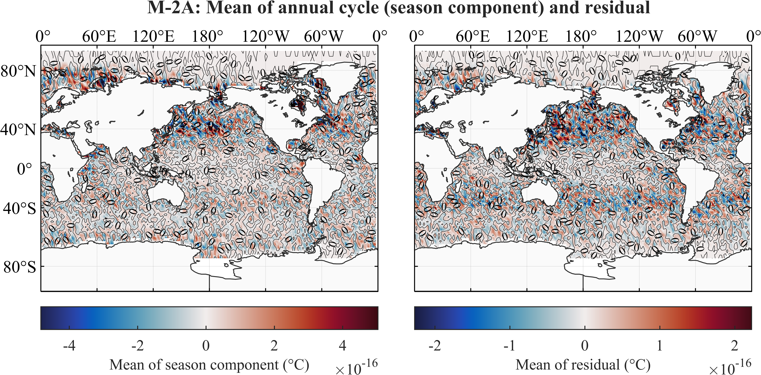

图33 对ERSST v5全球SST数据(1902-2021)，M-2A方法输出的seasonal component (a)和residual (b)的平均值.

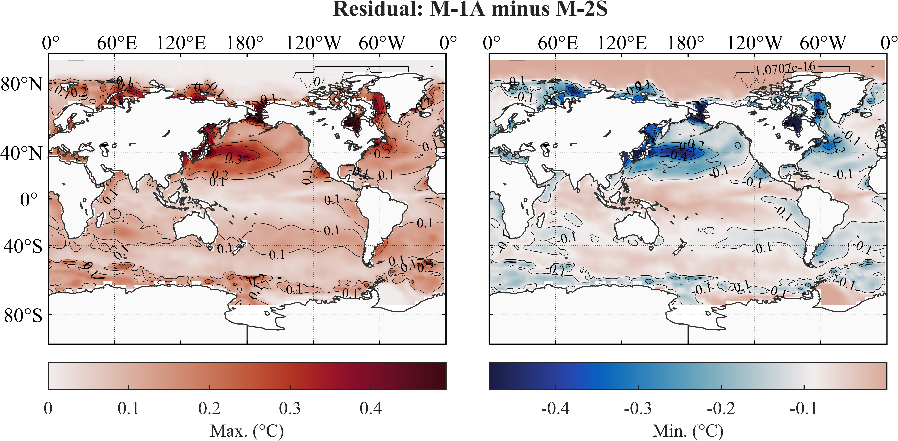

图34 对ERSST v5全球SST数据(1902-2021)，M-2S方法与M-1A方法输出的residual之差.

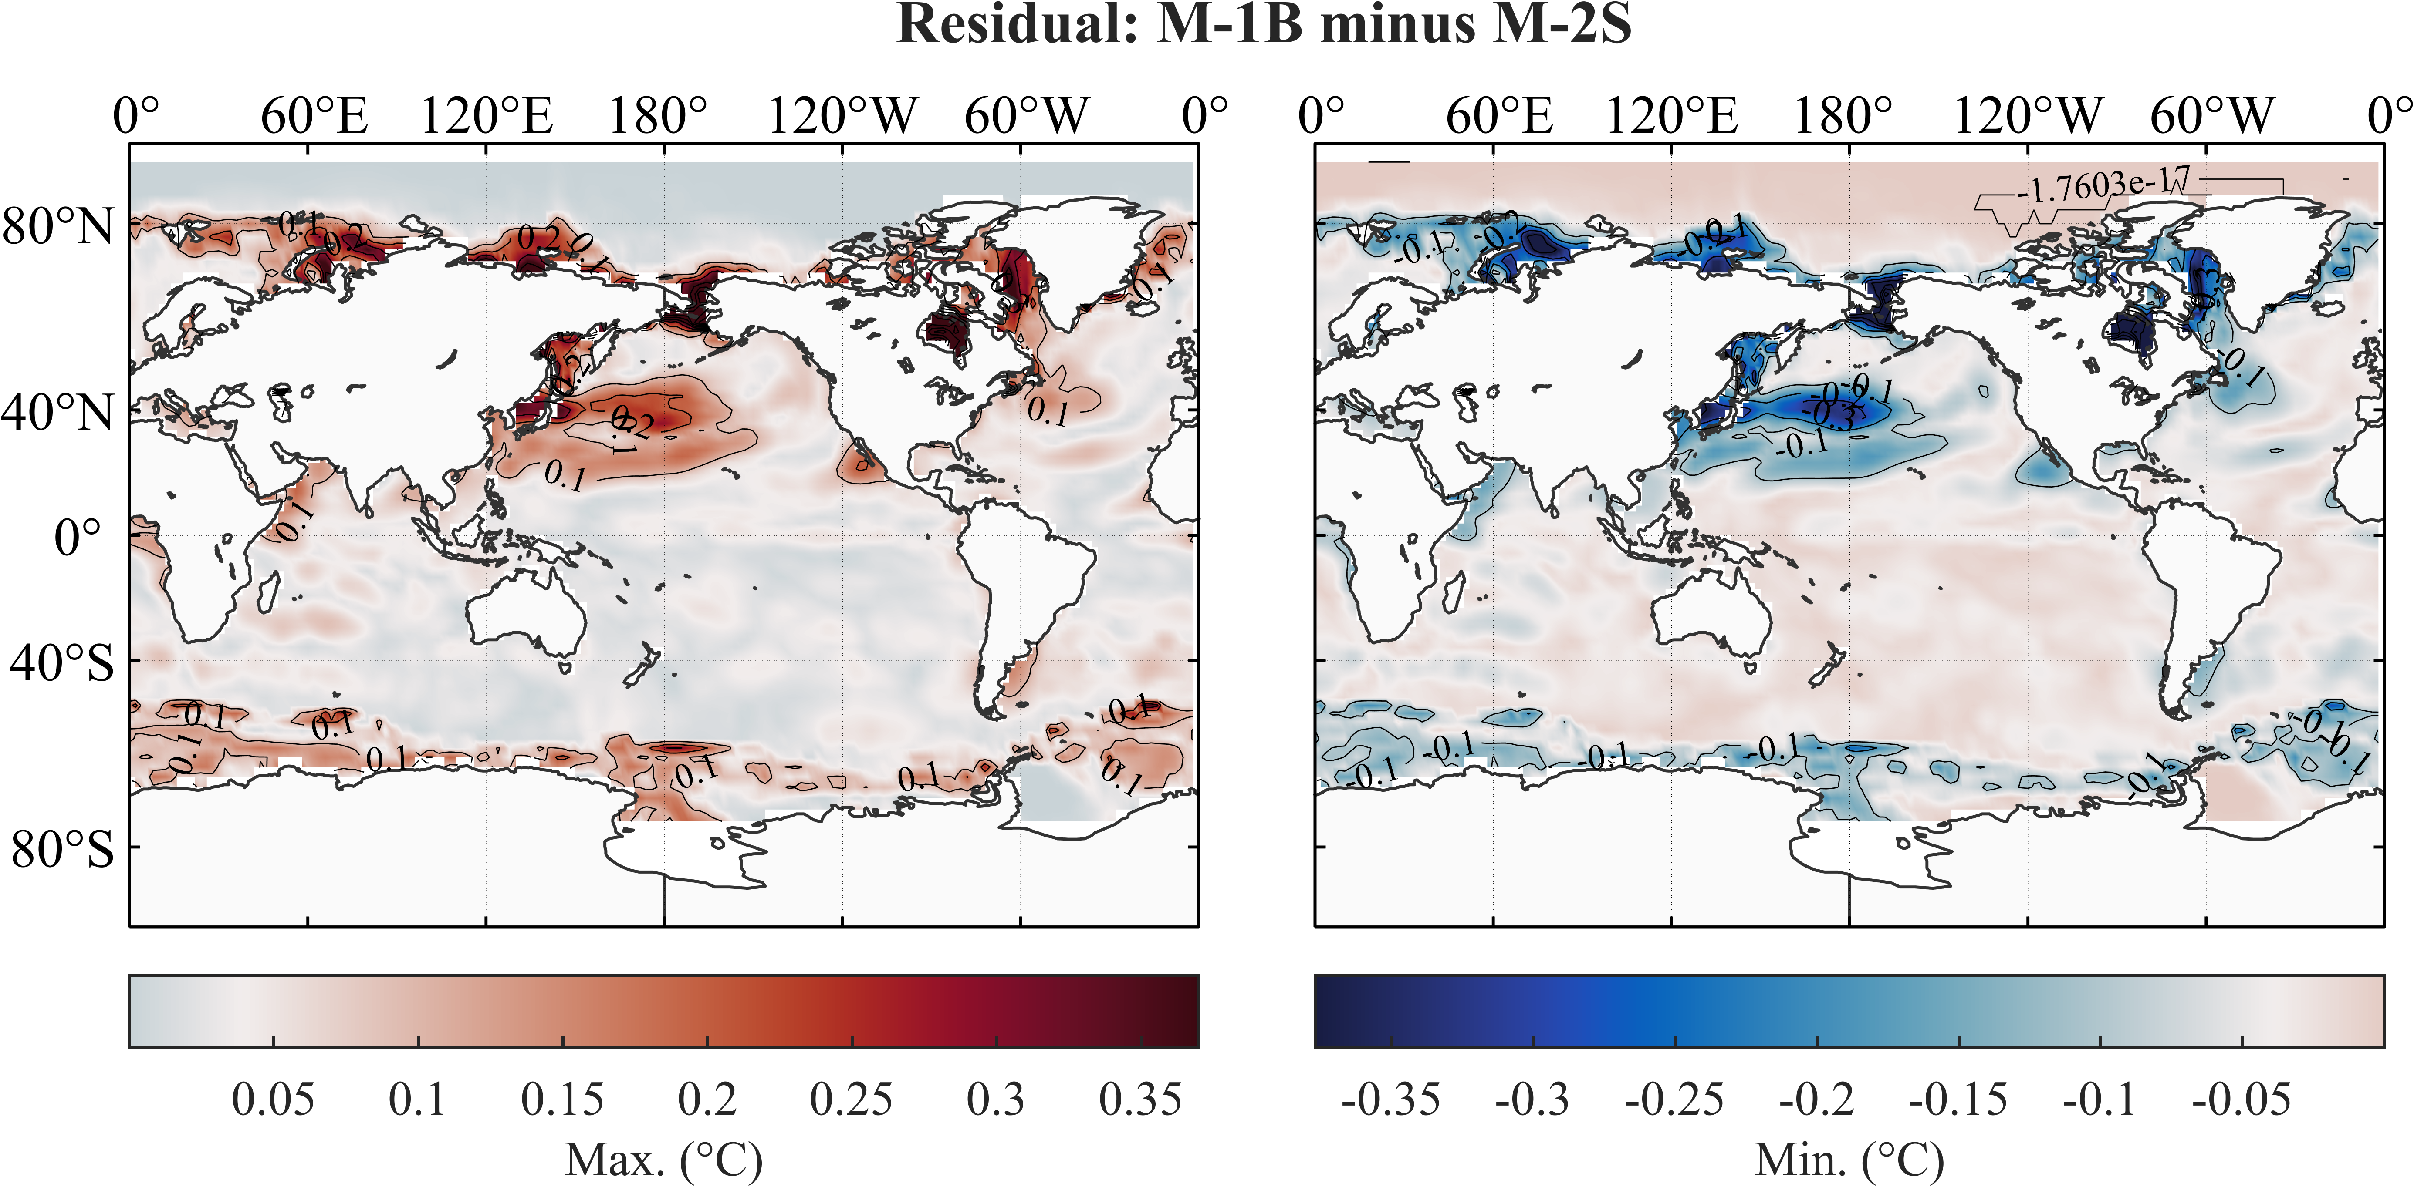

图35 对ERSST v5全球SST数据(1902-2021)，M-2S方法与M-1B方法输出的residual之差.

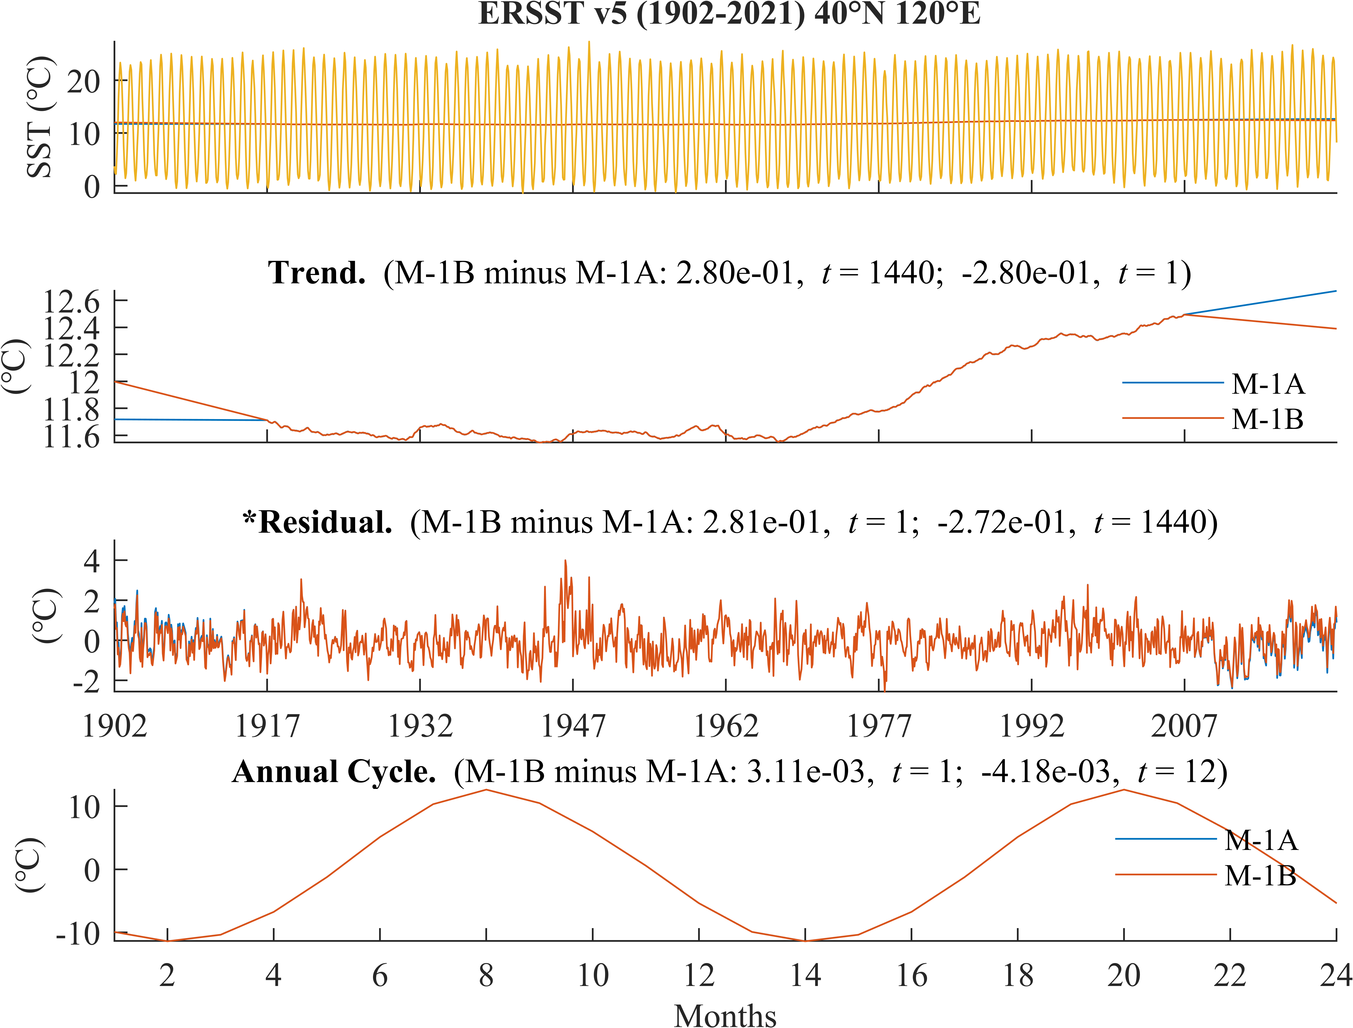

图36 对ERSST v5全球SST数据(1902-2021)在40°N, 120°E，M-1A方法与M-1B方法的经典分解结果.

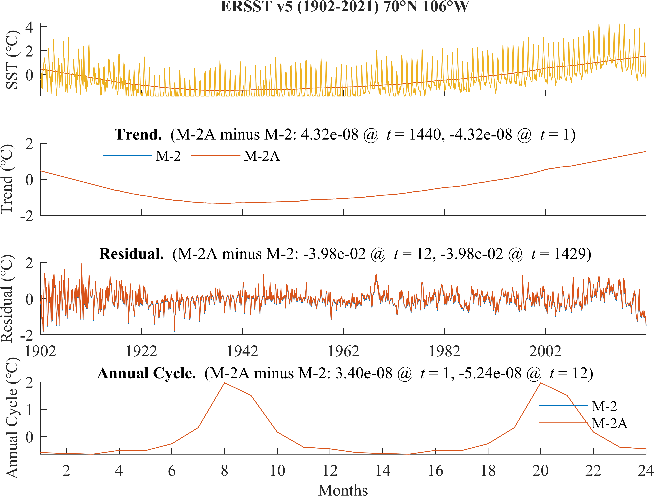

图37 对ERSST v5全球SST数据(1902-2021)在70°N, 106°W，M-2方法与M-2A方法的经典分解结果.

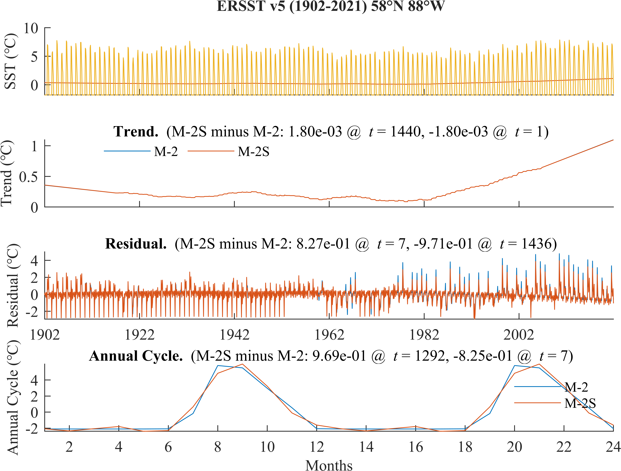

图38 对ERSST v5全球SST数据(1902-2021)在58°N, 88°W，M-2S方法与M-2方法的经典分解结果.

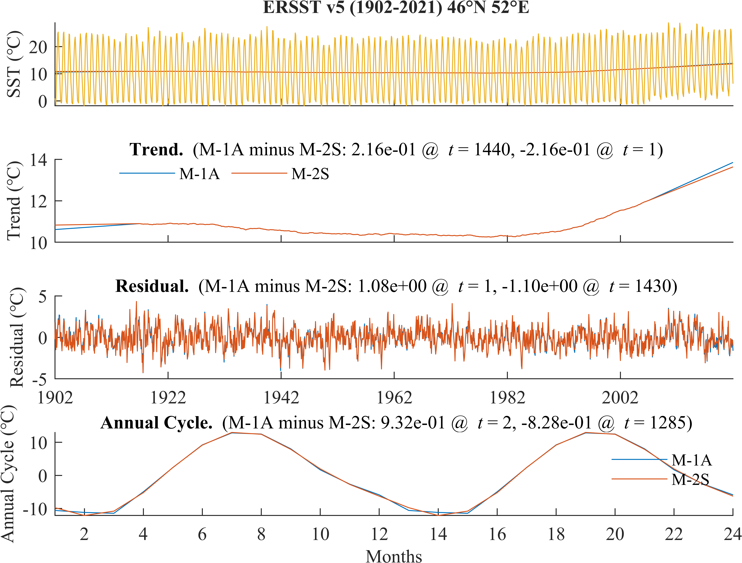

图39 对ERSST v5全球SST数据(1902-2021)在46°N, 52°E，M-2S方法与M-1A方法的经典分解结果.

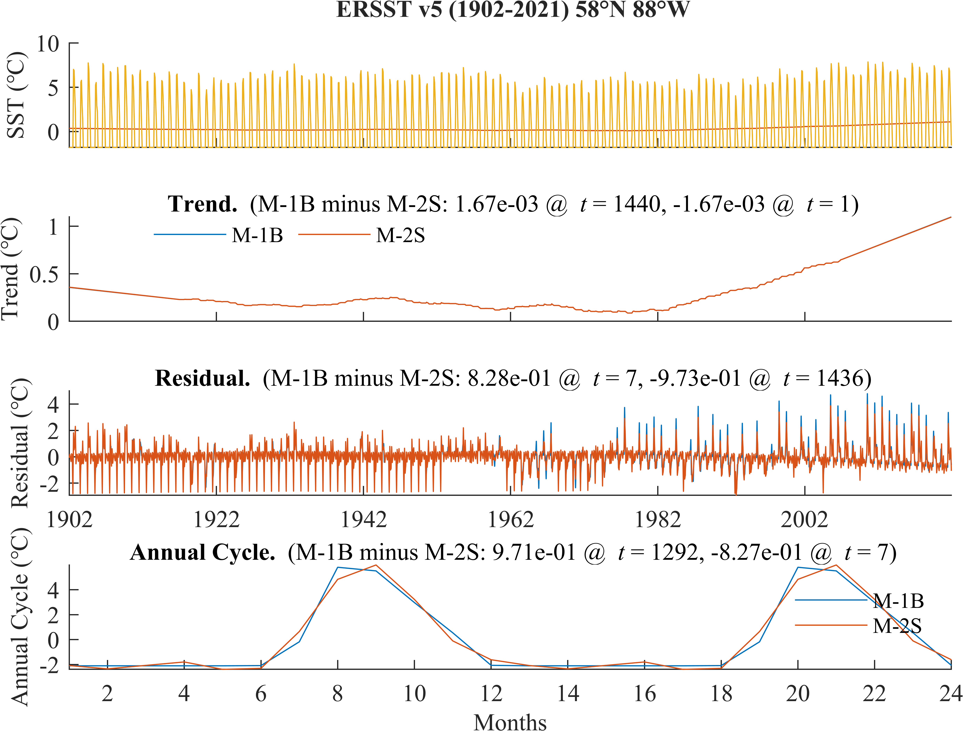

图40 对ERSST v5全球SST数据(1902-2021)在58°N, 88°W，M-2S方法与M-1B方法的经典分解结果.

### Comparison of different methods

M-1B与M-1A的差异. 由于这两种分解方式的区别，仅在于trend与seasonal component估计和去除次序的不同，下文称这种区别导致的分解结果差异为交换误差(swap error). 在ERSST算例中，输出residual差异的最值分布（图23）表明，差异较大区域出现在北半球两个西边界暖流及其延伸区，最大可达约0.28℃（40°N, 120°E，图36）；其他多数区域，这个差值不超过0.1℃. 从图36可进一步看出，M-1B与M-1A的差异主要出现在时间序列的首尾两端，最值出现在端点处，其原因如下：*a) LWLR的边缘效应*. 本文采取的LWLR区间长度是30年，即时间序列首、尾15年的trend是由以首、尾15年时刻为中心、30年时间区间上的原序列值（M-1A）或deseason后的值（M-1B）通过线性拟合决定的，而两种方法的拟合结果的差异在LWLR区间中心附近是很小的（这便是为什么除在首尾15年外的时刻，M-1A和M-1B的输出差异很小）；而越靠近时间序列的两端点，就越远离LWLR区间中心，从而trend的差别就越大. *b) 季节信号对线性拟合的影响*. M-1A在实施LWLR时，时间序列中仍含有季节信号，而M-1B没有. 季节信号虽然是长期零均值的，但其去除与否仍将对线性拟合结果产生影响，当季节周期的解释方差较大时，这影响有可能相对大. 这影响通过LWLR的边缘效应获得放大，造成在时间序列的首尾两端，M-1B与M-1A的输出差异变大. 从图17, 图20, 图23可以看出，两种方法输出差异较大（小）的地方，季节信号的解释方差往往也较大（小）. 上述结果提示：季节信号对线性回归的影响及其被LWLR的边缘效应放大，是造成M-1A和M-1B输出差异的重要原因. 待补充：对M-1A和M-1B的输出季节信号差异最大位置的分析.

M-1A与M-2的差异. 在ERSST算例中，M-1A对M-2的输出residual差异的最值分布（图24）类似于对M-1B的（图23）；这是因为，M-1B对M-2的输出residual差异较小（图25），最大仅约0.013℃（12°S, 14°E），其可能的原因将在后面分析.

M-2S与M-2的差异. 在ERSST算例中，M-2S对M-2的输出residual差异较大（图26），空间分布类似于M-1B和M-1A的输出residual差异（图23），差异较大区域同样出现在北半球两个西边界暖流的延伸区，但差值更大，最大可达约0.83℃（58°N, 88°W）. 还注意到，M-2S方法提取的seasonal components与M-2的差异的最值分布（图27）与M-2S方法与M-2方法输出的residual差异的最值分布（图26）类似. 考察M-2S与M-2的输出residual差异最大处的经典分解结果（58°N, 88°W, 图38），发现两个方法的输出trend差异很小（~10-3℃），而输出季节信号的差异的最值与输出residual的差异的最值同量级（~1℃）. 这些观察提示，因季节周期定义的不同导致的输出季节信号差异，是造成同属预估-校正类方法的M-2和M-2S的经典分解结果差异的主要原因.

M-2与M-1A, M-1B的差异. 在ERSST算例中，M-2的输出residual非常接近M-1B的（图25），差异最大约0.013℃（12°S, 14°E）；但远离M-1A的（图24），差异最大约0.28℃（40°N, 120°E）. 这个观察提示：相比于M-1A，M-1B可取得更接近预估-校正方法的效果；或者说，以M-1B为参考，本文采取的M-2系列方法的校正收益不明显. 这与在理想试验中的情况不同?!

M-2A与M-1A, M-1B, M-2的差异. 上面的结果启发我们，若在M-2类中，交换trend和season的估计次序，成为M-2A方法，是否将使输出接近M-1A？在ERSST算例中，M-2A的输出residual仍非常接近M-1B的（图29），差异最大仅约0.025℃（64°N, 162°W）；但仍远离M-1A的（图28），差异最大约0.28℃（40°N, 120°E）. 与此一致的是，M-2A的输出residual对M-2的差异较小（图30），差值最大约0.04℃（70°N, 106°W）. 上述试验结果表明：与M-1系列相比，在M-2系列中，交换误差被抑制. 这个结果提示：与M-1系列方法相比，采取M-2系列方法，可缓解由于对气候变率特别是长期趋势的物理理解的争议而引起的方案选择问题. 从这个角度，若要采取M-1方法，似乎应建议采取分解结果更接近M-2系列的M-1B.

M-1B, M-2, M-2A三种方法的输出接近，但相对远离M-1A的可能原因是什么？前面在讨论M-1A和M-1B的差异时，我们已经指出，M-1B对trend的估计量是从去除季节信号的时间序列中通过LWLR得到的，这与M-1A从带有季节信号的时间序列中估计trend的做法不同；季节信号对线性回归的影响及其被LWLR的边缘效应放大，是造成M-1A和M-1B输出差异的重要原因. 类似地，同属于预估-校正类方法的M-2和M-2A，不论第一步是估计trend（M-2）还是估计seasonal component（M-2A），经过一步校正后，trend的估计量都是从已去除季节信号的时间序列中通过LWLR得出的，这与M-1A不同. 从这个角度，M-1B, M-2, M-2A三种方法的输出接近，但相对远离M-1A的观察，是符合预期的，可用季节信号对LWLR的影响来解释.

进一步考察导致M-2和M-2A差异的原因. 在ERSST算例中，M-2和M-2A的输出seasonal component差异一般不超过10-6℃（图31）；M-2A可保持residual样本均值（图33），而M-2不可（图32），且M-2的residual样本均值空间分布（图32）与M-2和M-2A的输出residual差异的最值空间分布（图30）一致. 再考察M-2和M-2A的输出residual的差异最大位置（70°N, 106°W，图37）上的经典分解结果，发现输出的trend和seasonal component的差别很小（~10-8℃），而输出residual分量的差别近乎为一常数（0.040℃）. 这些结果说明，提取的residual的样本均值非零，是造成M-2和M-2A输出差异的主要原因；因residual的样本均值很小，故M-2与M-2A的输出差异很小；若不计这种原因导致的差异，则M-2和M-2A方法的输出是一致的. 这个结果支持了上一段的观点.

M-2S与M-1A, M-1B的差异. 前面的结果启发我们，既然M-2和M-2A都接近M-1B而远离M-1A，那么同属M-2系列的M-2S方法，是否存在M-1系列近似？在ERSST算例中，M-2S和M-1A（图34）, M-1B（图35）的输出residual的差异都较大，最大约1℃. 考察M-2S与M-1A的输出residual的最大差异所在位置（46°N, 52°E, 图39）上的经典分解结果，可见M-2S和M-1A的输出季节信号的差异可超过0.9℃，这对输出余项的差异有重要贡献. 两个方法的输出trend的差异在时间序列的首、尾15年以外时刻较小，在两个端点处取得最值（约0.22℃），故在时间序列两端附近，M-2S和M-1A输出trend的差异对residual的差异也有贡献. 考察M-2S与M-1B的输出residual的最大差异所在位置（58°N, 88°W, 图40）上的经典分解结果，可见M-2S与M-1B的输出trend的差异很小（~10-3℃），而输出季节信号的差异的最值和输出residual差异的最值同量级（~1℃），说明M-2S与M-1B的输出residual差异主要是由输出季节信号的差异造成的. 同时，M-1B与M-2S的输出residual的差异不是零均值的，提示输出residual的样本均值对两种方法的输出residual差异亦有少量贡献. 综上，造成M-2S与M-1A, M-1B的差异的可能原因包括：a) 因季节周期定义的不同导致的输出季节信号差异；b) 季节信号对线性回归的影响及其被LWLR的边缘效应放大（M-1B无此项）；c) 提取的residual的样本均值非零（M-1A无此项）.

# Discussion

## 经典分解的基本假定及合理性

假定季节信号是单音的？（对比：日变化周期）？加性分解？EMD？数据驱动的预报？

## 对时间序列经典分解方案的物理-数学理解

trend视作气候系统本身的一种特殊变率，或是外加的独立信号，将导致 M-1B, A 两种方法，引起混淆。建议：将物理和序列分析过程分开理解，因为最终都是要做经典分解。

## 造成各分解方式间差异的因素

trend 的非线性，季节信号的解释方差，年际、年代际变率的幅度。M-1A, B 的差异-空间分布，和其他指标的联系。

## 预估-校正的收益

比较 M-2 系列内部，和横向比较 M-1 系列。

## 时间序列分解质量评价

因气候系统的非线性决定了总响应不是各输入独立作用的输出之和、要素时间序列采取“随机过程 -> 一次实现”的理解方式、各分量没有数学上严格的客观定义，故难以找到一种完美的、唯一的、纯客观的评价指标。这是分解方式多样的理论根源。本文采取的各指标，仅供参考，不必然表示各方法优劣。

## 年际及以上变率的数学期望和样本均值

由于观测时间有限，“长期变率可能是更长时间周期信号的一部分”。有些方法，若假定季节周期是零均值的，则可自动保证变率零均值。是否合理？

## 未来研究建议

本文研究表明，在气候变化的背景下，各分解方式确可能造成差异，有时甚至显著。故建议：后续研究应注意讨论这种差异对结论的影响；在承认非线性的情况下，建立各分量的内秉、客观、物理、数学定义，和配套的客观分解方式；和应用统计、计量经济学等部门合作。

# Conclusions

本文以三种常用的经典分解方案为例，研究了不同的分解方案对结果的影响. 结果表明，采取不同的分解方法，对结果会造成一定的影响. 在某些情况(趋势强非线性，趋势增量大，季节信号的解释方差小?)下，影响更明显. 在全球气候变化的背景下，本文的结果值得学界关注.

基于本文的讨论，我们认为，气候态(包括长期趋势，季节周期分量等)应是客观的，但趋势和季节周期的定义，以及相应的分解方案及其参数的选取却带有主观性，这是分解方案选取问题的根源. 因此，我们对后续研究提出以下建议：(1) 后续研究应对气候态各分量建立客观定义，并建立相应的自适应分解方案. (2) 在对气候事件的分类和讨论中，若使用了某种时间序列分解方法，则应增加讨论采取其他分解方法对结果的影响，以避免研究结论被分解方案选取带来的虚假变率误导.

# References

Chen, X., & Li, T. (2021). An Improved Method for Defining Short-Term Climate Anomalies. *Journal of Meteorological Research*, *35*(6), 1012-1022. <https://doi.org/10.1007/s13351-021-1139-2>

Findley, D. F., Monsell, B. C., Bell, W. R., Otto, M. C., & Chen, B.-C. (1998). New Capabilities and Methods of the X-12-ARIMA Seasonal-Adjustment Program. *Journal of Business & Economic Statistics*, *16*(2), 127-152. <https://doi.org/10.1080/07350015.1998.10524743>

Narapusetty, B., DelSole, T., & Tippett, M. K. (2009). Optimal Estimation of the Climatological Mean. *Journal of Climate*, *22*(18), 4845-4859. <https://doi.org/10.1175/2009jcli2944.1>

Pezzulli, S., Stephenson, D. B., & Hannachi, A. (2005). The Variability of Seasonality. *Journal of Climate*, *18*(1), 71-88. <https://doi.org/10.1175/jcli-3256.1>

Wu, Z., Huang, N. E., Long, S. R., & Peng, C.-K. (2007). On the trend, detrending, and variability of nonlinear and nonstationary time series. *Proceedings of the National Academy of Sciences*, *104*(38), 14889-14894. <https://doi.org/10.1073/pnas.0701020104>